NCWM Board of Directors
2026 Annual Meeting Agenda

Mr. Kevin Schnepp, NCWM Chairman
California

INTRODUCTION
This is the agenda of the Board of Directors (hereinafter referred to as the “Board”) for the 111th Annual Meeting of the National Council on Weights and Measures (NCWM). This report is based on the Interim Report offered in the NCWM Publication 16, testimony heard at public hearings, comments received from the regional weights and measures associations and other parties, the addendum sheets issued at the Annual Meeting, and actions taken by the membership at the voting session of the Annual Meeting. The Informational items presented below were adopted as presented when the Board’s report was approved.
Table A identifies the agenda and appendix items. Agenda items are identified in the Report by Reference Key Number, Item Title, and Page Number. Item numbers are those assigned in the Interim Meeting agenda. A Voting item is indicated with a “V” after the item number. An item marked with an “I” after the reference key number is an Informational item. An item marked with a “D” after the reference key number is a Developing item. The developing designation indicates an item has merit; however, the item was returned to the submitter for further development before any action can be taken at the national level. An agenda “Item Under Consideration” is a statement of proposal and not necessarily a recommendation of the BOD. Suggested revisions are shown in bold face print by striking out information to be deleted and underlining information to be added. Table B lists the results of any Voting Items.
Items may be grouped into “Blocks” if they are:
- Opposing Items: Items in direct conflict with each other, and only one may be adopted,
- Interdependent Items: Items addressing a similar topic where, if one is adopted, all need to be adopted, and
- Related Items: Items addressing a similar topic across multiple codes or regulations.

Some Voting Items are considered individually; others may be grouped in a consent calendar. Consent calendar items are Voting Items that the Board has assembled as a single Voting Item during their deliberation after the Open Hearings, assuming that the items are without opposition and will not require discussion. The Voting Items that have been grouped into consent calendar items will be listed on the addendum sheets. Prior to adoption of the consent calendar, the Board will remove specific items from the consent calendar upon request to be discussed and voted upon individually.
The Board may change the status designation of agenda items (Developing, Informational, Assigned, Voting and Withdrawn) up until the report is adopted, except those items which are marked Developing, Informational, Assigned or Withdrawn cannot be changed to Voting Status. Any change from the Board Interim Report (as contained in this publication) or from what appears on the addendum sheets will be explained to the attendees prior to a motion and will be acted upon by the active members of NCWM prior to calling for the vote.
An “Item under Consideration” is a statement of proposal and not necessarily a recommendation of the Board. Suggested revisions are shown in bold face print by striking out information to be deleted and underlining information to be added. Requirements that are proposed to be nonretroactive are printed in bold faced italics. Additional letters, presentation and data may have been submitted for consideration with this item. Please refer to https://www.ncwm.com/publication-16 to review these documents.
All sessions are open to registered meeting attendees. If the Board must discuss any issue that involves proprietary information or other confidential material; that portion of the session dealing with the special issue may be closed if (1) the Chairman or, in his absence, the Chairman-Elect approves; (2) the Executive Director is notified; and (3) an announcement of the closed meeting is posted on or near the door to the meeting session and at the registration desk. If possible, the posting will be made at least a day before the planned closed session.
Subject Series List
Activity Reports ACT Series
Strategic Planning, Policies, and Bylaws SPB Series
Financial FIN Series
Other Items OTH Series

Table A
Table of Contents
Reference Key | Title of Item | BOD Page
ACT – Activity Reports 7

ACT-1 I Membership 7

ACT-2 I Meetings 8

ACT-3 I Participation in International Standard-Setting 8

ACT-4 I Associate Membership Committee Activity 8

ACT-5 I Task Groups, Subcommittees, Steering Committees 9

ACT-6 I Regional Association Activities 11
SPB – Strategic Planning, Policies, and Bylaws 12

SPB-24.1 I Electronic Publications 15 & 16 12

SPB-26.1 V Article X – Voting System 13
FIN – Financial 16

FIN-26.1 I Associate Membership Dues 16

FIN-1 I Treasurer's Report 18
Appendices
A ACT-3: Report of the Activities of the International Organization of Legal Metrology (OIML) and Regional Legal Metrology Organizations A21
B ACT-4: Associate Membership Committee (AMC) Agenda and Draft Meeting Minutes B25
Table B
Glossary of Acronyms and Terms

Acronym | Term | Acronym | Term
AMC | Associate Membership Committee | NTEP | National Type Evaluation Program
NCWM | National Council on Weights and Measures | OIML | International Organization of Legal Metrology
NIST | National Institute of Standards and Technology | OWM | Office of Weights and Measures
Details of All Items
(In order by Reference Key)

ACT – Activity Reports

ACT-1 I Membership
The chart and graph below show NCWM membership levels of recent years by membership categories. October 1 is the lowest level of membership for each fiscal year because it is the day that any memberships that were not renewed lapse. Significant growth is realized over the following 12 months as additional members return and new members are added. The potential growth remains significant, and NCWM continues to enhance programs and services that add value to membership.
Year Type | March 2018 | March 2019 | March 2020 | March 2021 | March 2022 | March 2023 | March  2024 | March  2025 | March 2026
Associate | 760 | 739 | 726 | 712 | 701 | 674 | 667 | 728 | 762
Foreign Associate | 88 | 90 | 99 | 98 | 100 | 96 | 100 | 101 | 117
Total Associate | 848 | 829 | 825 | 810 | 801 | 770 | 767 | 829 | 879
State Government | 684 | 796 | 817 | 672 | 731 | 756 | 714 | 700 | 668
Local Government | 468 | 458 | 456 | 427 | 406 | 396 | 395 | 390 | 375
Total  Active | 1152 | 1254 | 1273 | 1099 | 1137 | 1152 | 1109 | 1090 | 1043
NIST | 15 | 16 | 17 | 16 | 16 | 19 | 13 | 14 | 14
Other Federal Government | 11 | 10 | 8 | 7 | 8 | 7 | 9 | 13 | 11
Foreign Government | 16 | 15 | 15 | 12 | 14 | 14 | 15 | 17 | 17
Retired | 224 | 227 | 239 | 246 | 245 | 248 | 249 | 229 | 227
Total Advisory | 266 | 268 | 279 | 281 | 283 | 288 | 286 | 273 | 269
Grand Total | 2266 | 2351 | 2377 | 2190 | 2221 | 2210 | 2162 | 2192 | 2191

ACT-2 I Meetings
Interim Meetings:
- January 24-27, 2027 Sonesta Redondo Beach & Marina: Redondo Beach, California
- January 23-26, 2028 Biltmore Los Angeles, Los Angeles: California
Annual Meetings:
- July 26-30, 2026 111th Annual Meeting: Marriott Old City, Philadelphia, Pennsylvania
- July 11-15, 2027 112th Annual Meeting: Marriott Knoxville Downtown, Knoxville, Tennessee
- July 23-27, 2028 113th Annual Meeting: Hyatt Regency St. Louis Arch, St. Louis, Missouri
NCWM strives to plan meetings in locations that have reasonably priced airline service and are within government per diem rates. For more information about our meetings, contact Ms. Elisa Stritt, NCWM Director of Operations, at (402) 434-4872 or elisa.stritt@ncwm.com.

ACT-3 I Participation in International Standard-Setting
The NIST Office of Weights and Measures will provide a report of its important efforts in international standard-setting at the NCWM Annual Meeting in July. See Appendix A for the previous report.

ACT-4 I Associate Membership Committee Activity
Approximately 40% of NCWM members are Associate members. The Associate Membership Committee (AMC) is organized under the Bylaws of the National Conference on Weights and Measures, Inc. Also, AMC operates by separate Bylaws, which are available on the Committee page of www.ncwm.com. AMC meets at least 2 times per year in conjunction with NCWM Interim and Annual Meetings, and they invite all to attend. The AMC consists of between 5 and 10 members who, amongst themselves, elect officers to serve as Chair, Vice-Chair, and Secretary/Treasurer. See Appendix B for information on current members and officers.
AMC has established a reputation for promoting and improving NCWM and has demonstrated its desire to improve understanding of weights and measures activities in the public and private sectors.
The NCWM membership dues for Associate members of $115 are $15 higher than that for Active or Advisory members. The extra $15 is not for NCWM but rather is placed in a separate account referred to as the AMC Fund. The AMC has the discretion to allocate the funds in various ways. One means of allocating these funds is to provide grants in support of weights and measures training. The Committee receives applications and awards training grants from the AMC fund following their "Guidelines for Selection and Approval of Training Funds," which are posted on the Committee's webpage on www.ncwm.com. Downloadable applications for training grants and reimbursement forms are also available at this site.
The criteria for receiving AMC funds for training are as follows:
1. Funding request forms that are complete, specific, and detailed will receive priority attention for approval.
Based on the degree of missing or ambiguous information provided, individual requests may not be given any consideration during the AMC review process, pending further clarification.
2. Preference is given to training requests that benefit higher numbers of participants over those for fewer or single-person benefit. The Committee also gives priority consideration to multi-state training that encourages uniformity.
3. In general, attending meetings such as NCWM Annual Meetings, Interim Meetings, or regional associations
meetings will not be considered training.
4. As a lower priority, the committee will consider requests for the purchase of training materials but not requests for the purchase of assets (such as projectors).
5. Reasonable funding for travel and expenses will be considered if it is necessary to acquire an "expert trainer" that would benefit a high number of weights and measures officials. This will be an option when qualified volunteers are not available.
Neutral Comments:
Advisory:
- AMC Chairman Jim Pettinato provided a synopsis of the AMC meeting proceedings during the 2026 Interim BOD open hearings.
  - Since the last Annual Meeting two new requests for funding have been received/approved. At the AMC meeting, the financial report was reviewed; the balance in the training fund is currently healthy.
  - The AMC representatives on each of the standing committees provided an update of current activity of interest to AMC members. The AMC members in attendance expressed support for the Board's consideration of the AMC member dues increase.

ACT-5 I Task Groups, Subcommittees, Steering Committees
Task Groups, Subcommittees, Steering Committees:
Focus groups, task groups, subcommittees, and steering committees are created by the NCWM Chairman and operate as defined in NCWM Policy 1.5.1. Subgroups Supporting the Work of the Organization. A task group is given a specific charge, and it reports to the appropriate NCWM standing committee. A task group will disband after completing its assignment. A subcommittee is charged with ongoing responsibilities in support of a standing committee in a specific field of expertise. A steering committee is charged with unbiased fact-finding to assist NCWM membership in decision-making on difficult issues. A steering committee will disband upon completion of its specific charge.
NCWM offers resources to these task groups and subcommittees including meeting space at Interim and Annual Meetings, conference calling and web meeting services, group email services, a dedicated web page for posting and archiving documents related to their work, and broadcast e-mail services to reach targeted audiences. Additionally, NIST OWM has provided technical advisors and web meeting forums. These tools enable year-round progress of task group and subcommittee work.
Because NCWM task groups and subcommittees are part of the NCWM organizational structure and report directly to its standing committees, their proposals may appear in NCWM Publication 15 without first being vetted through a regional association. NCWM vets any such proposals through its open hearings.
At the 2026 Interim Meeting, the board received updates from the following groups that report to the board:
- Mahesh Albuquerque reported that the EVSE Training Planning Committee is progressing well in preparation for the training to take place in Garden Grove, CA in February 2026.
- Kevin Schnepp provided an update on the EVSE Task Group.
- Jason Flint reported that the Standards Development Task Group has completed a review of Concept 1 of the 2018 Carter Team Report, and has begun a review of Concept 2 to determine the viability of voting twice per year.
- Additionally, Steve Benjamin, chair of the former Promotional Toolkit Task Group, offered to work with some state metrologists to develop a video promoting metrology laboratories' work. Some Associate Membership Committee funds remain earmarked for the video productions, and the NCWM will continue to provide matching funds in that effort.
Current task groups and subcommittees are listed here.
Reporting to the Board of Directors:
Policy and Bylaw Review Task Group
Chair: Chuck Corr
563-357-4167, chuckcorrconsulting@gmail.com
Training Planning Task Group
Chair: Mahesh Albuquerque
303-318-8502, mahesh.albuquerque@state.co.us
EVSE Task Group
Chair: Scott Dolan
802-828-2436, scott.dolan@vermont.gov
NCWM Standards Development Task Group
Chair: Jason Flint
973-420-8915, flintj@dca.njoag.gov
Reporting to the Laws and Regulations Committee:
Fuels and Lubricants Subcommittee
Chair: Vanessa Benchea
813-868-8263, Vanessa.Benchea@fdacs.gov
Packaging and Labeling Subcommittee
Chair: Chris Guay
513-652-6597, guay.cb@gmail.com
Uniform Shipment Law Task Group
Chair: Miland Kofford
801-538-7158, mkofford@utah.gov
Moisture Allowance Task Group
Chair: Tory Brewer
304-722-0602, tory.d.brewer@wv.gov
LPG Electronic Temperature Compensation Task Group
Chair: Christopher Wagner
610-308-3822, cwagner@npga.org
LMD Density Correction Task Group
Chair: To Be Determined
Reporting to the Specifications and Tolerances Committee:
Cannabis Task Group:
Chair: Evan Foisy
631-560-3497, EFoisy@andonline.com
Milk Meter Tolerance Task Group
Chair: Aaron Yanker
719-250-1851, aaron.yanker@state.co.us
Verification Scale Division (e) Task Group
Chair: Evan Foisy
631-560-3497, EFoisy@andonline.com
Transportation-for-Hire Systems Task Group
Chair: Mark Lovisa
225-925-3780, mlovisa@ldaf.state.la.us
WIM Vehicle Scale Task Group
Chair: Jim Willis
518-485-8377, james.willis@agriculture.ny.gov
LMD Density Correction Task Group
Chair: To Be Determined
Reporting to the Professional Development Committee:
Safety Subcommittee
Chair: John Satterlee
217-785-8480, john.satterlee@illinois.gov
Women in Weights and Measures Subcommittee
Co-Chair: Cheryl Ayer Co-Chair: Brandi Harder
303-318-8502, cheryl.e.ayer@agr.nh.gov 715-234-9171, bharder@ricelake.com
Metrology Subcommittee
Chair: Frank Greene
860-713-7237, frank.greene@ct.gov
Member Education and Mentorship Subcommittee
Chair: Brian Fuller
515-201-5413, Brian.Fuller@IowaAgriculture.gov
Fraud Prevention and Education Task Group
Chair: Alan Walker
805-274-9044, alan.walker@FDACS.gov

ACT-6 I Regional Association Activities
2026 Meetings
NEWMA Annual Meeting
April 27-30, 2026
Location Warwick, Rhode Island
Contact: Steve Timar, steve.timar@agriculture.ny.gov
NEWMA Interim Meeting
October 5-7, 2026
Location Galloway, New Jersey
Contact: Steve Timar, steve.timar@agriculture.ny.gov
CWMA Annual Meeting
April 20-23, 2026
Wichita, Kansas
Contact: Sherry Turvey, Sherry.Turvey@ks.gov
CWMA Interim Meeting
To Be Determined
Contact: Sherry Turvey, Sherry.Turvey@ks.gov
WWMA Annual Meeting
Portland, Oregon
September 20-24, 2026
Contact: Miland Kofford, mkofford@utah.gov
SWMA Annual Meeting
October 24-29, 2026
Atlanta, Georgia
Contact: Valerie Forbes, valerie.forbes@delaware.gov

SPB – Strategic Planning, Policies, and Bylaws

SPB-24.1 I Electronic Publications 15 & 16
Source:
Board of Directors
Purpose:
Get membership feedback on eliminating printed copies of Publications 15 & 16.
Item under Consideration:

NCWM offers Publications 15 and 16, the Interim and Annual Meetings agendas, in two formats. They are available as downloads from the NCWM website and provided as printed books at the meetings. NCWM is gradually reducing the number of printed copies, and will discontinue printing them in 2027. Attendees will continue to have access to the publications in PDF format from the NCWM website, and NCWM will provide adequate power supply throughout the ballroom for electronic devices.
Previous Action:
2024: Informational
2025: Informational
2026: Informational
Original Justification:
Society has become less dependent on paper by recognizing the advantages of electronic files. They provide easy word searches and links from a table of contents to a specific item in the file. By eliminating printed books, NCWM would provide a positive environmental impact while realizing cost savings from printing and shipping hundreds of large books twice yearly.
Recognizing the need for electronic devices, NCWM would include access to power supplies throughout the meeting rooms.
Item Development:
2025 Annual Meeting: Very limited printed copies of Publications 15 and 16 will be available in 2026. NCWM will discontinue printing these publications in 2027.

2025 NCWM Interim Meeting: Staff has reduced the number of books published based on the demand of previous meetings. NCWM will continue assessing the demand while the board encourages attendees to move toward viewing on their electronic devices.

SPB-26.1 V Article X – Voting System
Source:
NCWM Policy and Bylaws Review Task Group
Purpose:
Clarify the process for amending the reports.
Item under Consideration:
Amend the NCWM Bylaws as follows:
Article X - Voting System
...

Section 6 - Committee and Board of Directors Reports
Alternatives that may be used in voting on the reports:
- vote on the entire report at once,
- Vote on the report by separate and distinct parts which can be done by a
  - vote on grouped items or sections, and/or
  - vote on individual items; according to
    - committee discretion,
    - on request by a registered attendee, or
  - vote to adopt the remainder of the report after having voted on the individual items within the report.
Once a vote on an individual item, grouped item(s) or section(s) is completed that result will stand unless there is a successful action to reconsider a specific vote per Roberts Rules, and cannot be recalled for another vote at the same Annual Meeting.

Section 7 - Amendments and Changes

Technical Items
  - Changes
Committee chairs A committee may offer changes to their final reports on the day of voting amend the classification or the proposed text of an item in its report until there is a call for the vote on that item.

Amendments
Substantive amendments can be made at the request of to the classification or the proposed text can be proposed from the floor by weights and measures officials only, and:
    - a A majority of the voting delegates of the House of State Representatives and the House of Delegates must vote favorably before a proposed amendment can be accepted for debate.
    - A two-thirds favorable vote of the House of State Representatives and the House of Delegates on the amendment is required for passage (the requirement for a minimum vote of 27 in each House also applies).

Business Items
  - Changes
Committee or Board members The Board of Directors may offer editorial changes to their final reports on the day of voting amend the classification or the proposed text of an item in their report until there is a call for the vote on the item.

Amendments
Substantive amendments can be made at the request of to the classification or the proposed text can be proposed from the floor by any member, and:
    - a A majority of the voting delegates of each House must vote favorably before a proposed amendment can be accepted for debate.
    - a A two-thirds favorable vote of each House on the amendment is required for passage (the requirement for a minimum vote of 27 in all three Houses also applies).

...

Section 9A - Voting - Technical Issues
Only members of the House of Delegates and the House of State Representatives will vote on the technical questions before the Corporation. At the conclusion of debate (if authorized) on a motion, there shall be a call for the vote by voice vote, a show of hands, standing, or electronic count. The requirements for minimum votes in a house are found in Article X, Section 4.

Motion Accepted If:
  - the majority of the House of State Representatives casts the required minimum votes in favor of the item

And
  - the majority of the House of Delegates casts the minimum required votes in favor of the item or the House of Delegates fails to cast the minimum required votes in opposition to the item.

Motion Rejected If:
  - the majority of the House of State Representatives casts the minimum required votes in opposition of the item

And
  - the majority of the House of Delegates casts the minimum required votes in opposition of the item or the House of Delegates fails to cast the minimum required votes in favor of the item.

Issue Returned to Committee for Future Consideration If:
  - The House of Representatives fails to cast the minimum required votes.
  - The minimum required votes is cast in each house but one house votes yea and the other house votes nay.

Or
  - Either the House of Representatives or House of Delegates casts a tie vote of 27 votes or more each in favor and in opposition to the item.
The issue cannot be recalled for another vote at the same Annual Meeting.
...

Section 9B - Voting - Business Issues
All members of the Corporation, including Associate Members, will vote on all business issues before the Corporation. At the conclusion of debate (if authorized) on a motion, there shall be a call for the vote by voice vote. In the event that a voice vote is too close to be determined in the opinion of the Chair, there shall be a show of hands, standing vote, or machine (electronic) vote count. There is no minimum voting requirement for any house to conduct business on issues.

Motion Accepted If:
  - a majority of those members present and voting vote Yea.

Motion Rejected If:
  - a majority of those members present and voting vote Nay.

Tie Vote:
  - In the case of a tie vote, the vote of the Chair shall prevail.

Section 10 - Procedures
The Corporation officers and committees observe in all of their procedures the principles of due process  the protection of the rights and interests of affected parties; specifically, they: (a) give reasonable advance notice of contemplated committee studies, items to be considered for committee action, and tentative or definite recommendations for Corporation action, for the information of all parties at interest, and (b) provide that all interested parties have an opportunity to be heard by committees and by the Corporation.
Previous Status:
New Proposal
Original Justification:
The NCWM Policy and Bylaws Review Task Group reports to the Board of Directors. The task group has recognized some ambiguity in the bylaws regarding the procedures to amend items on the agendas of committees and the board. This leaves interpretation to the parliamentarian. The changes proposed by the task group aim to clarify the process outlined in the bylaws, thereby avoiding scrutiny in the parliamentarian’s instructions.
Comments in Favor: No Comments
Regulatory:

Industry:

Advisory:

Comments Against: No Comments
Regulatory:

Industry:

Advisory:

Neutral Comments: No Comments
Regulatory:

Industry:

Advisory:

Item Development:
New Proposal
Additional letters, presentation and data may have been submitted for consideration with this item. Please refer to https://www.ncwm.com/publication-15 to review these documents.

FIN – Financial

FIN-26.1 I Associate Membership Dues
Source:
Seraphin Test Measure
Purpose:
Provide additional funds for the Associate Membership Committee (AMC) to support training for weights and measures programs.
Item under Consideration:
Increase Associate Member dues from $115 to $140.

Previous Status:
New proposal
Original Justification:
The Associate Membership Committee discussed AMC funds that are available for training at the 2025 NCWM Annual Meeting. Recently the AMC has received requests that have exceeded the available funds and have had to reduce or deny the requested amount. After discussion, the AMC voted on and approved that it request to the NCWM Board of Directors that it raise Associate Member dues from $115 to $140. This would provide the Associate Member Committee with approximately $20,000 per year of additional funding for training support.
The submitter acknowledges that the $25 increase in dues could be a burden to some Associate Members.
The increase of dues would be a vote of the Board of Directors as provided for in the NCWM Bylaws, Article IV, Section 1 – Fee.
Comments in Favor: No Comments
Regulatory:

Industry:

Advisory:

Comments Against: No Comments
Regulatory:

Industry:

Advisory:

Neutral Comments: No Comments
Regulatory:

Industry:

Advisory:

Item Development:
Hearing no comments, the board has approved the new dues levels for the 2026-2027 fiscal year.
Additional letters, presentation and data may have been submitted for consideration with this item. Please refer to https://www.ncwm.com/publication-15 to review these documents.

FIN-1 I Treasurer's Report
NCWM’s financial health is strong and there are no concerns. NCWM has successfully funded the startup of its NTEP laboratory without incurring debt, and has begun operating it effectively. All financial transactions and balances have been properly recorded and reported, and our internal controls, including the FY 25 annual audit by Dana F. Cole & Company completed on December 5, 2025, are effective in ensuring the accuracy and reliability of the financial information. Our financial statements accurately reflect NCWM’s financial position and performance. We have sufficient liquidity to meet our current and future obligations, and financial performance is in line with expectations based on the current market. There are no immediate risks or areas of concern that require attention. I recommend continuing to monitor NCWM’s financial performance and taking proactive measures to ensure its long-term financial stability.
Respectfully submitted by Mahesh Albuquerque, Treasurer.
ASSETS | March 31, 2025 |  | March 30, 2026
Current Assets | $ |  | $
Checking/Savings
Associate Member Fund | 32,908.80 |  | 30,684.66
Certificates of Deposit | 266,690.70 |  | 306,640.34
Equities | 961,424.55 |  | 1,163,394.69
Money Market Fund | 131,120.81 |  | 399,180.16
Checking | 27,767.05 |  | 35,804.87
Savings | 17.46 |  | 35,370.40
Total Checking/Savings | 1,419,929.37 |  | 1,971,075.12
Accounts Receivable | 38,511.74 |  | 19,392.66
Other Current Assets | 565,234.71 |  | 394,547.73
Fixed Assets | 12,190.32 |  | -83,457.23
Other Assets | 456,936.08 |  | 448,435.33
TOTAL ASSETS | 2,492,802.22 |  | 2,749,993.61
LIABILITIES & EQUITY
Liabilities
Current Liabilities | 446,966.08 |  | 333,208.00
Total Liabilities | 446,966.08 |  | 333,208.00
Equity
Designated - Associate Membership | 55,203.91 |  | 30,395.96
Unrestricted Net Assets | 1,792,088.60 |  | 1,911,279.78
Net Income | 198,543.63 |  | 475,109.87
Total Equity | 2,045,836.14 |  | 2,416,785.61
TOTAL LIABILITIES & EQUITY | 2,492,802.22 |  | 2,749,993.61

Kevin Schnepp, California | NCWM Chairman
Jason Flint, New Jersey | NCWM Chairman-Elect
Marc Paquette, Vermont | NTEP Committee Chair
Mahesh Albuquerque, Colorado | Treasurer
Daniel Walker, Ohio | Active Membership - Central
James Willis, New York | Active Membership – Northeastern
Paul Floyd, Louisiana | Active Membership - Southern
Bill Striejewske, Nevada | Active Membership - Western
Matt Curran, Florida | At-Large
Jason Glass, Kentucky | At-Large
Ray Johnson, Fairbanks Scales | AMC Representative

Don Onwiler, NCWM | Executive Director
Katrice Lippa, NIST, OWM | Executive Secretary
Erica Garnier, Measurement Canada | Advisor
Jeff Gibson, NCWM | NTEP Administrator
Board of Directors

Appendix A
July 2025 Report of the Activities of the International Organization of Legal Metrology (OIML) and Regional Legal Metrology Organizations
National Institute of Standards and Technology (NIST), Office of Weights and Measures (OWM)

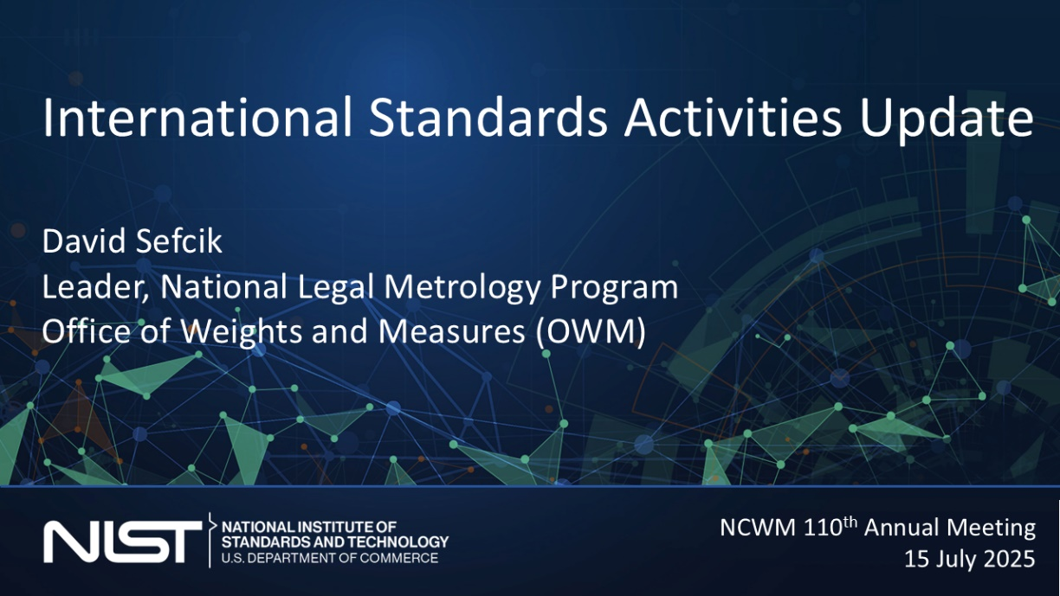
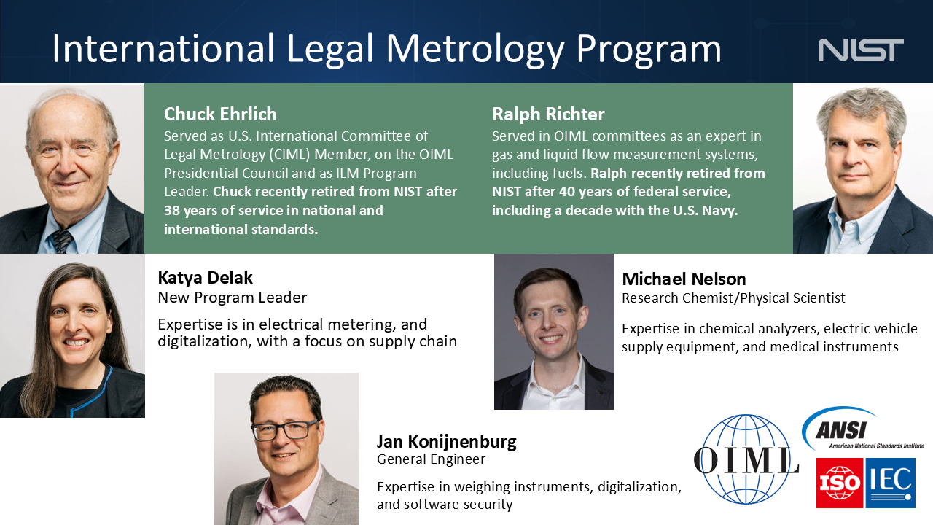

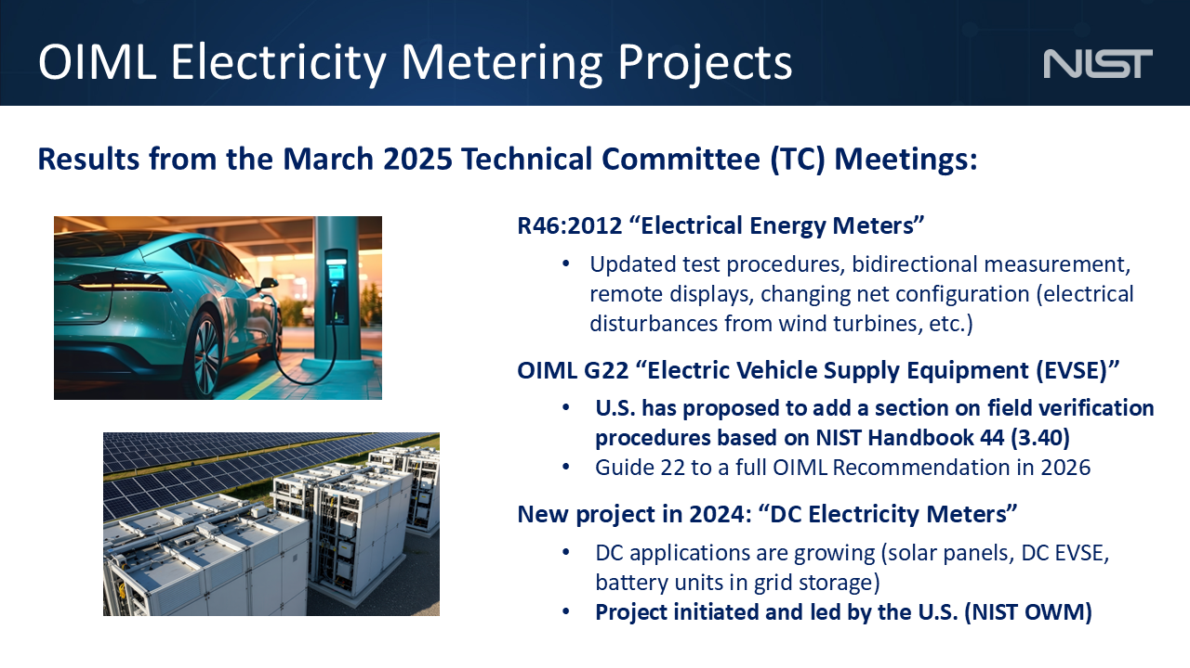
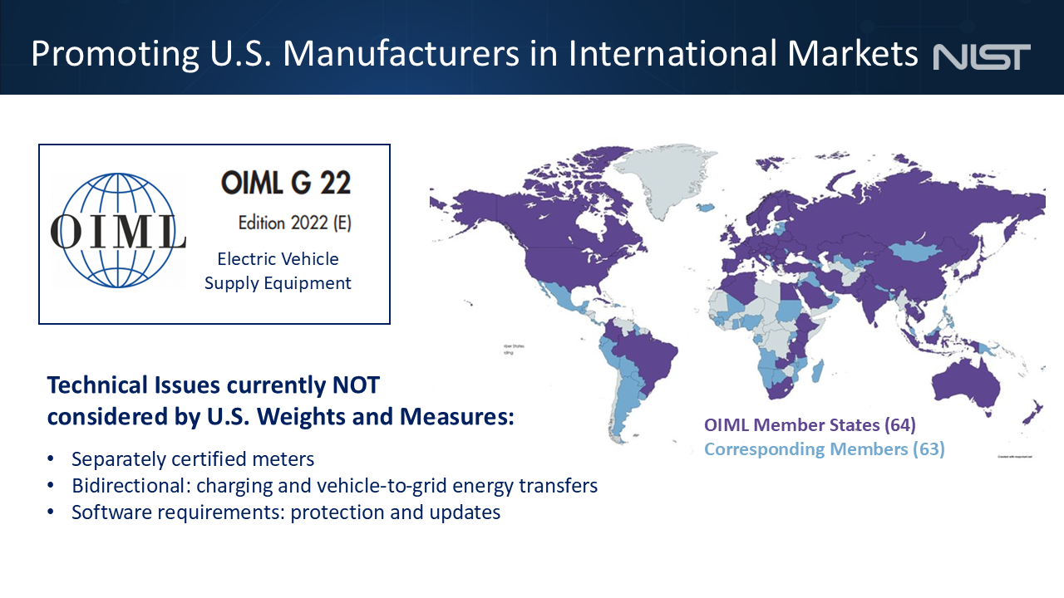



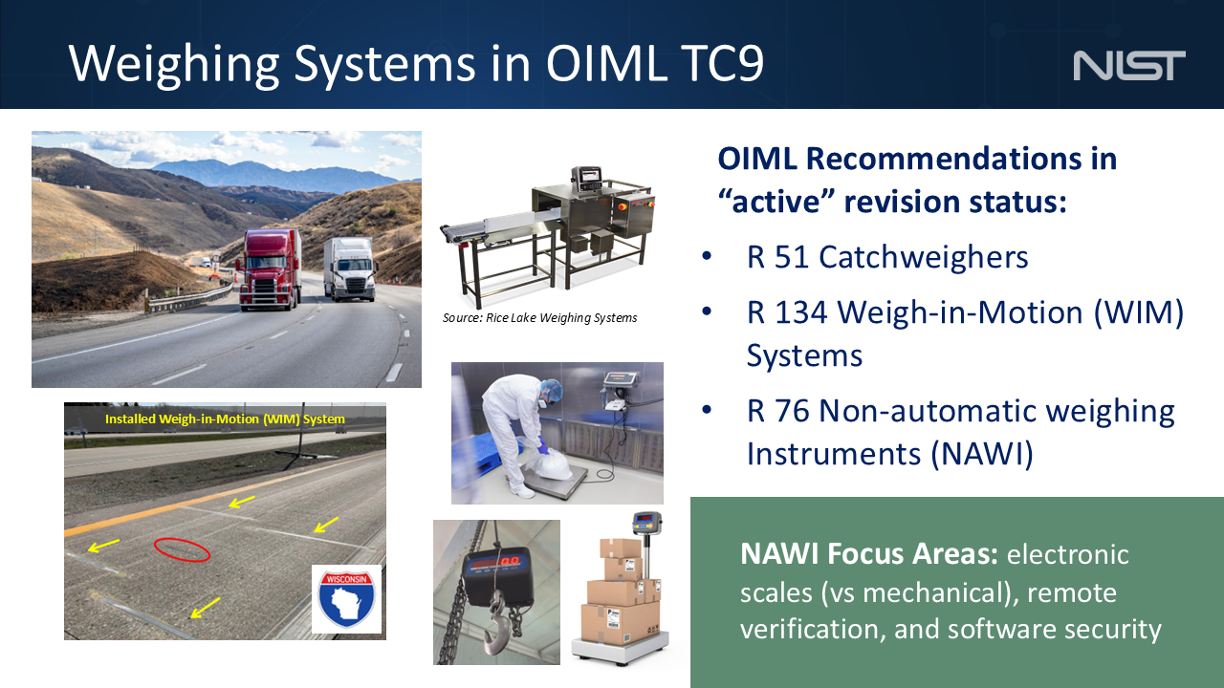

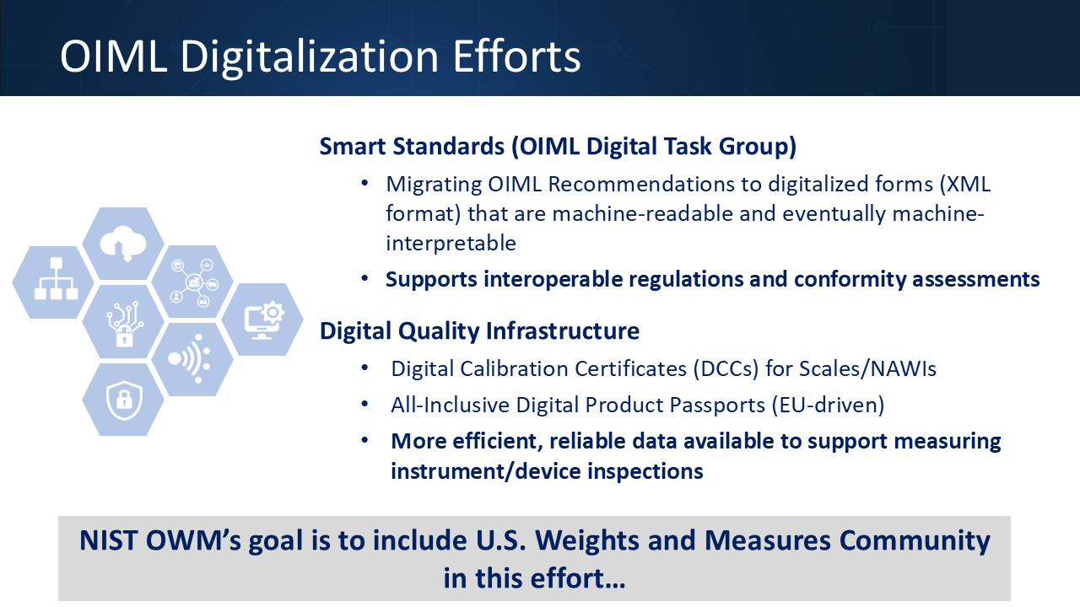

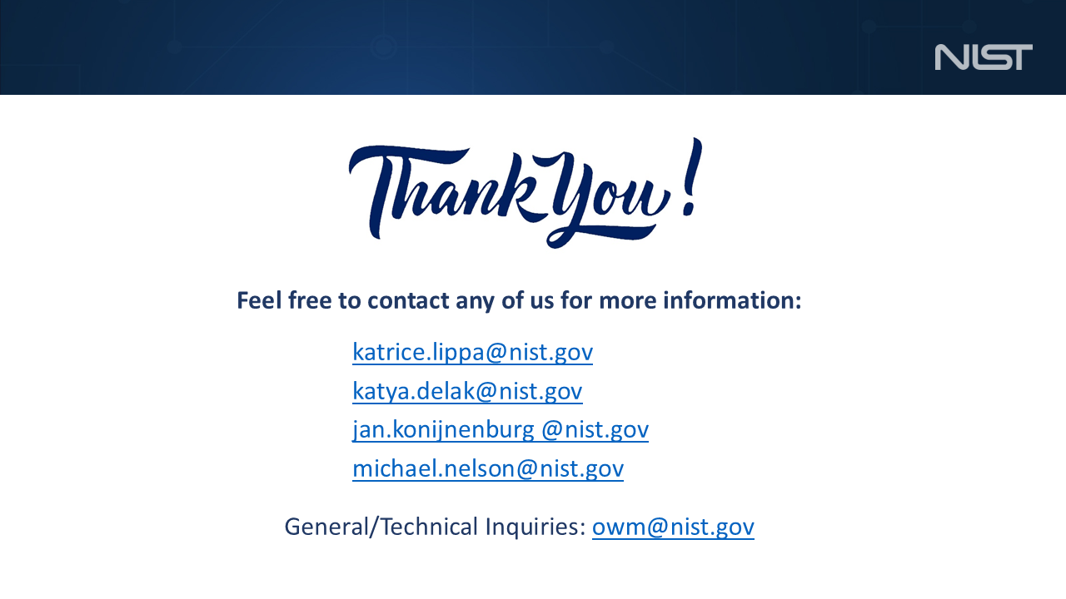

Appendix B
Associate Membership Committee (AMC) Agenda and Draft Meeting Minutes
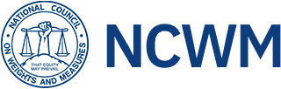

Associate Membership Committee Minutes
Tuesday, January 13th, 2026
NCWM 2026 Interim Meeting – Mobile, AL

Call to Order: Chair Jim Pettinato called the meeting to order at approximately 7:10 AM.
Roll Call/Introductions: There were 10 Associate members in attendance.
- Jim Pettinato [Chair]
- Brent Price [Vice-chair and L&R Representative]
- Reid Wagner [Secretary/Treasurer]
- Ray Johnson [BOD Representative]
- Perry Lawton [PDC Representative]
- Dale Delarber
- Chuck Corr
- Richard Suiter
- Steve Trueman
- Ron Gibson

Vice-chair Brent Price provided an overview of the committee’s charter for new potential participants.

Secretary/Treasurer Reid Wagner agreed to record the minutes for the meeting.

Approval of Agenda: The committee reviewed and approved the meeting agenda. Copies of the agenda were made available to attendees.

Approval of Previous Meeting Minutes: The committee reviewed and approved the previous meeting minutes from the July 2025 meeting. A copy of the minutes was also made available to attendees.

Financial Report: The committee reviewed the current financial report. In summary, the account balance as of 12/30/2025 was $29,522.31. Payments pending in the amount of $12,123.12 were included in the committee financial report; however, Ray Johnson reported in the Board of Directors update that the Toolkit Task Group has been idle, and that the “Toolkit Task Group” line item should be struck from payment pending section, and a new request will need to be submitted if the task group desires funds.

The committee noted that after this adjustment, the resulting pending payments amount should reflect $11,500.00 and that the reported net balance of $17,399.19 in available funds on the financial statement should be adjusted to $18,022.31.

Secretary/Treasurer Reid Wagner provided an overview of the received requests for training funds from New Mexico and New York State. Jim Pettinato reviewed the voting records for the approvals of these trainings. There are also approved funds for training in Connecticut that to date have not been requested.
NCWM Standing Committee Reports:

Board of Directors (BOD): Ray Johnson delivered the BOD report.
- The Toolkit Task Group has been idle, so it should be struck from the current financial report.
  - See applicable adjustments under the Financial Report section of these minutes for the adjusted available funds.
- The Scale Manufacturer’s Association (SMA) had their Fall board meeting in Lincoln, NE. SMA members were able to visit the NCWM offices and NTEP lab.

Laws & Regulations (L&R): Brent Price updated members on current discussions and topics of interest within the L&R Committee.

Professional Development Committee (PDC): Perry Lawton updated members on current topics and upcoming events of interest within the PDC.
- EVSE training in February 2026.
  - There are still sponsorship opportunities for AMC members available. Contact Perry Lawton or Mahesh Albuquerque for more information.

Old Business: The committee reviewed the planned increase in AMC member dues, which are slated to go up from $115 to $140 and take effect beginning in the Fall of 2026. There were no objections heard.

New Business: No new business.

Next Meeting: The next meeting of the AMC committee will be held in Philadelphia, PA during the 2026 NCWM Annual Meeting in July.

Meeting Adjournment: The meeting was adjourned at ~8:15 AM.

