Laws and Regulations (L&R) Committee
2026 Annual Meeting Agenda
Mauricio Mejia, Committee Chair
Florida

INTRODUCTION

This is the agenda of the Laws and Regulations Committee (hereinafter referred to as the “Committee”) for the 111th Annual Meeting of the National Council on Weights and Measures (NCWM). This report is based on the Interim Report offered in the NCWM Publication 16, testimony heard at public hearings, comments received from the regional weights and measures associations and other parties, the addendum sheets issued at the Annual Meeting, and actions taken by the membership at the voting session of the Annual Meeting. The Informational items presented below were adopted as presented when the Board’s report was approved.
Table A identifies the agenda and appendix items. Agenda items are identified in the Report by Reference Key Number, Item Title, and Page Number. Item numbers are those assigned in the Interim Meeting agenda. A Voting item is indicated with a “V” after the item number. An item marked with an “I” after the reference key number is an Informational item. An item marked with a “D” after the reference key number is a Developing item. The developing designation indicates an item has merit; however, the item was returned to the submitter for further development before any action can be taken at the national level. An agenda “Item Under Consideration” is a statement of proposal and not necessarily a recommendation of the BOD. Suggested revisions are shown in bold face print by striking out information to be deleted and underlining information to be added. Table B lists the results of any Voting Items.
Items may be grouped into “Blocks” if they are:
- Opposing Items: Items in direct conflict with each other, and only one may be adopted,
- Interdependent Items: Items addressing a similar topic where, if one is adopted, all need to be adopted, and
- Related Items: Items addressing a similar topic across multiple codes or regulations.

Some Voting Items are considered individually; others may be grouped in a consent calendar. Consent calendar items are Voting Items that the Board has assembled as a single Voting Item during their deliberation after the Open Hearings, assuming that the items are without opposition and will not require discussion. The Voting Items that have been grouped into consent calendar items will be listed on the addendum sheets. Prior to adoption of the consent calendar, the Board will remove specific items from the consent calendar upon request to be discussed and voted upon individually.
The Board may change the status designation of agenda items (Developing, Informational, Assigned, Voting and Withdrawn) up until the report is adopted, except those items which are marked Developing, Informational, Assigned or Withdrawn cannot be changed to Voting Status. Any change from the Board Interim Report (as contained in this publication) or from what appears on the addendum sheets will be explained to the attendees prior to a motion and will be acted upon by the active members of NCWM prior to calling for the vote.
An “Item under Consideration” is a statement of proposal and not necessarily a recommendation of the Board. Suggested revisions are shown in bold face print by striking out information to be deleted and underlining information to be added. Requirements that are proposed to be nonretroactive are printed in bold faced italics. Additional letters, presentation and data may have been submitted for consideration with this item. Please refer to https://www.ncwm.com/publication-16 to review these documents.
All sessions are open to registered meeting attendees. If the Board must discuss any issue that involves proprietary information or other confidential material; that portion of the session dealing with the special issue may be closed if (1) the Chairman or, in his absence, the Chairman-Elect approves; (2) the Executive Director is notified; and (3) an announcement of the closed meeting is posted on or near the door to the meeting session and at the registration desk. If possible, the posting will be made at least a day before the planned closed session.
Subject Series List
Handbook 130 – General GEN Series
Uniform Laws
Uniform Weights and Measures Law WAM Series
Uniform Weighmaster Law WML Series
Uniform Fuels and Automotive Lubricants Inspection Law FLL Series
Uniform Regulations
Uniform Packaging and Labeling Regulation PAL Series
Uniform Regulation for the Method of Sale of Commodities MOS Series
Uniform Unit Pricing Regulation UPR Series
Uniform Regulation for the Voluntary Registration of Servicepersons and Service Agencies
for Commercial Weighing and Measuring Devices RSA Series
Uniform Open Dating Regulation ODR Series
Uniform Regulation for National Type Evaluation NTP Series
Uniform Fuels and Automotive Lubricants Regulation FLR Series
Uniform E-commerce Regulation ECM Series
Examination Procedure for Price Verification PPV Series
NCWM Policy, Interpretations, and Guidelines POL Series
Handbook 133 NET Series
Other Items OTH Series
Table A
Table of Contents
Reference Key | Title of Item | L&R Page
pal – uniform packaging and labeling regulation 31

PAL-26.1 W 6.3. Net Quantity. 31
MOS – uniform regulation for the Method of Sale of commodities 36

MOS-24.2 V 2.16.3.1. Tare Weights, Part (c) Allowable difference. 36

MOS-26.2 A 2.21.2. Metered Sales by Liquid Volume. 43

MOS-26.3 A Section 2.20 Gasoline and Gasoline Oxygenate Blends 47
UPR – Uniform Unit Pricing Regulation 53

UPR-26.1 V Uniform Unit Pricing Regulation: Multiple Sections 53
FLR – Uniform Fuels and Automotive Lubricants Regulation 60

FLR-26.1 A 7.2. Reproducibility Limits 60
ecm – uniform e-commerce regulation 65

ECM-26.1 V Section 2. Definitions, Section 3. Required Declarations for E-commerce Sites Offering Products for Sale, Section 5. Unit Pricing Requirements on E-Commerce Sites for Products Offered for Sale, Section 10. Prominence and Placement of Required Information on E-commerce Sites: Offering E-commerce Products for Sale 65
OTH – OTHER ITEMS 70

OTH-24.1 A X. Uniform Shipment Law 70

OTH-07.1 D Fuels and Lubricants Subcommittee 77

OTH-11.1 D Packaging and Labeling Subcommittee 79
NET – Handbook 133 80

NET-26.1 W Table 2-3. Moisture Allowances 80
ITEM Block 4 (B4) MOISTURE ALLOWANCE CONSIDERATION 84

B4: POL-25.1 A 2.6.12. Point-of-Pack Inspection Guidelines. 85

B4: NET-25.1 A 1.2.6.1. Applying a Moisture Allowance Consideration, 2.3.8. Moisture Allowances Considerations, 4.10.2.2. Moisture Shrinkage Allowance Consideration for Structural Plywood and Wood-based Structural Panels, 4.11.2.1. Shrinking Allowance Consideration 86
APPENDICES
A OTH-11.1 Quantity-Related Expressions on a Principal Display Panel A97

Table B
Glossary of Acronyms and Terms

Acronym | Term | Acronym | Term
ASTM | ASTM International | NEWMA | Northeastern Weights and Measures Association
API | American Petroleum Institute | NIST | National Institute of Standards and Technology
CFR | Code of Federal Regulations | NCWM | National Council on Weights and Measures
CWMA | Central Weights and Measures Association | OWM | Office of Weights and Measures
FALS | Fuels and Lubricants Subcommittee | PALS | Packaging and Labeling Subcommittee
FDA | Food and Drug Administration | S&T | Specifications and Tolerances
FTC | Federal Trade Commission | SAE | SAE International
HB | Handbook | SWMA | Southern Weights and Measures Association
ILMA | Independent Lubricant Manufacturers Association | UPLR | Uniform Packaging and Labeling Regulation
L&R | Laws and Regulations | USDA – FSIS | U.S. Department of Agriculture – Food Safety and Inspection Service
LPG | Liquefied Petroleum Gas | USNWG | U.S. National Work Group
MAV | Maximum Allowable Variation | WWMA | Western Weights and Measures Association

Details of All Items
(In order by Reference Key)

pal – uniform packaging and labeling regulation

PAL-26.1 W 6.3. Net Quantity.
Source:
CPR Squared
Purpose:
To enhance consumer safety and reduce the financial burden of product recalls by mandating dynamic QR codes unique to each production batch on consumer package labels. Currently, inadequate batch-specific labeling leads to broader, costlier recalls, with an average direct cost of $10 million per food recall and approximately $7 billion in annual U.S. economic losses due to foodborne outbreaks. These inefficiencies expose consumers to heightened health risks, with 48 million annual foodborne illness cases, 128,000 hospitalizations, and 3,000 deaths. Dynamic QR codes enable precise tracking, targeted recalls, and real-time safety information access, minimizing health risks, reducing unnecessary product waste, and lowering economic losses for businesses and consumers.
Item under Consideration:
Amend NIST Handbook 130 Uniform Packaging and Labeling Regulation as follows:
6.3. Net Quantity.
– A declaration of net quantity of the commodity in the package, exclusive of wrappers and any other material packed with such commodity (except as noted in Section 10.3. Aerosols and Other Pre-pressurized Containers Dispensing Product Under Pressure), shall appear on the principal display panel of a consumer package and, unless otherwise specified in this regulation (see Sections 6.6. Prescribed Units, SI, through 6.9. Bi-dimensional Commodities), shall be in terms of the largest whole unit.
6.3.1. Use of “Net Mass” or “Net Weight.”
– When stating the net quantity of contents in terms of weight a quantity declaration may stand alone [e.g., “200 g (7 oz)” or “1 lb (453 g)”] or may include the term “net mass” or “net weight” either preceding or following the declaration. The term “net” by itself may be used on food labels. However, the quantity of contents shall always declare the net quantity of contents even when such terms are not used.
(Amended 1993)
6.3.2. Use of “Net Contents”.
– When stating the net quantity of contents in terms of fluid measure or numerical count, a quantity declaration may stand alone [e.g., “177 mL (6 fl oz)”] or may include the term “net” or “net contents” either preceding or following the declaration.
(Amended 2019)
6.3.3. Lines of Print or Type.
– A declaration of quantity may appear on one or more lines of print or type.
(Amended 1982)
6.3.X Dynamic QR Code –
(a) Requirement: All food and beverage consumer packages subject to this regulation shall include a dynamic QR code unique to each production batch on the label. The dynamic QR code shall link to a secure, updatable digital platform providing real-time information on product safety, recall status, and traceability details, compliant with ISO/IEC 18004 standards.
(b) Content: The digital platform accessible via the dynamic QR code shall include, at minimum:
- Batch identification number.
- Production and expiration dates.
- Recall status, if applicable, including details of any safety alerts or corrective actions specific to food safety (e.g., contamination, allergen mislabeling).
- Contact information for the manufacturer or responsible entity.
- Traceability data, such as the source of ingredients or production facility, where relevant to food safety.
(c) Accessibility: To ensure inclusivity, food and beverage packages shall also display the batch identification number in human-readable form and provide a toll-free telephone number or website URL as alternative methods to access the information specified in paragraph (b).
(d) Security: Dynamic QR codes shall incorporate encrypted links and cryptographic signatures to prevent unauthorized access, tampering, or fraudulent redirects, adhering to industry-standard cybersecurity protocols.
(e) Implementation: This requirement shall apply to all food and beverage consumer packages produced on or after January 1, 2027, to allow sufficient time for manufacturers to adapt labeling processes and establish digital infrastructure.
(f) Exemptions: Food and beverage consumer packages exempt from this requirement include those with a net weight or volume less than 10 grams or 10 milliliters, or as otherwise determined by the National Council on Weights and Measures, where labeling space constraints render compliance impractical.
Previous Status:
New Proposal
Original Justification:
Current labeling practices often use generic information that does not distinguish between batches, complicating recalls and exposing consumers to unnecessary dangers. Dynamic QR codes per batch provide a secure, updatable mechanism for tracking products from production to consumption, enabling swift, targeted recalls for specific batches (e.g., due to contamination or mislabeling). This approach reduces the scope of recalls, prevents widespread panic, minimizes economic losses, and empowers consumers with instant access to safety information via their smartphones, fostering greater trust and protection. Nationally, this addresses inconsistencies in recall efficiency across states and aligns with federal initiatives for food safety and traceability, such as those from the FDA.
Concern: Mandating dynamic QR codes increases costs for manufacturers, especially small businesses, due to labeling and database maintenance expenses.
Rebuttal: Many food and beverage products already include voluntary QR codes, so switching to dynamic QR codes is a simple change that leverages existing infrastructure. Affordable platforms exist for about $50/month.
Concern: Consumers without smartphones or internet access may be unable to scan QR codes, limiting accessibility.
Rebuttal: Voluntary QR codes are already common, and dynamic QR codes can include printed batch numbers or toll-free lines as alternatives, ensuring inclusivity while improving safety.
Concern: Dynamic QR codes are vulnerable to hacking, risking consumer data or fraudulent redirects.
Rebuttal: Many food and beverage products use voluntary QR codes securely; dynamic QR codes with ISO/IEC 18004 standards and encrypted links enhance safety, with audits preventing cyber risks.
Concern: Adding dynamic QR codes complicates labeling, potentially confusing consumers or cluttering packaging.
Rebuttal: Since many food and beverage products already feature voluntary QR codes, switching to dynamic ones is a minor adjustment that integrates seamlessly, enhancing safety with clear instructions.
Concern: Small manufacturers lack expertise to implement dynamic QR code systems.
Rebuttal: Voluntary QR codes are already widely used; transitioning to dynamic codes is straightforward with user-friendly platforms and NCWM support, boosting consumer safety.
Concern: QR code scanning may fail in areas with poor internet, hindering safety information access.
Rebuttal: Many food and beverage products use voluntary QR codes effectively; dynamic codes can include offline-readable data, and infrastructure improvements ensure broader safety benefits.
Concern: Mandating QR codes may reduce reliance on traditional safety communication methods.
Rebuttal: Voluntary QR codes already complement labels; dynamic QR codes enhance this system, providing batch-specific safety data without replacing existing disclosures/
Concern: Maintaining dynamic QR code databases is resource-intensive for manufacturers and regulators.
Rebuttal: Many food and beverage products already manage voluntary QR code databases; dynamic systems use scalable cloud solutions, simplifying the shift for enhanced recall safety.
Concern: Consumers may distrust QR codes due to privacy concerns, reducing adoption.
Rebuttal: Voluntary QR codes are widely accepted; dynamic codes with transparent, anonymized data policies build trust, improving safety through better recall access.
Concern: Small retailers may struggle to verify dynamic QR code compliance, increasing burden.
Rebuttal: With voluntary QR codes already in use, dynamic codes are a simple upgrade, and NCWM guidelines can streamline retailer verification for safety compliance.
Concern: Dynamic QR codes could be counterfeited, leading to fraudulent recalls or misinformation.
Rebuttal: Voluntary QR codes already exist securely; dynamic codes with cryptographic signatures ensure authenticity, enhancing consumer safety and recall precision.
Concern: Industry may resist QR code mandates, prioritizing cost over safety.
Rebuttal: Many food and beverage products already use voluntary QR codes, so dynamic codes are a low-cost shift that reduces recall costs and boosts consumer safety, aligning with industry goals.
Concern: QR code mandates may delay product launches due to compliance timelines.
Rebuttal: Voluntary QR codes are common; transitioning to dynamic codes by January 1, 2027, is a simple change that aligns with existing processes, prioritizing safety.
Concern: Not all consumers will scan QR codes, limiting safety benefits.
Rebuttal: Voluntary QR codes are already scanned by many; dynamic codes enhance safety for those who use them, complementing traditional labels for broader impact. Batch number can be looked up on mfgr website.
Concern: QR codes may not integrate with existing recall processes, causing inefficiencies.
Rebuttal: Many food and beverage products use voluntary QR codes; dynamic codes align with FDA/USDA protocols, simplifying recalls and improving consumer safety outcomes.
Concern: Mandating dynamic QR codes for batch-specific traceability on food and beverage package labels is a regulatory action that falls under the FDA’s jurisdiction, as the FDA oversees food safety and labeling requirements under the Federal Food, Drug, and Cosmetic Act and the Food Safety Modernization Act. The NCWM’s role is limited to weights and measures, and imposing QR code requirements exceeds its authority, potentially creating overlapping or conflicting federal and state regulations.
Rebuttal: The NCWM has clear authority under NIST Handbook 130 to establish uniform labeling standards for consumer commodities, including food and beverage products, to ensure accurate and consumer-relevant information, as seen in existing regulations like Section 6. The proposed dynamic QR code requirement complements FDA regulations, such as FSMA’s traceability provisions, by providing a state-level mechanism to enhance recall precision and consumer safety without conflicting with federal rules. The NCWM’s focus on batch-specific labeling aligns with its mission to standardize packaging information, and coordination with FDA guidelines (e.g., ISO/IEC 18004 standards for QR codes) ensures harmony. States adopting this amendment can implement it as part of their weights and measures programs, which already regulate food labeling, thereby supporting rather than duplicating FDA efforts.
The submitter requested Voting status in 2026.
Comments in Favor:
Weights and Measures Officials:
- None
Industry:
- None
Advisory:
- None
Comments Against:
Weights and Measures Officials:
- Multiple weights and measures officials opposed this item stating it is not a weights and measures issue, that the item addresses food safety and public health concerns and falls under federal regulations instead, others pointed fraud concerns using QR codes and questioned the fact that duplicate information is requested. In addition, it questioned the inclusion of this item in section 6.3 Net Quantity. All of them recommended Withdraw.
Industry:
- None
Advisory:
- The NIST OWM representative recommended Withdraw.
Neutral Comments:
Weights and Measures Officials:
- None
Industry:
- None
Advisory:
- None
Item Development:
New Proposal 2026
NCWM Interim 2026: Several weights and measures officials voiced concern that this item was not a weights and measures issue and recommended withdraw. Based on those comments and those from NIST OWM, the Committee concurred and withdrew the item.
Regional Associations’ Comments:
WWMA 2025 Annual Meeting:

The committee received comments from Ms. Wendy Hahn (County of Stanislaus, California), Mr. Aaron Yanker (Colorado Department of Agriculture, Weights and Measures), Mr. Jose Arriaga (County of Orange, California), Mr. Mike Brooks (Arizona Department of Agriculture Weights and Measures Services Division), Mr. Kurt Floren (County of Los Angeles, California), Mr. Austin Shepherd (County of San Diego, California), and Mr. Matt Douglas (California Division of Measurement Standards) with a general consensus that this is not a Weights and Measures issue and recommending that the item be withdrawn.

Some of the comments heard also included that this might be an FDA jurisdictional matter; that this might be better addressed by, or included in, the Food Safety Modernization Act; or that this might be a Public Health jurisdictional matter.

Other concerns raised included that this may increase production costs and create gaps in usability for non-smart phone users. Enforcement concerns were also heard including that Weights & Measures officials do not have the authority to implement broad recalls as well as the concern that this is not just a matter of verifying that the quick response (QR) code is present but also that the information provided by use of the QR code is accurate.

The WWMA L&R committee recommends the item be withdrawn.

CWMA 2025 Interim Meeting:
Questions were brought up as to how this really applies to Weights & Measures and one individual wanted the item withdrawn. Nothing currently exists that would prohibit an entity from adding a dynamic QR code of this nature.
The CWMA L&R committee recommends the item be withdrawn.
NEWMA 2025 Interim Meeting:
A regulator from New York commented they are not opposed to QR codes, but feels it is not a weights and measures issue, and indicated they do not enforce food safety regulations. A regulator from New Jersey commented that this is not a weights and measures issue, but may be geared toward FDA or FTC regulations, and recommended a Withdrawn status. A regulator from Vermont agreed with New York and New Jersey.

After hearing comments from the floor, the committee recommended a Withdrawn status, and the body concurred.
SWMA 2025 Annual Meeting:
Mr. Tory Brewer with West Virginia commented that this is not a weights and measures issue. That the item specifically asks for there to be a requirement for recalls. He opposes this item and recommends Withdraw.
Matthew Curran, Florida – recommend forwarding this item and asking that it be Assigned to PALS for further evaluation and vetting. He believes the topic has potential merit and use beyond the weights and measures realm but need to ensure it is weights and measures related before going into the Handbooks. There are currently food products in Florida that are required to have QR codes for required consumer information and there are many companies that have elected to add QR codes on their products, so the concept is currently utilized. He also would caution against exclusions (as proposed) as this may create unintended loopholes, if not written properly.
Ms. Alison Wilkinson with the state of Maryland echoes Florida in that the item be Assigned to PALS.
Mr. Jason Glass with the state of Kentucky recommends an editorial change with section 6.3.X (f). To edit “conference” to “council” within the section.
6.3.X Dynamic QR Code –
(f) Exemptions: Food and beverage consumer packages exempt from this requirement include those with a net weight or volume less than 10 grams or 10 milliliters, or as otherwise determined by the National Conference Council on Weights and Measures, where labeling space constraints render compliance impractical.
The Committee has referenced the recommended editorial changes to this item and based on the comments made from the floor, believes this item has merit and recommends Developing status.

Additional letters, presentation and data may have been submitted for consideration with this item. Please refer to https://www.ncwm.com/publication-15 to review these documents.

MOS – uniform regulation for the Method of Sale of commodities

MOS-24.2 V 2.16.3.1. Tare Weights, Part (c) Allowable difference.
Source:
National Propane Gas Association
Purpose:
Resolve the discrepancy that exists between Handbook 130 and Title 49 of the Code of Federal Regulations with respect to the allowable differences between the stamped tare weight and the actual tare weight of cylinders used for compressed or liquefied gases in refillable cylinders.
Item under Consideration:
Amend the Uniform Regulation for the Method of Sale of Commodities as follows:
2.16.3.1. Tare weights.
…
(c) Allowable difference. – If the stamped or stenciled tare is used to determine the net contents of the cylinder, the allowable difference between the actual tare weight and the stamped (or stenciled) tare weight, or the tare weight on a tag attached to the cylinder for a new or used cylinder, shall be within:
(1) For cylinders manufactured prior to December 28, 2022, shall be within:
i. ¹/₂ % for tare weights of 9 kg (20 lb) or less; or
ii. ¹/₄ % for tare weights of more than 9 kg (20 lb).
- The allowable difference between the actual tare weight and the stamped (or stenciled) tare weight, or the tare weight on a tag attached to the cylinder for a new or used cylinder manufactured prior to December 28, 2022, shall be within:
i. ¹/₂ % for tare weights of 9 kg (20 lb.) or less cylinders ; or
ii. ¹/₄ % for tare weights of more than 9 kg (20 lb.) cylinders.
- For cylinders manufactured on or after December 28, 2022, shall be within the following limits prescribed by general requirements for specification cylinders, 49 C.F.R. § 178.35:
    - For a cylinder of 25 lb or less at the time of manufacture, a lower tolerance of (-) 3 % and an upper tolerance of (+) 1 %; or
    - For a cylinder exceeding 25 lb at the time of manufacture, a lower tolerance of (-) 2 % and an upper tolerance of (+) 1 %.
- The allowable difference between the actual tare weight and the stamped (or stenciled) tare weight, or the tare weight on a tag attached to the cylinder for a new or used cylinder manufactured on or after December 28, 2022 shall be within:
- for tare weights of 11 kg (25lb) or less cylinders :
  - a lower tolerance of (-) 3% and,
  - an upper tolerance of (+) 1%; or
- for tare weight of more than 11 kg (25lb) cylinders:
  - a lower tolerance of (-) 2% and,
  - an upper tolerance of (+) 1%
As prescribed by general requirement for specification cylinders, 49 C.F.R § 178.35
NOTE: Failure of a cylinder tare weight to be within the required allowable difference is considered a Method of Sale violation. The cylinder shall be removed from use until the tare weight is corrected.
3.13.2 Test Procedures
a. Test Procedure for Cylinders Labeled by Weight
- Follow Section 2.3.1. “Define the Inspection Lot.” Use a “Category A” sampling plan in the inspection; select a random sample.
- The cylinder should be marked or stenciled with a tare weight. The marked value may or may not be used by the filling plant when determining the net weight of those cylinders sold or filled by weight. If there is a tare weight marked on the net contents tag or directly on the cylinder, then an actual tare weight was determined at the time of fill. If there is no tare weight marked on a tag or on the cylinder, then the stamped or stenciled tare weight is presumed to have been used to determine the net contents.

Note: Check the accuracy of the stamped tare weights on empty cylinders whenever possible. The actual tare weight must be within (a) 1/2 % of the stamped tare weight for 9.07 kg (20 lb) tare weights or less or (b) 1/4 % of the stamped tare weight for greater than 9.07 kg (20 lb) tare weights. (see NIST Handbook 130, Method of Sale Regulation, Section 2.16. “Compressed or Liquefied Gases in Refillable Cylinders.” establishes the allowable tolerance for cylinders based on the date of manufacture.
The allowable difference between the actual tare weight and the stamped (or stenciled) tare weight, or the tare weight on a tag attached to the cylinder, for a new or used cylinder manufactured prior to December 28, 2022, shall be within:
- 1/2 % for tare weights of 9 kg (20 lb) or less cylinders ; or
- 1/4 % for tare weights of more than 9 kg (20 lb) cylinders.
The allowable difference between the actual tare weight and the stamped (or stenciled) tare weight, or the tare weight on a tag attached to the cylinder, for a new or used cylinder manufactured on or after December 28, 2022, shall be within:
- for tare weights of 11 kg (25 lb) or less cylinders s:
- a lower tolerance of (-) 3 % and,
- an upper tolerance of (+) 1 %; or
- for tares weight of more than 11 kg (25 lb) cylinders:
- a lower tolerance of (-) 2 % and,
- an upper tolerance of (+) 1 %.
As described by general requirement for specification cylinders, 49 C.F.R. § 178.35
The cap is not included in the tare weight.
Previous Status:
2025: Voting – Returned to Committee
2024: Informational
Original Justification:
The data presented in NIST Special Publication, “NIST SP 2200-01, 2022 NCWM-NIST National Survey on 20 lb LPG (Propane) Cylinders,” is sufficient evidence that the tolerances imposed in Handbook 130 on the marking of tare weights for propane cylinders are not in sync with the real world. For example, the report states that “nearly half (44.3%) of new cylinders and significantly less (32.0% of used cylinders were in compliance with existing tare weight requirements,” (in reference to the current Handbook 130 requirements). Which means, of course, that the great majority of cylinders, even new cylinders, were not in compliance. The reasons for that include the following:
- As quoted from the report, “Initial assessments suggest that cylinder manufactures use a tolerance of 1%, which is primarily based on Transport Canada’s requirement of 1%.” If a cylinder’s tare weight can vary +/- 1% from stamped value as manufactured, a cylinder’s actual tare weight cannot be expected to be within +/- 0.5% of the marked value after the cylinder at any point in time thereafter.
- For practical reasons, some manufacturers may use a statistical method to arrive at an average tare weight based on previous measurements of a sufficiently large sample pool. Whatever variance there may be in the actual weight of the cylinder versus the marked tare weight, the fact is that over 98% of the new cylinders weighed were in compliance with the DOT tolerances.
- The following statement from the report is very telling: “It is highly unusual and irregular to see a tolerance where a very significant majority of the packages are in compliance (in this case, 98.4%).” The report goes on to state that 34.3% of “used” cylinders would not be in compliance with the DOT tolerances. These two statements call attention to the fact that these grill cylinders are in constant circulation, subject to a wide variety of conditions, treatment and possible abuse by potentially many different customers, thereby underlining the need to steer clear of overburdensome and unwarranted regulation.
- Scales utilized in most retail locations where cylinders are filled are beam scales which do not have the capability of weighing cylinders to the sensitivity or number of decimal places necessary to verify the initial tare weight while a cylinder is under vacuum using Handbook 130 requirements. Additionally, there is no requirement in any national code or standard to fill cylinders by weight at the point of sale when the cylinder is transported for non-commercial use. These cylinders are not considered to be transported “in commerce” and are therefore not required to be filled by weight, thereby allowing for the determination of maximum fill level using the fixed maximum liquid level gauge. Scales are not required to be installed at these facilities.
- Even when the product is released to the atmosphere to “empty” the cylinder, there will always be some amount of liquid and vapor remaining in the cylinder, unless the cylinder has been put under vacuum. The liquid, of course, is much denser than air and the vapor in the cylinder is 1.5 times the weight of the air that was in the sample cylinders when they were weighed to establish the “average” tare weights.
- A minus tolerance of -3% will not result in extreme loss to the propane marketer in most cases, because the overfilling prevention device (OPD) will activate and prevent the overfilling of the cylinder in the vast majority of cases. As stated in the report, only 1.1% of all cylinders tested exceeded the legal filling limit. Considering the time of year that this project was undertaken and in some northern states, it is very likely that some of those cylinders may have been filled volumetrically when the temperature was below 40 °F, it would not be unusual that more product was put into the cylinder because the OPD is calibrated to the maximum fill at 40 °F and the liquid density increases as the temperature gets colder.
- The price for a pound of propane as stated in the report seems high, as it would equate to $5.51 per gallon (4.24 lbs. per gallon). The Department of Energy published the average cost of propane in 2022 and it was shown to be $2.23 per gallon.
Opposing arguments may take the following form:
- “The purpose of Handbook 130 is to ensure that the customer gets what he pays for and that the propane marketer doesn’t lose out, either.” The rebuttal to this argument from the standpoint of the customer is provided in the justification in number 18 above. From the marketer’s standpoint, the fact that the vast majority of retail gallons sold in the U.S. are sold by NPGA members and that those very members endorsed this proposal is evidence that marketers are not concerned about the small quantities of gas that may not be billed to the customer.
- “We should make DOT change their tolerances instead of NCWM changing theirs.” The fact is that NCWM allowable differences are so unreasonable that 56% of newly manufactured cylinders were not in compliance with them. That should be reason enough to realize that NCWM needs to change. In addition, once gas is put into a cylinder, there will always be a little bit of liquid remaining in the cylinder unless it is vacuum purged or opened to the atmosphere. This means that accurately measuring the tare weight of a cylinder becomes very difficult unless specific procedures are followed to ensure that the cylinder is truly “empty.”

The submitter requested that this be a voting item in 2024 and a retroactive requirement, enforceable to all devices.
Comments in Favor:
Weights and Measures Officials:
- Several weights and measures officials supported amending the Item as proposed by NIST OWM and moving it forward as a Voting item.
Industry:
- The representative for the National Propane Gas Association recommended that the Committee adopt the language changes provided by NIST OWM and move the item forward as a Voting item.

Advisory:
- None
Comments Against:
Weights and Measures Officials:
- A weights and measures official representing California opposed this item and recommended Withdraw.
Industry:
- None
Advisory:
- The NIST OWM representative shared that the Federal DOT code changes on tare weight allowable differences have been implemented and they supersede the NIST Handbook regulation . He stated that we need to move to avoid Federal preemption. The NIST OWM representative provided suggested language changes and requested them to be reflected in HB 130 and HB 133 to align the requirements in both publications.
- None
Neutral Comments:
Weights and Measures Officials:
- None.
Industry:
- None
Advisory:
- None

Item Development:
NCWM 2026 Interim: The Committee accepted the proposed changes by NIST OWM including adding the new language to NIST Handbook 133 to harmonize the requirements in both Handbooks. The item now shows Section 3.13.2 of HB 133, incorporating a reference to the allowable tare differences in HB 130. Additionally, the Committee added the words “cylinders” to that language to better denote the allowable tare differences of each specific cylinder size, per example, instead of reading “for tare weight of 11 kg (25 lb.) or less” it reads “for tare weights of 11 kg (25 lb.) or less cylinders ”. With these changes the item is moving forward as Voting.
NCWM 2025 Annual: The Committee was provided with proposed new language for the item from NIST OWM. The new language was developed in consultation with the National Propane Gas Association. The Committee, hearing support for the language from membership, accepted the proposed changes from NIST OWM. The new language appears in this report. The previous version can be found in NCWM 2025 Publication 16.

The Item, however, did not receive enough votes to pass or fail and was returned to the Committee.
NCWM 2025 Interim: During open hearings the Committee heard support for this item to remain Informational. During the L&R committee’s work session the committee assigned a Voting status. NIST OWM suggested assigning Voting status to it pending information from DOT which at the time of writing this report has not been received from DOT.
However, during a subsequent Committee work session dated February 14, 2024, Mr. John McGuire, NIST OWM, stated that additional language previously submitted within the 2023 Southern Weights and Measures regional meeting from NIST OWM should be considered.
This NIST OWM additional language can be found on the NCWM website under supporting documents.
NCWM 2024 Annual: The Committee continues to receive little comment on this issue. The Committee also heard from John McGuire NIST OWM who reiterated that they are still working with DOT. This item remains Informational pending the results of the DOT survey.
NCWM 2024 Interim: The Committee heard little comment on this issue. The Committee also heard from NIST OWM who informed the Committee that they are still working with DOT and recommended the item remain informational. For this reason, the Committee assigned Informational status to the item.
Regional Associations’ Comments:
WWMA 2025 Annual Meeting:

Mr. Chris Wagner with the National Propane Gas Association (NPGA) stated that during the NCWM Annual Meeting both the National Institute of Standards and Technology (NIST) and NPGA testified in support of this joint proposal as currently written. As part of this testimony, both NIST and NPGA addressed the fact that the Department of Transportation (DOT) maintains a federal code prohibiting any other entity from imposing rules in conflict with 49 CFR. The current wording contained in 2.16.3.1. Tare Weights, Part (c) Allowable difference is in conflict with 49 C.F.R. § 178.35, and thusly prohibited by 49 C.F.R. § 107.202 . It is NPGA’s belief that the current proposal as written rectifies this conflict and allows DOT to continue to work through public comments submitted by the industry. Mr. Chris Wagner stated that he supports a voting status.
Mr. Scott Simmons, representing P 20:10 Services LLC, expressed support for the item and agrees with Mr. Wagner’s comments.
Mr. Kurt Floren (County of Los Angeles, California) posed a question regarding whether the intention of the item was to cause a difference in enforcement based upon the 2022 date.
Mr. Chris Wagner responded with a statement that this creates a cleaner proposal for Weights and Measures. The NPGA’s opinion is that 49 CFR 107.202 could be interpreted to retroactively preempt the Weights and Measures tolerances, but the industry prefers a non-retroactive interpretation.
Mr. Matt Douglas (California Division of Measurement Standards) expressed opposition because the consumer protection parameters fall within the safety requirements. Mr. Douglas was not aware of the CFR code regarding preemption referenced and would like more time to review.
The WWMA L&R committee recommends a voting status for this item.
CWMA 2025 Interim Meeting:
No comments.
The CWM L&R committee recommends an information status for this item.
NEWMA 2025 Interim Meeting:
A regulator from New Jersey commented that they are not in favor of this item as the tolerances are too large. However, due to not receiving any feedback from USDOT, the item is fully developed to be aligned with the federal code and recommends a Voting status.
After hearing comments from the floor, the committee recommended a Voting status, and the body concurred.
SWMA 2025 Annual Meeting:
Mr. Chris Wagner with NPGA provided the following comments:
DOT prohibits any other entity from imposing rules in conflict with 49 CFR with regard to the design, manufacturing, fabrication, marking, maintenance, reconditioning, repairing, or testing of a packaging or a container which is represented, marked, certified, or sold as qualified for use in the transportation of hazardous materials. The current wording contained in 2.16.3.1. Tare Weights, Part (c) Allowable difference is in conflict with 49 C.F.R. § 178.35, and thusly prohibited by law. It is NPGAs belief that the current proposal as written rectifies this conflict and allows DOT to continue to work through public comments submitted by the industry. The specific language contained in DOTs preemption rule is listed below.
49 CFR § 107.202 Standards for determining preemption.
(a) Except as provided in § 107.221 and unless otherwise authorized by Federal law, any requirement of a State or political subdivision thereof or an Indian tribe that concerns one of the following subjects and that is not substantively the same as any provision of the Federal hazardous materials transportation law, a regulation issued under the Federal hazardous material transportation law, or a hazardous material transportation security regulation or directive issued by the Secretary of Homeland Security that concerns that subject, is preempted:
(1) The designation, description, and classification of hazardous material.
(2) The packing, repacking, handling, labeling, marking, and placarding of hazardous material.
(3) The preparation, execution, and use of shipping documents pertaining to hazardous material and requirements related to the number, content, and placement of those documents.
(4) The written notification, recording, and reporting of the unintentional release in transportation of hazardous material and other written hazardous materials transportation incident reporting involving State or local emergency responders in the initial response to the incident.
(5) The design, manufacturing, fabrication, marking, maintenance, reconditioning, repairing, or testing of a packaging or a container which is represented, marked, certified, or sold as qualified for use in the transportation of hazardous material.
He supports this item and recommends moving forward with Voting status.
The Committee has considered the comments and finds this item to be fully developed and recommends a Voting status.
Additional letters, presentations and data may have been submitted for consideration with this item. Please refer to https://www.ncwm.com/publication-15 to review these documents.

MOS-26.2 A 2.21.2. Metered Sales by Liquid Volume.
Source:
National Propane Gas Association
Purpose:
Modify 2.21.2 (b) and (c) of IV. Uniform Regulations B. Uniform Regulation for the Method of Sale of Commodities, to require automatic temperature compensation to be performed electronically to ensure the most immediate reaction time of compensation equipment due to questionable reaction time data for mechanical temperature compensation devices in low flow applications.
Item under Consideration:
Amend NIST Handbook 130 Uniform Regulation for the Method of Sale of Commodities as follows:
2.21.2. Metered Sales by Liquid Volume. – All metered sales by liquid volume shall be accomplished using metering systems as follows:
(a) Sales using metering systems with a maximum rated capacity greater than 20 gal/min shall be accomplished using a metering system that automatically compensates for the effects of temperature.
(b) Sales using metering systems with a maximum rated capacity equal to or less than 20 gal/min that were placed into service after January 1, 20267, shall be accomplished by use of a metering system that automatically and electronically compensates for the effects of temperature.
(c) Effective January 1, 2034, all metered sales (through all capacities of metering devices, regardless of installation and service date)through devices with a maximum rated capacity equal to or less than 20 gal/min that were placed into service prior to January 1, 2027, shall be accomplished by use of a metering system that automatically and electronically compensates for the effects of temperature.
Previous Status:
New Proposal
Original Justification:
Existing data has been presented by way of a Linco-Electromatic, Inc. Technical Paper that calls into question the efficacy of mechanical temperature compensation equipment when connected to low flow pumping or dispensing systems. This paper calls out a reaction time ranging from three to six minutes before adequate compensation begins. With this lag time no single container filled by an LP Gas dispenser would receive compensated product if utilizing a mechanical temperature compensator. To ensure equity for propane sellers and buyers proper and immediately reactive temperature compensation equipment is needed.
The submitter acknowledged that State Weights and Measures officials have stated that during the conduction of meter proving with mechanical temperature compensation they have not witnessed the slow reaction times stated in the Linco- Electromatic, Inc. Technical Paper, although there is a flush performed prior to the actual meter flow test and not from direct start up.
The submitter requested Voting status in 2026.
Comments in Favor:
Weights and Measures Officials:
- None
Industry:
- None
Advisory:
- None
Comments Against:
Weights and Measures Officials:
- None
Industry:
- None
Advisory:
- None
Neutral Comments:
Weights and Measures Officials:
- The Committee heard from multiple weights and measures officials who recommended the item to be Developing or Assigned to a Work Group. They expressed concerns regarding the additional burden placed on the industry, the availability of these devices as well as their suitability and accuracy under normal testing conditions. Most of them concurred on the need for a study to obtain sound data supporting an electronic temperature compensation requirement.
Industry:
- Representatives from the National Propane Gas Association and Meter Manufacturers Association recommended the item be assigned to a Work Group.
Advisory:
- The representative of NIST OWM supported the item to be Developing or assign it to a Work Group.
Item Development:
New Proposal 2026
NCWM 2026 Interim: Taking into consideration the concerns of those that provided comments and the request of the submitter, the Committee decided to recommend that this item be assigned to a Work Group and keep open the effective dates proposed in it. The work group will coordinate and oversee, in conjunction with the industry, the design and execution of a study to determine the effectiveness and cost-efficient viability of electronic temperature compensators in all applications before they become a requirement. Depending on the results of the study, if established the item has merit, the Work Group will recommend final language, any required alignment of it with other publications, and effective dates.
Regional Associations’ Comments:
WWMA 2025 Annual Meeting:
Mr. Chris Wagner with the National Propane Gas Association (NPGA) referenced a study called the “Linco-Electromatic, Inc. Technical Paper” which demonstrates that electronic temperature compensation is immediate and meaningful in comparison with mechanical temperature compensation, which has a lag time that renders it ineffective for small drafts. He also stated the electronic compensators are more expensive so retailers, if left to their own devices, will install mechanical compensators to comply with the 2034 requirement. The NPGA polled the industry and no contradictory data could be found. Mr. Chris Wagner recommended a voting status.
Mr. Scott Simmons (P 20:10 Services LLC) was opposed to the item and recommended the item be withdrawn. He expressed that mechanical automatic temperature compensators (ATCs) have been in use on dispensers with flow rates less than 20 gallons per minute for more than the 32 years that he has been testing and inspecting these devices. He also stated that both mechanical and electronic compensators are accurate and doesn’t believe that existing technology should be limited without supporting statistical data.
Mr. Simmons pointed out that the technical paper was based on large volumes of crude oil and does not apply to small deliveries of LPG. Additionally, he voiced concern that many propane companies have already invested in mechanical temperature compensators to comply with recently adopted requirements and would have to replace this equipment should this proposal be adopted.
Mr. Mahesh Albuquerque (Colorado Division of Oil and Public Safety) stated that his position was neutral on this item but shared the concern of the cost of replacement being substantial. He stated that Colorado has adopted regulations requiring ATCs by 2030 but does not specify whether these need to be mechanical or electronic.
Mr. Albuquerque stated it wasn’t fair to require a business to who just invested in a mechanical ATC to have to replace the ATC with an electronic ATC.
Mr. John Beall (County of Ventura, California) stated that while working in the field he checked propane deliveries with mechanical compensators and did not notice a trend of mechanical compensators being associated with inaccuracies. He sees the need to move towards ATC but not necessarily specifying which one must be required.
Mr. Mike Brooks (Arizona Department of Agriculture, Office of Weights and Measures) recommended forming a task group to address the contradiction in previous testimonies regarding the applicability of the study and the merits of mechanical vs electronic compensators.
Mr. Brent Ricks (Montana Weights and Measures Program) stated that Montana has a statute requiring compensation but does not specify whether these need to be electronic or mechanical. They have noticed more failures for mechanical than electronic for high flow rates but there are no electronic compensators at low flow rates to compare. Mr. Brent Ricks concurred with Mr. Mike Brooks about creating a task group.
Mr. Chris Wagner (NPGA) is not in opposition to further studies and recognizes the study was on a different product but claimed that it is the only study in existence today. He clarified that an item can always be downgraded but not upgraded; and that he is concerned with the potential that 7000 mechanical ATCs may be installed annually only to be forced to be replaced with electronic ATCs after the studies confirm what they already know - that electronic ATCs are more accurate. He recommends a voting status for this item realizing the item can always be downgraded in the future.
Mr. Loren Minnich asked a question as a consumer. If consumers buy about 4lbs for a typical cylinder, what is the draft size used during a test?
Mr. Matt Douglas (California Division of Measurement Standards) responded to Mr. Minnich indicating that the test draft is approximately 20 gallons. He also stated that he was not aware the study was not for the same product and that these devices have been National Type Evaluation Program (NTEP) approved already. He said that he recognizes the NPGA viewpoint about replacement however this item as it exists is not ready for a vote.
Mr. Scott Simmons (P 20:10 Services LLC) stated that a test draft size is 20 or 25 gallons and that an empty consumer LPG bottle would receive approximately 4.5 gallons. On that small of a draft there would be limited benefit for an ATC. He reiterated that the mechanical ATCs have been in use for many years and have been type approved, and ATCs are already required by our Handbooks. He also stated that there is only one company who developed an electronic ATC. There are currently no electronic ATCs installed on meters operating under 20GPM, so if this requirement goes into effect all of the meters that already have temperature compensation will need to be upgraded. We should not outlaw approved technology without significant data. Without the data we cannot make a decision.
Mr. Aaron Yanker (Colorado Department of Agriculture, Weights and Measures) stated that he was cautious about assigning this to a task group and suggested that industry should supply supporting data. Mr. Yanker then stated that if not withdrawn the item should be assigned a developing status.
The WWMA L&R Committee recommends a developing status for this item and suggests that the NPGA reach out to stakeholders to collect data to support the necessity of electronic temperature compensators over mechanical. The WWMA L&R Committee further recommends to the NCWM L&R Committee that, once such data is available, the merit of this item and both the effective and non-retroactivity dates identified in subsections (b) and (c) should be reassessed.
CWMA 2025 Interim Meeting:
A letter of opposition was received from Colorado and is posted on the CWMA website. Ivan Hankins, IA, concurs with the letter of opposition and recommended withdrawal of this item.
The CWMA L&R Committee recommends a Withdrawn Status for this item.
NEWMA 2025 Interim Meeting:
A regulator from New York commented that the way the proposal is currently written in section 2.21.2(c) leaves out devices that may be installed on January 1, 2027, and pointed out that the Handbook currently reads “Effective January 1, 2030”, and needs to be struck to include the new date of 2034. New York recommended a Voting with the editorial changes. The committee referenced a supporting document that appear on the NEWMA website from a representative of P 20:10 Services, LLC. The supporting document requested a Withdrawn status for several reasons, but namely that a study the submitter relied on for data was confined to measuring crude oil, and not LPG.
After hearing comments from the floor, and considering the supporting document, the committee recommended a Voting status, and the body concurred.
During a subsequent committee review of this item, it was discovered that the comments made by New York regarding the 2030/2034 date were based on the language that appears in the 2025 Handbook. The committee now points out that during the 2025 Annual NCWM Meeting, a vote was held on MOS-25.1, which changed the date to 2034, and it will appear as such in the 2026 Handbook. After further review, the committee recommends the following editorial changes to section 2.21.2(c) based on the remaining comments from New York, to include “on or before” prior to January 1, 2027:
(c) Effective January 1, 2034, all metered sales (through all capacities of metering devices, regardless of installation and service date) through devices with a maximum rated capacity equal to or less than 20 gal/min that were placed into service on or before prior to January 1, 2027, shall be accomplished by use of a metering system that automatically and electronically compensates for the effects of temperature.
SWMA 2025 Annual Meeting:
Mr. Chris Wagner, with the NPGA commented that members are preparing for a $198 million infrastructure investment to comply with the retroactive requirements for temperature compensation. Industry and manufacturers admittedly have no data to substantiate or refute existing study that has been submitted into the record related to temperature compensation. NPGA has developed an initial study proposal in partnership with meter manufacturers, NIST, dispenser manufacturers, propane marketers, and the Propane Education and Research Council but seeks State Weights and Measures input prior to finalization of test methodology and protocol and in witnessing of proposed testing. NPGA has secured all funding necessary to complete the study. NPGA seeks Assigned or Developing status.
Ms. Alison Wilkinson with the state of Maryland agrees with NPGA that this item should be given a Developing status.
Based on the comments made from the floor the Committee recommends a Developing status.
Additional letters, presentation and data may have been submitted for consideration with this item. Please refer to https://www.ncwm.com/publication-15 to review these documents.

MOS-26.3 A Section 2.20 Gasoline and Gasoline Oxygenate Blends
Source:
American Petroleum Institute
Purpose:
Add requirements to the method of sale for liquid measuring devices that perform temperature compensation and/or density correction.
Item under Consideration:
Amend NIST Handbook 130 Uniform Regulation for the Method of Sale of Commodities as follows:
2.20. Gasoline and Gasoline Oxygenate Blends
2.20.1. Method of Retail Sale. – Type of Oxygenate must be Disclosed. – All automotive gasoline or automotive gasoline-oxygenate blends kept, offered, or exposed for sale, or sold at retail containing at least 1.5 mass percent oxygen shall be identified as “with” or “containing” (or similar wording) the predominant oxygenate in the engine fuel. For example, the label may read “contains ethanol” or “with MTBE.” The oxygenate contributing the largest mass percent oxygen to the blend shall be considered the predominant oxygenate. Where mixtures of only ethers are present, the retailer may post the predominant oxygenate followed by the phrase “or other ethers” or alternatively post the phrase “contains MTBE or other ethers.” In addition, gasoline-methanol blend fuels containing more than 0.3 % by volume methanol shall be identified as “with” or “containing” methanol. This information shall be posted on the upper 50 % of the dispenser front panel in a position clear and conspicuous from the driver’s position in a type at least 12.7 mm (1/2 in) in height, 1.5 mm (1/16 in) stroke (width of type).
(Amended 1996)
2.20.2 Product Transfer Document Requirements. – The retailer shall be provided information that complies with PTD requirements for gasoline, gasoline additives, and gasoline regulated blendstocks 40 C.F.R. § 1090.1110, at the time of delivery of the fuel, on product transfer documents such as an invoice, bill of lading, shipping paper, or other documentation. Additional declarations may be required for specific fuels and/or measuring devices:
(a) For fuels containing multiple oxygenates or oxygenates other than ethanol a declaration of the predominant oxygenate or combination of oxygenates present in concentrations sufficient to yield an oxygenate content of at least 1.0 % by volume in the fuel. Where mixtures of only ethers are present, the fuel supplier may identify either the predominant oxygenate in the fuel (i.e., the oxygenate contributing the largest mass percent oxygen) or alternatively, use the phrase “contains MTBE or other ethers.”
(b) For fuels containing more than 0.3 % by volume methanol a declaration shall be identified as “with” or “containing” methanol.

(c) A written invoice based on a reading of a device that is equipped with an automatic or nonautomatic temperature compensator shall show the net volume delivered and that the volume delivered has been adjusted to the volume at 15 °C (60 °F).
(d) A written invoice based on a reading of a device that is equipped with an automatic or nonautomatic density-correction system shall show the excess volume for the finished product and the net standard volume inclusive of the excess volume for the finished product adjusted to the volume at 15 °C (60 °F).
(Added 1984) (Amended 1985, 1986, 1991, 1996, 2014, 2022, and 2023, and 202X)
Previous Status:
2026: New Proposal
Original Justification:
Section IV., B. Method of Sale of Commodities, gasoline and gasoline oxygenate blends does not have a requirement for an invoice to include a statement that a calculated volume has been adjusted to a temperature of 15 °C (60 °F). The proposed language adds such a requirement.
Handbook 44 allows the use of automatic and nonautomatic temperature compensators to be used to calculate the net volume of the product at a reference temperature, but there is not a requirement in the Method of Sale to reflect that information on the invoice, though it is industry practice to do so. Additionally, due to the fact that the volume of gasoline and ethanol when blended is more than the volume of the two liquids measured separately, a proposal to modify Handbook 44 has been submitted to the NCWM to clarify that it is acceptable to use specific density-correction methods that allow for the accurate determination of volume growth that occurs when gasoline is blended with ethanol to make finished gasoline.
Automatic temperature compensators have been used for decades throughout the United States to calculate the net volume of the fuel being sold at terminals. Including a statement on the invoice to that effect identifies that the calculation has been done.
In 2019, the American Petroleum Institute published a Manual of Petroleum Measurement Standards (MPMS) Chapter 11.3.4, Miscellaneous Hydrocarbon Properties - Denatured Ethanol and Gasoline Component Blend Densities and Volume Correction Factors, that identifies multiple blending scenarios to calculate the excess volume that occurs when gasoline and ethanol are blended. Ch. 11.3.4 is a subchapter of the parent document Ch. 11, Physical Properties Data.
Ch. 11 is used throughout the petroleum industry to ensure the physical properties of the fuels are properly assessed to ensure that the fuel measured throughout the manufacturing and distribution system is done accurately and transparently using industry recognized standards. Indeed, measurements are taken at the refinery when fuel is moved into a pipeline, when the fuel is moved out of the pipeline into a terminal, and when the fuel is loaded from the terminal into a truck for delivery to a retail gasoline station. A recently released video by NIST states that every drop of fuel “passes through a meticulous system of measurements” from where the crude oil is extracted to the terminal to “prevent costly losses.” [Source: Trust in Transactions: The Economic Power of Data – Moser April 9, 2025, https://www.nist.gov/pml/owm/weights-and-measures-economic-index.] The meticulous system of measurements often use API approved standards that are developed by the API Committee on Petroleum Measurement (COPM). Consequently, it is not a stretch to say that it is “firmly established trade custom and practice” to use the API MPMS standards to measure fuels throughout the industry worldwide. [see reference to HB 130, III. Uniform Laws, A. Weights and Measures Law, Section 16, Method of Sale (p. 29)]
The requirements for invoices in Handbook 130 – Section IV., Sec. B. Uniform Regulation for the Method of Sale of Commodities, Paragraph 2.20. Gasoline and Gasoline Oxygenate Blends – are minimal in scope providing only a reference to the U.S. Environmental Protection Agency (EPA) rules. These rules, summarized below require only the volume of the product being transferred to be identified.
EPA Rules at 40 C.F.R. § 1090.1110, PTD requirements for gasoline, gasoline additives, and gasoline regulated blendstocks, paragraph “(a) General requirements. On each occasion when any person transfers custody or title of any gasoline, gasoline additive, or gasoline regulated blendstock, other than when fuel is sold or dispensed to the ultimate end user at a retail outlet or WPC facility, the transferor must provide the transferee PTDs that include the following information: (1) All applicable information required under § 1090.1100 and this section.” [emphasis added]
Section “1090.1100 General Requirements” states (a)(1)(iii) a PTD must include a set of information including (iii) “The volume of the product being transferred.” [emphasis added]
This proposed change to HB 130 Method of Sale makes it clear that if the volume of a product is calculated and changed to reflect a change in volume, that the invoice reflects that change and cites the reference temperature.
Today multiple API standards (identified below) ensure accurate and transparent measurement. Further, sales agreements may state that where temperature compensation is used, those calculations incorporate the methods and procedures specified in API MPMS Chapter 11.
  - Ch. 8.1 Manual Sampling of Petroleum Products (ASTM D4057)
  - Ch. 5.x Metering (5.1 General Considerations for Measurement by Meters, with specific chapters that address for displacement meters, turbine meters, Coriolis meters, ultrasonic flow meters, Fidelity and Security of Flow Measurement Pulsed-Data Transmissions Systems)
  - Ch. 6.x – Metering Systems (6.1 Metering Assemblies- General Considerations, with specific chapters for - Truck and Rail Loading and Unloading Measurement Systems; - Pipeline and Marine Loading/Unloading Measurement Systems; and Lease Automatic Custody Transfer Systems)
  - Ch. 4.x Proving Systems (Displacement Provers, Master-Meter Provers, Field Standard Test Measures, Methods of Calibration for Displacement and Volumetric Tank Provers, Part 1—Introduction to the Determination of the Volume of Displacement and Tank Provers)
  - Ch. 7.4 Dynamic Temperature Measurement
  - Ch. 11 Physical Properties Data (ASTM D1250, Adjunct)
    - Chapter 11.1 - Temperature and Pressure Volume Correction Factors for Generalized Crude Oils, Refined Products, and Lubricating Oils
    - Ch. 11.3.3 Miscellaneous Hydrocarbon Product Properties—Denatured Ethanol Density and Volume Correction Factors
    - Ch. 11.3.4 Miscellaneous Hydrocarbon Properties - Denatured Ethanol and Gasoline Component Blend Densities and Volume Correction Factors
    - Ch. 11.4.1 Density of Water and Water Volumetric Correction Factors for Water Calibration of Volumetric Provers
  - Ch. 12.2 Calculation of Petroleum Quantities using Dynamic Measurement Methods and Volumetric Correction Factors
  - Ch. 21.2 Electronic Liquid Measurement Using Positive Displacement and Turbine Meters
Why should we use and accept API standards? Handbook 130, Uniform Weights and Measures Law, Section 16, recognizes “firmly established trade custom and practice” that dictate how liquid fuels are sold. Specifically, it states,
Section 16. Method of Sale
Except as otherwise provided by the Director or by firmly established trade custom and practice,
(a) commodities in liquid form shall be sold by liquid measure or by weight; and
(b) commodities not in liquid form shall be sold by weight, by measure, or by count.
The method of sale shall provide accurate and adequate quantity information that permits the buyer to make price and quantity comparisons.
(Amended 1989)
In 2024, the U.S. customers consumed 137 billion gallons of gasoline (most of which was 10% ethanol) and 63 billion gallons of diesel fuel. Another 24 billion gallons of jet fuel were consumed in the U.S. At each stage of the process from producing the crude oil to selling the finished fuel to a retail gasoline station the product is measured. So, while there is over 224 billion gallons of finished product consumed in the U.S., those molecules have likely been measured many times over. These measurements are so important that the API Committee on Petroleum Measurement (COPM) meets twice a year, with over 700 people in attendance, at each meeting to review the standards that are used in the U.S. and around the world. By definition, the petroleum industry uses the API standards which are firmly established trade custom and practice.
Some have raised concerns that metering systems should not modify the volume of the product after it has gone through the custody meter. This concern appears to be premised on the belief that the gross volume and the net standard temperature compensated volume are measured. In practice, the only measured volume is the gross volume and that is measured by counting pulses from the meter in accordance with an API standard. The gross volume is then used by the custody transfer system or the automatic terminal management system to calculate the net volume using another set of API standards including Chapters 5.x, 6x, 7.4, 11.1, 11.3.3, 11.3.4, 12.2, and 21.2. Please see above for the names of these standards.
Some have indicated that HB 130, IV. Uniform Regulations, A. Uniform Packaging and Labeling Regulation, Paragraphs 7.4.(b) and 7.5.(b) may already include a requirement.
7.4. SI Units: Mass, Measure.
(b) in units of liquid measure shall be in terms of the liter or milliliter, and shall express the volume at 20 °C, except in the case of petroleum products or distilled spirits, for which the declaration shall express the volume at 15.6 °C, and except also in the case of a commodity that is normally sold and consumed while frozen, for which the declaration shall express the volume at the frozen temperature, and except also in the case of malt beverages or a commodity that is normally sold in the refrigerated state, for which the declaration shall express the volume at 4 °C;
(Amended 1985)
7.5 U.S. Customary Units: Weight, Measure.
(b) in units of liquid measure shall be in terms of the United States gallon of 231 cubic inches or liquid quart, liquid pint, or fluid ounce subdivisions of the gallon and shall express the volume at 68 °F, except in the case of petroleum products or distilled spirits, for which the declaration shall express the volume at 60 °F, and except also in the case of a commodity that is normally sold and consumed while frozen, for which the declaration shall express the volume at the frozen temperature, and except also in the case of a commodity that is normally sold in the refrigerated state, for which the declaration shall express the volume at 40 °F, and except also in the case of malt beverages, for which the declaration shall express the volume at 39.1 °F;
(Amended 1985)
The submitter requested that this be a Voting Item in 2026.
Comments in Favor:
Weights and Measures Officials:
- None
Industry:
- The Submitter representing the American Petroleum Institute gave a presentation and explained that the purpose of the item is to show adjustments made to correct inaccuracy in volume when blending ethanol and gasoline and that he believes the item is fully developed. He recommended putting the item forward as Voting and others from industry agreed with the submitter and recommended a voting status.
Advisory:
- None

Comments Against:
Weights and Measures Officials:
- A weights and measures official from Illinois presented a handout opposing this item which is available on the NCWM site under supporting documents.
Industry:
- None
Advisory:
The Chair of FALS shared that there was both support and opposition to this item in the FALS meeting. For this reason, FALS took no position.
Neutral Comments:
Weights and Measures Officials:
- Numerous weights and measures officials spoke on the proposed item and agree this should have an Assigned or Developing status.
Industry:
- The submitter after hearing comments from the floor agreed that this item should align between L&R and S&T.
Advisory:
- The representative of NIST OWM stated that there should be harmonization between MOS and FLR and need to move the items before S&T and L&R together. They recommended assigning this item and the S&T item to a Work Group.
Item Development:
New Proposal 2026
NCWM 2026 Interim: The Committee received comments in favor of this item from several industry representatives; they expressed the item was fully developed and recommended voting status. On the other hand, no weights and measures officials supported the item as written. A representative from Illinois recommended withdrawn, some others recommended further development, and many recommended it to be assigned to a Work Group for further review and development. weights and measures officials, Advisors from NIST OWM, FALS, and even the submitter concurred the proposed language in this item shall also be included in FLR 3.2.5. In addition, several weights and measures officials and NIST Advisors recommended this item to move forward contingent to Item LMD-26.1 from the L&R agenda moving forward as voting.
The Committee recommends this item be assigned to a Work Group for further vetting and developing. The Task Group will be charged with determining if the item is needed or not, and if yes, developing the final language and including it in FLR 3.2.5 to align both sections. In addition, the group will recommend if the items shall move forward as voting contingent to one another or not.
Regional Associations’ Comments:
WWMA 2025 Annual Meeting:
Mr. Matt Sheehan (Chevron) gave a presentation, which is available on the WWMA website, and recommended a voting status.
Russ Lewis (Marathon Petroleum) supported a voting status.
Mr. Kevin Schnepp (California Division of Measurement Standards) made the comment that there have been efforts to harmonize the Uniform Fuels and Automotive Lubricants Regulation with the Uniform Regulation for the Method of Sale of Commodities and that FLR 3.2.5 would need to be harmonized with this MOS language.
The submitter acknowledged that this item is a companion to LMD-26.1, on the Specifications and Tolerances Committee agenda, and provided a roster of the industry-led Density Correction Work Group that contributed to the development of this item. This roster of participants is posted on the WWMA website.
The WWMA L&R Committee recommends a voting status.
CWMA 2025 Interim Meeting:
Individuals were concerned on the number of regulators not being involved in API’s work. Several regulators and individuals recommended withdrawal or an assigned status and one individual was in support of voting status.
The CWMA L&R Committee recommends an informational status for this item.
NEWMA 2025 Interim Meeting:
A presentation was given by a representative of American Petroleum Institute (API), which explained the growth in a final product when ethanol and gasoline are blended together. He commented that for those terminals that do not have a side-stream meter, rather relying on ratio blending meters, a density correction system would allow an accurate calculation of the growth of the product, and this item would require the results of that calculation to be on product transfer documents. The representative from API recommended a voting status. A representative from Marathon Petroleum commented that their older terminals were designed to deliver “neat” hydrocarbons and when ethanol blending was required, they had to retrofit the terminals. She pointed out that a flow meter needs a specific length of unobstructed pipe to get the symmetrical velocity profile for an accurate measurement. If a side stream configuration is not possible or practical, then a density correction system would need to be used. She indicated that these systems allow accurate delivery to the customers. Marathon Petroleum supports the proposal and requests a voting status. A representative from Growth Energy commented that the company implements ethanol into the fuel stream in the US in various ways and is curious how this would apply to retailers. There was discussion between API and Growth Energy on this topic, and the committee indicated that this proposal was specific to wholesale meters and if there were further questions about possible retail implementation, the two representatives should contact each other. A regulator from New Jersey commented that this item is interdependent on the passage of LMD-26.1, and if the practice of density correction systems is allowed, then the corrections should absolutely be recorded on the invoice. New Jersey recommended a Withdrawn status, but also recommended that if both LMD-26.1 and MOS-26.1 move forward, then NCWM should find a way to have both items heard in tandem through the process. A representative from TSL Consulting commented that there is language in the Uniform Engine Fuels and Automotive Lubricants Regulation that is almost identical to the original language in the Uniform Method of Sale, and asked this committee to make a recommendation to harmonize the languages, especially for States that adopt both.
He also commented that this item is not interdependent on LMD-26.1, rather it is complimentary, as the handbook does not currently prohibit density correction. The regulator from New Jersey agreed with this comment. The representative from TSL Consulting recommended Voting status.
After hearing comments from the floor and reviewing the presentations provided by API, the committee recommended a Developing status, and the body concurred. The committee also recommends that the submitter work with the NCWM L&R Committee to identify the language in the Uniform Fuels and Automotive Lubricants Regulation Section 3.2.5 Product Transfer Document (PTD) Requirements that need to be modified so they align with this proposal.
SWMA 2025 Annual Meeting:
Mr. Prentiss Searles with API presented the item.
Mr. Randy Jennings as the Vice Chair with FALS commented that the conforming amendment to the proposal to include F.3.2.5. not be added to this proposal. That Handbook 130 engine fuel regulation focuses on quality.
Mr. Matt Shein with Chevron supports this item and recommends Voting status.
Mr. Russ Lewis with Marathon Petroleum echoes Chevrons’ statement and recommends a Voting status.
Mr. Jared Scott with Exxon Mobile echoes Chevrons’ statements and recommends a Voting status.
Ms. Alison Wilkinson, with the state of Maryland, believes this is not ready to be moved forward and is not fully developed and suggests additional oversite review from regulators.
The Committee has accepted the request that was made from the floor to not make a recommendation to NCWM to include the conforming amendment F.3.2.5. to this item. Based on other comments made from the floor, the Committee finds this item has merit, is fully developed, and recommends a Voting status.
Additional letters, presentation and data may have been submitted for consideration with this item. Please refer to https://www.ncwm.com/publication-15 to review these documents.

UPR – Uniform Unit Pricing Regulation

UPR-26.1 V Uniform Unit Pricing Regulation: Multiple Sections

Source:
NIST office of Weights and Measures
Purpose:
The purpose of this proposal reflects necessary changes to align unit pricing practices with modern consumer needs, evolving retail environments, and technological advancements. These revisions aim to enhance the clarity, consistency, and accessibility of unit pricing across various retail formats, including digital marketplaces and brick-and-mortar retail establishments. By standardizing best practices, the updates improve consumers' ability to compare prices accurately, regardless of product type, packaging, or sales channel.
States should adopt the revised regulation to promote uniformity, protect consumer rights, and support informed purchasing decisions. Uniform adoption reduces confusion and compliance burdens on interstate retailers while strengthening enforcement of fair pricing practices. It ensures that all consumers, regardless of their location or abilities, benefit from accurate, legible, and meaningful unit price information. Adopting this regulation also signals a commitment to economic equity and consumer protection, helping states foster competitive markets that prioritize trust, fairness, and efficiency in both brick-and-mortar and digital retail environments.
Item under Consideration:
Amend the NIST Handbook 130 Uniform Unit Pricing Regulation as follows:
Uniform Unit Pricing Regulation
as adopted by
The National ConferenceCouncil on Weights and Measures
1. Background
The Uniform Unit Pricing Regulation (UUPR) (renamed in 1983) provides a national approach to the subject for those jurisdictions choosing to adopt such a regulation. The traditional approach of the ConferenceCouncil in drafting Uniform Regulations has been to design specific implementing Regulations for the enforcement of the broader requirements of the Uniform Weights and Measures Law. Given the authority of Sections 1211.(c) and (d), and the mandate of Section 1615. of this Law, as well as the trend in unit pricing, both voluntary and mandatory, the UUPR is considered appropriate. Unit pricing has been a concern of the weights and measures official and has been required for random weight packages for a long time.
In 1993, the NCWM was contacted by several weights and measures jurisdictions and retail trade associations who requested that the UUPR be updated to add new commodity groups and pricing requirements. The comments indicated that many commodity groups for non-food products were not included in the table and that some of the required units may not be appropriate for many of the new products being sold in stores. Another concern was that the UPR specified pricing only on the basis of price per pound on most products sold by weight. This has resulted in some jurisdictions not enforcing the requirements on stores that voluntarily use unit price on the basis of price per ounce instead of price per pound. The NCWM agreed that the UUPR should be revised to encourage wider adoption and use of the uniform regulation and that provisions for unit pricing in metric units should be included.
At the 1997 Annual Meeting, the NCWM adopted revisions to the regulation to permit retail stores that voluntarily provide unit pricing to present prices using various units of measure.
The NCWM eliminated the table of product groupings because it is difficult to keep it current and inclusive, so some newer products were not included under the uniform requirements. The table was replaced with requirements that specify that the unit price is to be based on price per ounce or pound, or price per 100 grams or kilogram, if the packaged commodity is labeled by weight. For example, the proposed revisions would require the unit price for soft drinks sold in various package sizes (e.g., 12 fl. oz cans through 2 L bottles) to be uniformly and consistently displayed in terms of either price per fluid ounce, price per quart, or price per liter. The NCWM also increased the price of commodities exempted from unit pricing from 10 cents to 50 cents. The NCWM believed these revisions would ensure that unit pricing information facilitates value comparison between different package sizes and/or brands offered for sale in a store.
The NCWM also considered several comments on this item from members of the U.S. Metric Association (USMA). Most of these comments suggested that the UUPR be amended to require unit pricing in metric units and permit U.S. customary unit pricing to be provided voluntarily. When it developed the proposed revisions, the NCWM included guidelines for both U.S. customary and metric unit pricing and believes this is the correct approach to implementing metric revisions in the regulation. The NCWM would like to make it clear that the UUPR applies only when stores voluntarily provide unit pricing information. Its purpose is to provide a standard that retailers must follow to ensure that consumers will have pricing information that helps them make value comparisons. The decision to provide unit price information in metric or U.S. customary units rests with retailers who will respond to consumer preference. The NCWM believes that consumer preference will be the deciding factor as to when and how quickly metric unit pricing is used in the marketplace. Therefore, the NCWM does not support amendments to include mandatory provisions in the UUPR, as these provisions would take the decision to go to metric unit pricing out of the hands of consumers and retailers. Finally, the NCWM does not want to include any requirement that may discourage retailers from voluntarily providing unit price information.
(Amended 1997 & 202X)
In December 2014, NIST published a unit pricing best practice guide, NIST OWM published the original Special Publication SP 1181, “Unit Pricing Guide, A Best Practice Approach to Unit Pricing,” in 2015, which can be found at https://doi.org/10.6028/NIST.SP.1181. The guide was developed to provide retailers with information about the best practice requirements for the unit pricing of pre-packaged commodities, which will improve the accuracy, usability, and uniformity of unit pricing information offered in retail stores. In 2024, the Unit Price workgroup was reconvened to review and update the guide, including making recommendations for unit pricing best practices in the online environment and addressing electronic shelf labels in conventional retail stores. The guide is not intended to conflict with the UUPR. Mandatory regulations should be consulted to ensure those requirements are met before the recommended best practice requirements in this guide are implemented.
*The National ConferenceCouncil on Weights and Measures (NCWM) is supported by the National Institute of Standards and Technology (NIST) in partial implementation of its statutory responsibility for “cooperation with the states in securing uniformity in weights and measures laws and methods of inspection.”
2. Status of Promulgation
The table beginning on page 6 Figure 1, illustrates the status of adoption of the Uniform Unit Pricing Regulation.
For a table detailing which states have adopted the Uniform Unit Pricing Regulation refer to NIST Handbook 130 Section II. Uniformity of Laws and Regulations, Subsection C. Summary of State Laws and Regulations in Weights and Measures
Table of Contents
C. Uniform Unit Pricing Regulation 153
1. Background 153
2. Status of Promulgation 154

Section 1. Application 159
Section 2. Definitions 159
Section 23. Terms for Unit Pricing 159
Section 34. Exemptions 159
Section 45. Pricing 160
Section 56. Presentation of Price 160
Section 67. Uniformity 160
Section 78. Effective Date 161

C. Uniform Unit Pricing Regulation

Section 1. Application
The purpose of this regulation is to establish uniform requirements for the presentation and display of unit pricing information for consumer commodities offered for retail sale. Unit pricing enables consumers to make value-based price comparisons by providing cost-per-unit-of-measure information. This regulation supports fair marketing practices, promotes pricing transparency, and enhances consumer choice across all retail channels, including in-store and e-commerce environments.
Except for random and uniform weight packages that clearly state the unit price in accordance with existing regulations, any retail establishment providing unit price information for packaged commodities shall provide the unit price information in the manner prescribed herein.
(Amended 202X)
Section 2. Definitions
2.1 Unit Price – A Unit price is the cost per unit of measure of products, such as the cost per milliliter or per ounce.
2.2 Retail Price – Retail price is the total selling price of a consumer commodity.
2.3 Electronic Shelf Label (ESL)- An ESL is an electronic display that retailers can use to present a product's name, price, unit price, and other information on a small wired or wireless panel, usually on the edge of a store shelf.
2.4 E-Commerce - E-commerce is the process of using digital platforms to offer for sale, transact sales, and deliver consumer product(s) or non-consumer product(s) when the purchaser is not physically present at the point of purchase.

(Amended 202X)

Section 23. Terms for Unit Pricing
The declaration of the unit price of a particular commodity in all package sizes offered for sale in a retail establishment shall be uniformly and consistently expressed in terms of:
The declaration of the unit price of a particular product category in all package sizes offered for sale in a retail establishment or e-commerce site shall be uniformly and consistently expressed in the terms below. The same unit of measure should be used whether sold in a standard pre-pack, random weight pre-pack, loose from bulk, and regardless of multiple locations within the store or e-commerce sites
(a) Price per kilogram or 100 g, or price per pound or ounce, if the net quantity of contents of the commodity is in terms of weight.
(b) Price per liter, or 100 mL, cubic meter, cubic decimeter, or cubic centimeter, or price per dry quart, or dry pint, cubic yard, cubic foot, or cubic inch if the net quantity of contents of the commodity is in terms of dry measure or volume.
(c) Price per liter or 100 mL, or price per gallon, quart, pint, or fluid ounce, if the net quantity of contents of the commodity is in terms of liquid volume.
(d) Price per individual unit or multiple units if the net quantity of contents of the commodity is in terms of count.
(e) Price per square meter, square decimeter, or square centimeter, or price per 100 square feet, square yard, square foot, or square inch, if the net quantity of contents of the commodity is in terms of area.
(f) Price per meter, decimeter, centimeter or price per yard, foot, or 100 feet, or inch, if net quantity of contents of the commodity is in terms of length.
(g) Products such as wine and spirits must be unit priced in metric only in accordance with federal law.

(h) Unit pricing based on non-standard or ambiguous measures (e.g., “uses”, “servings”) is prohibited.

(Amended 2023 & 202X)

Section 34. Exemptions
(a) Small Packages. – Commodities shall be exempt from these provisions when packaged in quantities of less than 28 g (1 oz) or 29 mL (1 fl oz) or when the total retail price is 50 cents or less.
(b) Single Items. – Commodities shall be exempt from these provisions when only one brand in only one size is offered for sale in a particular retail establishment.
(a) Infant Formula. – For “infant formula,” unit price information may be based on the reconstituted volume. “Infant formula” means a food that is represented for special dietary use solely as a food for infants by reason of its simulation of human milk or suitability as a complete or partial substitute for human milk.
(b) Variety and Combination Packages. – Variety and Combination Packages as defined in Section 2.9 and Section 2.10 in the Uniform Packaging and Labeling Regulation ^{[see Section 34. NOTE]} shall be exempt from these provisions.
Section 34. NOTE: See “Uniform Packaging and Labeling Regulation.”
(Amended 202X)

Section 45. Pricing
- The unit price shall be to the nearest cent when a dollar or more.
- If the unit price is under a dollar, it shall be listed:
- to the tenth of a cent; or
- to the whole cent.
The retail establishment shall have the option of using (b)(1) or (b)(2), but shall not implement both methods.
The retail establishment shall accurately and consistently use the same method of rounding up or down to compute the price to the whole cent.
Section 56. Presentation of Price
- In any retail or e-commerce establishment in which the unit price information is provided in accordance with the provisions of this regulation, that information may shall be displayed by means of a sign that offers the unit price for one or more brands and/or sizes of a given commodity, by means of a sticker, stamp, sign, label, ESL, or tag affixed to the shelf upon which the commodity is displayed, or by means of a sticker, stamp, sign, label, or ESL, tag affixed to the consumer commodity, and directly adjacent to the retail price.
- Where a sign providing unit price information for one or more sizes or brands of a given commodity is used, that sign shall be displayed clearly and in a non-deceptive manner in a central location as close as practical to all items to which the sign refers.
- If a single sign or tag includes the unit price information for more than one brand or size of a given commodity, the following information shall be provided:
- the identity and the brand name of the commodity;
- the quantity of the packaged commodity, if more than one package size per brand is displayed;
- the total retail sales price; and
- the price per appropriate unit, in accordance with Section 23. Terms for Unit Pricing.
- The unit price shall be displayed for all advertised item price offers.
- The words “Unit Price” must be directly adjacent to unit price.
- The term “per” shall precede the unit (e.g., $0.23 per oz)
- The height of the text providing the unit price should be as large as feasible, but shall be no less than 0.24 inches (6 mm).
- Electronic Shelf Labels (ESLs). ESLs must comply with all requirements set forth in this section and shall remain continuously visible (“always on”). The label must maintain legibility and prominence of unit pricing information equivalent to printed labels.
(Amended 2025)

Section 67. Uniformity
- If different brands or package sizes of the same consumer commodity are expressed in more than one unit of measure (e.g., soft drinks are offered for sale in 2 L bottles and 12 fl. oz cans), the retail establishment shall unit price the items consistently in the same unit of measure.
- When metric units appear on the consumer commodity in addition to other units of measure, the retail establishment or e-commerce site may include both units of measure on any stamps, tags, labels, signs, sign, label, ESL, tag or list.
(Amended 202X)

Section 78. Effective Date
This regulation shall become effective on __________, 20__.
Given under my hand and the seal of my office in the City of __________ on this __________ day of ________, 20_____.
Signed
(Amended 1997 & 202X)
Previous Status:
2026: New Proposal
Original Justification:
Unit pricing has existed in the U.S.A. since the early 1970s, growing out of the “truth-in-labeling” era. Consumers demanded more information (“right to know”) on labels to make informed purchase decisions. More recent innovations in retail sales, such as electronic shelf labels that utilize interactive devices such as QR codes, online advertising and sales, and related sales for pick up or delivery, and prices posted on applications that can be individualized to specific consumers, require new ways to inform consumers. Relatedly, evolutions in the retail marketplace have blurred the lines between traditional categories, with grocery, hardware, and even clothing stores offering products once exclusively sold by other categories of retailers, and have expanded the range of retailers concerned with disclosing unit prices. Consumers need unit pricing to make informed decisions about price and value comparisons for the products they are purchasing. Retailers also benefit when unit price labeling is implemented through improved pricing accuracy and greater inventory control, ultimately reducing the retailer's labor costs.
The submitter acknowledges that unit pricing has been in place for decades; the industry may not be ready to implement the additional requirements for e-commerce sites and technological advancements.
Comments in Favor:
Weights and Measures Officials:
- Multiple weights and measures officials supported this item and recommended Voting status.
Industry:
- None
Advisory:
- The representative from NIST OWM recommended Voting with editorial changes to Section 6.
Comments Against:
Weights and Measures Officials:
- None
Industry:
- None
Advisory:
- None
Neutral Comments:
Weights and Measures Officials:
- The weights and measures official from Arkansas recommended removing the status of promulgation map and just referencing the table showing the status of promulgation in the front of NIST Handbook 130.
Industry:
- None
Advisory:
- None
Item Development:
New Proposal 2026
NCWM 2026 Interim: Based on comments from the Arkansas weights and measures official the Committee deleted the map from the original proposal and added a section directing readers to where the summary of adoption by states can be found. The Committee also amended the item to reflect the editorial changes in the new Section 6 as suggested by NIST OWM; some of the language shown in the item wasn’t the original or current language in HB 130. The Committee believes this item is fully developed and has moved this forward for Voting.

Regional Associations’ Comments:
New Proposal
WWMA 2025 Annual Meeting:
No comments or status recommendation.
CWMA 2025 Interim Meeting:
Two regulators recommended developing this item. It was suggested to receive input from more stakeholders.
The CWMA L&R Committee recommends a developing status for this item.
NEWMA 2025 Interim Meeting:
No comments or status recommendation.
SWMA 2025 Annual Meeting:
Mr. Tory Brewer with the state of West Virginia recommends this item be given Informational status.
Mr. Mauricio Mejia, with the state of Florida, echoes West Virginia’s comments.
The Committee admitted this item during open hearings and opened it for comments though it was not in the Laws & Regulations Committees agenda. The Committee recommends this item be added to the table of contents and therefore agenda at NCWM interim and recommends an Informational Status based on the comments received on the floor.
Additional letters, presentation and data may have been submitted for consideration with this item. Please refer to https://www.ncwm.com/publication-15 to review these documents.

FLR – Uniform Fuels and Automotive Lubricants Regulation

FLR-26.1 A 7.2. Reproducibility Limits
Source:
Colorado Division of Oil and Public Safety
Purpose:
This proposal aims to clarify section 7.2.5. – Enforcement Action in the Uniform Fuels Regulation to address misleading and inadequate language from 2008.
Item under Consideration:
Amend NIST Handbook 130 Uniform Fuels and Automotive Lubricants Regulation as follows:
7.2. Reproducibility Limits.
7.2.1. AKI Limits.
– When determining the antiknock index (AKI) acceptance or rejection of a gasoline sample, the AKI reproducibility limits as outlined in the latest version of ASTM D4814, “Standard Specification for Automotive Spark-Ignition Engine Fuel,” Appendix X1 shall be acknowledged for enforcement purposes.
7.2.2. Reproducibility.
– The reproducibility limits of the standard test method used for each test performed shall be acknowledged for enforcement purposes, except as indicated in Section 2.2.1. Premium Diesel Fuel and Section 7.2.1. AKI Limits. No allowance shall be made for the precision of the test methods for aviation gasoline or aviation turbine fuels.
(Amended 2008)
7.2.2.1 Enforcement Action. - To avoid the exploitation of a test method's reproducibility limits by any regulated party, the Director may initiate enforcement action when several independent test results, of the same product sampled from the same source location at different times, are exceeding legal limits (such as specification values, posted values, certified values, or registered values).
(Added 202X).
7.2.3. SAE Viscosity Grades for Engine Oils.
– With the exception of the low-temperature cranking viscosity, all values required to define SAE Viscosity Grades, as defined in the latest version of SAE J300, “Engine Oil Viscosity Classification”, are critical specifications as defined by the latest version of ASTM D3244, “Standard Practice for Utilization of Test Data to Determine Conformance with Specifications”.
(Added 2008) (Amended 2021)
7.2.4. Dispute Resolution.
– In the event of a dispute over a reported test value, the guidelines presented in the latest version of ASTM D3244, “Standard Practice for Utilization of Test Data to Determine Conformance with Specifications,” shall be used to determine the acceptance or rejection of the sample.
7.2.5. Additional Enforcement Action.
– The Director may initiate enforcement action in the event that, based upon a statistically significant number of samples, the average test result for products sampled from the same source location is greater than the legal maximum or less than the legal minimum limits (specification value), posted values, certified values, or registered values.
(Added 2008) (Amended 2018)
Previous Status:
New Proposal 2026

Original Justification:
Nationwide, all state jurisdictions that are adopting the fuel quality regulations of NIST HB 130 acknowledge reproducibility* limits of
analytical test methods for enforcement action purposes.
Though these reproducibility limits (R) are acknowledged by these state regulatory agencies authorized to assure fuel quality, the objective and intent for all parties involved is to meet legal requirements, not to exploit the space given between a legal limit and the (acknowledged) reproducibility limit.
With the intent to avoid the exploitation of such R values by any regulated party, section 7.2.5. – Additional Enforcement Action was originally published in 2008 and amended in 2018.
The applicable section currently reads:
“7.2.5. Additional Enforcement Action. The Director may initiate enforcement action in the event that, based upon a statistically significant number of samples, the average test result for
products sampled from the same source location is greater than the legal maximum or less than the legal minimum limits (specification value), posted value, certified values, or registered values.”
However, the current language insufficiently articulates its intent, and obscures proper approach and conditional parameters. More specifically, the current Enforcement Action language does not articulate that its intent is to address situations where fuel quality characteristics are within reproducibility limits but often outside legal requirements. In addition, the language “the average test result for products sampled from the same source location” can mislead a regulatory agency to average a number of test results obtained from the same sample specimen**. However, “the average test result” shall be calculated from a number of independent test results obtained from independent sample specimens, each of which represent the same product, from the same location, sampled at different times. Finally, the word “additional” in the title “Additional Enforcement Action” implies that other enforcement action(s) already took place.
However, that won’t be the case because in most scenarios no enforcement actions will have been taken after each individual sampling and testing event, because the regulating agency acknowledged reproducibility limits at the conclusion of each individual sampling and testing event though the single test result exceeded legal limits.
When these discrepancies were first brought to the Fuels and Lubricants Subcommittee’s attention during the NCWM Interim Meeting in January of 2025, a focus group*** comprising of 13 diverse stakeholders from fuel industry and regulatory agencies was established. After email correspondence, two virtual meetings and an in-person meeting during the Annual NCWM Meeting in July of 2025, consensus on the following language was reached within the diverse focus group:
“To avoid the exploitation of a test method's reproducibility limits by any regulated party, the Director may initiate enforcement action when several independent test results, of the same product sampled from the same source location at different times, are exceeding legal limits (such as specification values, posted values, certified values, or registered values). (Added 202X).”
Consensus on the title and position within section 7. Test Methods and Reproducibility Limits were also reached by the focus group, and are as follows:
7.2.2.1. Enforcement Action
This title resolves the currently inaccurate title, and the sub-placement of this Enforcement Action regulation as 7.2.2.1 links it directly to its intended scope:
Section 7.2.2. Reproducibility.
In addition, Section 7.2.4. Dispute Resolution represents a process possibly necessary AFTER enforcement actions were initiated by a regulating agency. Hence, dispute resolutions should conclude Section 7. Test Methods and Reproducibility Limits, instead of end with 7.2.5 Additional Enforcement Action as currently published in HB 130.
* Reproducibility (R) of a standard test method is most often defined by the standard organization ASTM as the variability between single analytical test results obtained in different laboratories, each of which has applied the test method to test specimens taken from a single quantity of homogenous material.
** A sample specimen is a portion taken from a storage tank, truck, or dispenser, etc., is representative of a larger amount of product, and is used for testing to determine the quality, composition, as well as performance and safety suitability of a fuel product.
*** Enforcement Action Focus Group members: Kevin Adlaf, Vanessa Benchea, Scott Fenwick, Steven Harrington, Marilyn Herman, Randy Jennings, Russ Lewis, Vernon Miller, Timothy
Morales, Tamara Paik, Matthew Sheehan, and Jenny Tabbert.
It is not expected that there will be any opposition as this proposal is simply clarifying language in HB 130.
The submitter requested Voting status in 2026.
Comments in Favor:
Weights and Measures Officials:
- A weights and measures official representing Colorado stated that the item is fully developed and recommended Voting status.
Industry:
- None

Advisory:
- None
Comments Against:
Weights and Measures Officials:
- None

Industry:
- None
Advisory:
- None
Neutral Comments:
Weights and Measures Officials:
- None
Industry:
- None
Advisory:
- The FALS Chair requested that the item be assigned to FALS for further development.
Item Development:
New Proposal
NCWM 2026 Interim: The Committee assigned this item to FALS for further development.
Regional Associations’ Comments:
WWMA 2025 Annual Meeting:
The WWMA L&R Committee Chair Mr. Scott Wagner recused himself from the L&R working session for this item as he represents the submitter of this item.
Mr. Mahesh Albuquerque (Colorado Division of Oil and Public Safety) stated that Dr. Jenny Tabbert (Colorado) submitted this item and considers it a cleanup item which has been vetted by a focus group with FALS.
Mr. Matt Douglas (Representing the WWMA L&R Committee) asked a clarifying question regarding the omission of language regarding “…less than the legal minimum limits...” which appears in the current language but not in the proposal.
Mr. Randy Jennings (Vice Chair for FALS – temporarily performing the duties of the FALS Chair) responded to Mr. Douglas clarifying that the word “exceeding” is intended to be inclusive of “above” or “below” the legal limits. Mr. Jennings then provided comments that he was a participant in the 7.2 Reproducibility Limits Focus Group which held several meetings in the development of the proposed language. The Focus Group supports the item and it is his intention to meet with FALS after the regional meetings to seek consensus from FALS on this item. Mr. Jennings supported a voting status for this item.
Mr. Russ Lewis (Marathon Petroleum) stated that the “exceeding” language was reviewed by counsel as part of the development of the item and supported a voting status.
Mr. Matt Sheehan (Chevron) and Matt Douglas (California Division of Measurement Standards) also supported a voting status for this item.
The WWMA L&R Committee recommends a voting status.

CWMA 2025 Interim Meeting:
Ron Hayes, Retired, said the new language has become too specific and may change what FALS intended the language to be.
The CWMA L&R Committee recommends an informational status for this item.
NEWMA 2025 Interim Meeting:
No comments were heard during open hearings. The committee received a late submission of a supporting document indicating opposition to the item. The supporting document was not reviewed by the committee but was subsequently posted to the NEWMA website.
As no comments were heard from the floor and the late supporting documents were not reviewed, the committee did not recommend a status for this item, and the body concurred.
SWMA 2025 Annual Meeting:
Mr. Randy Jennings, Vice-Chair of FALS, also temporarily performing the duties of FALS Chair, and a participant on the 7.2 Reproducibility Limits Focus Group commented that the Focus group chair Jenny Tabbert, CO, held several virtual meetings this semester that resulted in the development of the language as presented. The Focus Group Members support the amendment as presented and recommends a Voting Status. It is Mr. Jennings intent to convene a FALS virtual meeting after the Fall Regional meetings and prior to the NCWM Interim. The aim of this meeting will be to seek consensus on this item from FALS as a whole. With that being said, Mr. Jennings commented that they have received feedback from one FALS member expressing concerns with the amended language so this will need vetting within FALS and we will report the subcommittee status at the Interim.
Based on the comments made from the floor the Committee recommends this item an Assigned status.
Additional letters, presentations and data may have been submitted for consideration with this item. Please refer to https://www.ncwm.com/publication-15 to review these documents.

ecm – uniform e-commerce regulation

ECM-26.1 V Section 2. Definitions, Section 3. Required Declarations for E-commerce Sites Offering Products for Sale, Section 5. Unit Pricing Requirements on E-Commerce Sites for Products Offered for Sale, Section 10. Prominence and Placement of Required Information on E-commerce Sites: Offering E-commerce Products for Sale

Source:
NIST Office of Weights and Measures
Purpose:
Adding unit pricing to e-commerce websites helps shoppers make more informed and cost-effective purchasing decisions by displaying the price per standardized unit of measure, such as per ounce, liter, or count, alongside the total product price. This transparency allows customers to easily compare the value of different product sizes, brands, and package types, ultimately fostering trust in the retailer. By simplifying comparison shopping, unit pricing can improve the user experience, encourage customer loyalty, and support better purchasing choices, while also aligning the platform with consumer protection best practices and potential regulatory requirements.

Item under Consideration:
Amend the Uniform E-commerce Regulation as follows:
Section 2. Definitions
…
2.21. Unit Price – A Unit price is the cost per unit of measure of products, such as the cost per milliliter or per ounce.
(Amended 202X)
…
Section 3. Required Declarations for E-commerce Sites Offering Products for Sale

3.1. E-commerce Site Requirements for Standard Packages.
– The following shall apply to e-commerce sites on which standard packages are offered for sale:
- Declaration of Identity. – The product declaration of identity shall appear on the e-commerce site in a conspicuous and prominent location. Wherever applicable, the product brand name or manufacturer/distributor name shall be combined with the declaration of identity. This information shall be provided separately from and in addition to any picture or image of the product (See Section 7 Declaration of Identity: E-commerce Products for additional information.)
- Declaration of Unit Price - The unit price of the product shall appear on the e-commerce site in a conspicuous and prominent location. This information shall be provided separately from and in addition to any picture or image of the product (See Section 5. Unit Pricing Requirements on E-Commerce Sites for Products Offered for Sale for additional information).
- Declaration of Net Quantity. – The declaration of net quantity shall appear on the e-commerce site in a prominent location and in a conspicuous manner which clearly communicates the package net quantity. This information shall be provided separately from and in addition to any picture or image of the product. This information shall be provided in both U.S. customary and SI units for products subject to the Fair Packaging and Labeling Act or as mandated for products under other Federal regulations (See Section 6. Declaration of Quantity – E-commerce Products for additional information.)
- Product Price. – The price of the product shall appear on the e-commerce site in a conspicuous and prominent location. Added cost information (if any) for shipping, delivery, taxes, and other services shall be provided to the customer prior to the completion of check-out and payment.
- Product Photo or Visual Product Representation/Image. – The e-commerce site shall provide a photo or visual representation (image) of the product to help consumers confirm the identity of the item they intend to purchase. While a product photo or image may show certain required information, required information shall appear separately from the picture/representation. Any information provided in the picture/image shall not conflict with information required by this regulation (See Section 9. Product Photograph or Accurate Product Depiction/Representation: E-commerce Site Requirements for additional information).
- Brand Name or Product Manufacturer. – The e-commerce site shall provide the name of the manufacturer, distributor or the brand of any product offered for sale, where applicable (See Section 8. Declaration of Responsible Person: E-commerce Products for additional information.)
(Amended 20XX)
…

Section 5. Unit Pricing Requirements on E-Commerce Sites for Products Offered for Sale

5.1. Products Subject to Unit Pricing on E-commerce Sites.
- Unit price information is required for bulk products andalong with standard and random packages offered for sale on an e-commerce site.
(Amended 20XX)
- Unit price information is optional for standard packages offered for sale on e-commerce sites.

5.2. Required Unit Price Information.
– The unit price shall be consistent with the required method of sale for the product. An e-commerce site shall determine the most effective units for ensuring value comparison of similar products with varying product sizes. Unit prices shall employ consistent units of measure for similar or competing products posted on the same e-commerce site (e.g., price per ounce, price per inch, etc.) (See Notes 1 & 2)
- The declaration of the unit price of a particular commodity in all package sizes offered for sale on an e-commerce site shall be uniformly and consistently expressed in terms of:
- Price per kilogram or 100 g, or price per pound or ounce, if the net quantity of contents of the product is in terms of weight.
- Price per liter, or 100 mL, cubic meter, cubic decimeter, or cubic centimeter, or price per dry quart, or dry pint, cubic yard, cubic foot, or cubic inch if the net quantity of contents of the product is in terms of dry measure or volume.
- Price per liter or 100 mL, or price per gallon, quart, pint, or fluid ounce, if the net quantity of contents of the product is in terms of liquid volume.
- Price per individual unit or multiple units if the net quantity of contents of the product is in terms of count.
- Price per square meter, square decimeter, or square centimeter, or price per 100 square feet, square yard, square foot, or square inch, if the net quantity of contents of the product is in terms of area.
- Price per meter, decimeter, centimeter, or price per yard, foot, 100-feet, or inch if the net quantity of contents of the product is in terms of length.
- Products such as wine and spirits must be unit priced in metric only in accordance with federal law.
- Unit pricing based on non-standard or ambiguous measures (e.g., “uses”, “servings”) is prohibited.
- The following exemptions from unit pricing requirements above are permitted:
- Small Packages. – Products shall be exempt from these provisions when packaged in quantities of less than 28 g (1 oz) or 29 mL (1 fl oz) or when the total retail price is 50 cents ($0.50) or less.
- Single Items. – Products shall be exempt from these provisions when only one brand in only one size is offered for sale in a particular retail establishment.
- Infant Formula. – For “infant formula,” unit price information may be based on the reconstituted volume. “Infant formula” means a food that is represented for special dietary use solely as a food for infants by reason of its simulation of human milk or suitability as a complete or partial substitute for human milk.
- Variety and Combination Packages. – Variety and Combination Packages as defined in Section 2.9. Combination Package and Section 2.10. Variety Package in the UPLR ^{[see Section 5. NOTE]} shall be exempt from these provisions.
- Unit pricing expressions shall be listed to the nearest cent when it is a dollar or more. If the unit price is under a dollar, it shall be listed to the tenth of a cent or the whole cent, but both methods cannot be used simultaneously. The e-commerce site shall be accurate and consistently use the same method of rounding to compute the unit price to the whole cent.
- The unit price information shall be displayed adjacent to the product pricing information.
Section 5. NOTE 1: See NIST Handbook 130, Uniform Packaging and Labeling Regulation.
Section 5. NOTE 2: See NIST Handbook 130 Uniform Unit Price Regulations.
(Amended 202X)
…
Section 10. Prominence and Placement of Required Information on E-commerce Sites: Offering E-commerce Products for Sale

10.1. General Requirements.
– All information required to appear on the e-commerce site which offers products for sale shall appear thereon in the English language and shall be prominent, definite, plain, and conspicuous as to size and style of letters and numbers and as to color of letters and numbers in contrast to color of background. Any required information that is either in hand lettering or hand script shall be entirely clear and equal to printing in legibility.
Location. – The required e-commerce site declarations below shall be present in the top 50 % the screen in which the product is offered for sale:
- identity;
- net quantity;
- product price;
- brand or manufacturer name; and
- package picture or photographic representation/depiction.
- Unit Price
- Style of Type or Lettering. – The required e-commerce site declarations shall be in such a style of type or lettering as to be boldly, clearly, and conspicuously presented with respect to other type, lettering, or graphic material on the screen.
- Color Contrast. – The required e-commerce site declarations shall be in a color that contrasts conspicuously with its background.
- Package Picture or Photographic Representation. – The product picture or photographic depiction shall be in the actual colors of the package or product. Slight variations in color shading are acceptable.
(Amended 20XX)
Previous Status:
New Proposal
Original Justification:
Including unit pricing on e-commerce websites is justified because it directly addresses the common challenge consumers face in comparing product value across varying package sizes and brands. Without a standardized cost per unit, shoppers may unintentionally overpay or overlook better-value options. Unit pricing eliminates ambiguity, enabling data-driven purchasing decisions that can lead to increased customer satisfaction and stronger brand loyalty. Additionally, many consumer advocacy groups and regulatory bodies promote or mandate unit pricing as a best practice, meaning its adoption can help ensure legal compliance while signaling a retailer’s commitment to transparency and fairness in pricing.
The submitter acknowledged that integrating accurate unit pricing can be complex, especially across thousands of products with varying packaging sizes and units. Ensuring consistency and correctness may require significant technical investment, increasing retailers' operational costs.
The submitter requested Voting status in 2026.
Comments in Favor:
Weights and Measures Officials:
- Two weights and measures officials recommended putting it forward as Voting.
Industry:
- None
Advisory:
- The representative of NIST OWM recommended putting it forward as Voting.
Comments Against:
Weights and Measures Officials:
- None
Industry:
- None
Advisory:
- None
Neutral Comments:
Weights and Measures Officials:
- None
Industry:
- None
Advisory:
- None
Item Development:
New Proposal 2026
NCWM 2026 Interim: The Committee assigned Voting status to this item as it is fully developed and ready for a vote. The Committee amended the item to align with the language in the Uniform Pricing Regulations by adding numerals (7) and (8) to section 5.2.(a) with the following language:

(7) “Products such as wine and spirits must be unit priced in metric only in accordance with federal law.”
(8) “Unit pricing based on non-standard or ambiguous measures (e.g., “uses”, “servings”) is prohibited.”
Regional Associations’ Comments:
WWMA 2025 Annual Meeting:
Mr. Kurt Floren (County of Los Angeles, California) made a statement recognizing that this item for unit pricing in e-commerce is being considered for adoption while unit pricing for physical retail locations is not uniformly adopted; however, there is a difference in the ease of making sufficient and adequate cost comparisons in-person as opposed to online. For that reason, he supports the item.
Mr. Jose Arriaga (County of Orange, California), Mr. Aaron Yanker (Colorado Department of Agriculture, Weights and Measures), and Mr. Matt Douglas (California Division of Measurement Standards) all joined in supporting the item for voting status.
The WWMA L&R Committee recommends a voting status.
CWMA 2025 Interim Meeting:
Ivan Hankins, IA, and Shelly Miller, WI-Retired, both supported this item. The CWMA L&R Committee recommends a voting status for this item.
NEWMA 2025 Interim Meeting:
Regulators from Vermont and New York commented that they support the item. A regulator from New Jersey commented that the item has merit and keeping the online spaced consistent with the brick-and-mortar space is always a good idea. However, the only issue envisioned is continuity of enforcement with states that have separate unit pricing regulations that may not be in line with this model regulation. New Jersey recommended a Developing status.
After hearing comments from the floor, the committee recommended a Developing status, and the body concurred.
SWMA 2025 Annual Meeting:
The Committee received no comments made during open hearing.
The Committee heard no opposing nor supporting comments during open hearings. The submitter was not present. The Committee believes this item needs to be further vetted by the NCWM membership and recommends a Developing status.
Additional letters, presentation and data may have been submitted for consideration with this item. Please refer to https://www.ncwm.com/publication-15 to review these documents.

OTH – OTHER ITEMS

OTH-24.1 A X. Uniform Shipment Law
Source: New Hampshire Weights and Measures

Purpose:
Provide model law language to address the shipment of goods.

Item under Consideration:
Adopt a new Handbook 130 Uniform Shipment Law as follows:
X. Uniform Shipment Law
Section 1. Purpose
To ensure transparent, equitable, and accountable shipment practices concerning the weight, measure, and freight classification of shipped goods.
Section 2. Scope
This Act:
- establishes an enforcement program;
- empowers the state to promulgate regulations as needed to carry out the provisions of the Act;
- provides for civil and criminal penalties.
Section 3. Definitions
As used in this Act:
3.X. Bill of Lading (BOL) / Waybill. – A legal instrument used in the transportation and shipment industries which lists the goods being shipped and the terms under which they will be delivered.
3.X. Carrier. – The business that transports an amount of goods.
3.X. Carrier Inspection Certificate. – A document used to signify that shipped goods have been inspected pertaining to, but not limited to, classification, density, weight, or measure.
3.X. Freight Class. – A system that groups freight into categories based on four factors: density, handling, stowability, and liability.
3.X. Goods. – All things which are movable and can be transported.
3.X. Handling Unit. – A single item or group of items that are packaged together and handled as a single unit throughout the shipping process. Handling units refer to packages or containers. These units are designed to facilitate the efficient and safe transportation, storage, and management of goods. They can vary in size and form.

3.X. Measuring System. – A set of devices and affiliated software used to measure and record the quantity, weight, volume, or size of goods. This includes all parts of the system, as well as where recorded representations are determined, and shall be approved for use by the state enforcement official in accordance with accepted standards.
3.X. National Motor Freight Classification (NMFC) Code. – A numeric code used in the U.S. freight industry to classify goods for shipping.
3.X. Progressive Number (Pro / Tracking Number). – A unique numeric identifier issued by a carrier for identification and tracking of a shipper’s specific order.
3.X. Quote. – A competitively solicited offer to furnish supplies or services by a method of procurement that is less formalized than a bid or a proposal.
3.X. Shipment. – A quantity of goods shipped with a carrier.
3.X. Shipper. – Individuals or businesses that send or request goods using a carrier.
3.X. Terminal or Service Center. – A facility designated for managing and coordinating the movement of trucks and goods, and may facilitate the assessment of goods for weight, measure, and freight classification.
3.X. Third-Party Logistics (3PL) Provider / Shipping Broker / Freight Forwarder. – An intermediary between the shipper and the carrier who coordinates and facilitates the transportation of goods and may include the arrangement of the import and export of cargo.
3.X. Unique Identifier. – A distinct code or number assigned to an individual, entity, document, or item that differentiates it from all others in a system.
3.X. Director. – The __________ of the Department of __________.
Section 4. Enforcing Official: Rules and Regulations
The Director is authorized to:
- enforce the provisions of this Act;
- issue reasonable regulations for the enforcement of this Act that shall have the force and effect of law; and
- adopt rules that include, but are not limited to;
- adherence to the provided written quote from either the carrier or 3PL is required, contingent upon the shipper supplying accurate and complete documentation pertaining to the shipment;
- the weighing, measuring, and freight class accuracies that must be followed;
- the required information that shall be submitted by both the carrier and 3PL to the shipper, if a correction is applied; and
- the period of recordkeeping in accordance with Title 49 Subtitle B Chapter III Subchapter B Part 379 Appendix A;

Section 5. Weighing and Measuring Practices and Equipment Used
All entities, including but not limited to, shippers, 3PL’s, or carriers, shall use weighing and measuring practices and equipment:
- in accordance with the requirements of the latest edition of NIST Handbook 44, “Specifications, Tolerances, and Other Technical Requirements for Weighing and Measuring Devices”; and
- that have been examined, tested, and approved for use by either a weights and measures official or authorized service provider. In the absence of an applicable NTEP program for said device, it shall be used in accordance with the manufacturer’s approved application.
Section 6. Weighing Device Used
All entities, including but not limited to shippers, 3PLs, or carriers, shall use an NTEP-approved weighing device. In the absence of an applicable NTEP program for said device, it shall be used in accordance with the manufacturer’s approved application.
Section 7. Measuring Device Used
All entities, including but not limited to shippers, 3PLs, or carriers, shall use an NTEP-approved measuring device. In the absence of an applicable NTEP program for said device, it shall be used in accordance with the manufacturer’s approved application.
Section 8. Carrier Inspection Certificate - Required Entries
- The documentation, when properly completed and signed, including digital signatures, shall be prima facie evidence of the accuracy of the recorded results and procedures followed.
- The recorded information to be provided on the documentation shall be prescribed by the Director and will include, but not be limited to, the following:
- employee identifier of the individual(s) who conduct(s) the inspection;
- date and time of the inspection;
- identifying information for the issuing terminal to include physical address and contact information;
- unique identifier of the weighing or measuring device used to conduct the inspection;
- indicated reweigh or remeasure value from the weighing device or measuring device for each handling unit;
- indicated NMFC code and commodity description related to freight class for each handling unit or shipment correlating to a change in weight, measure, or density;
- identifying information for both the Pro Number and BOL, if applicable; and
- name and address of the shipper from the point of origin.
Section 9. Copies of Carrier Inspection Certificates
The carrier and 3PL shall keep and preserve for the period of two years, a legible copy of each inspection certificate issued to the shipper. The certificates, as required in Section 8. Carrier Inspection Certificate - Required Entries, shall be available for inspection within 48 hours by a weights and measures official during normal business hours.
Section 10. Prohibited Acts
It shall be unlawful if any entity:
- violates any provisions of this Act or any regulation promulgated under this Act, with intent to defraud; or

- knowingly or with intent to defraud -

- provides a false commodity description, freight class, NMFC code, density, weight, or measurement either orally or written;

- satisfies fewer than all requirements of this Act as stated in Sections 5, 6, 7, 8, and 9;

- hinders or obstructs in any way the Director or their authorized agent in the performance of the Director’s official duties under this Act;

- uses or have in their possession a measuring system or any of its components that have been designed, modified, or used to facilitate fraud, or that has not been approved for commercial use by a weights and measures agency and/or official, or other authorized regulatory authority having jurisdiction over the measuring system.
*Removed (5) language which mimicked 10 (a).*
Section 11. Civil Penalties
11.1. Assessment of Penalties. – Any entity who by themselves or by their servant or agent commits any of the acts enumerated in Section 10. Prohibited Acts may be assessed by the _________ a civil penalty of:
- not less than $ nor more than $ for a first violation,
- not less than $ nor more than $ for a second violation within from the date of the first violation, and
- not less than $ nor more than $ for a third violation within from the date of the first violation.

11.2. Administrative Hearing. – Any entity subject to a civil penalty shall have a right to request an administrative hearing within __________ days of receipt of the notice of the penalty. The Director or their designee shall be authorized to conduct the hearing after giving appropriate notice to the respondent. The decision of the Director shall be subject to appropriate judicial review.
11.3. Collection of Penalties. – If the respondent has exhausted their administrative appeals and the civil penalty has been upheld, they shall pay the civil penalty within __________ days after the effective date of the final decision. If the respondent fails to pay the penalty, a civil action may be brought by the Director in any court of competent jurisdiction to recover the penalty. Any civil penalty collected under this Act shall be transmitted to _________.
Section 12. Criminal Penalties
12.1. Misdemeanor. – Any entity who by themselves or by their servant or agent commits any of the acts enumerated in Section 10. Prohibited Acts or violates any other provision of this Act shall be guilty of a Class __________ misdemeanor and upon conviction shall be punished by a fine not less than $__________, nor more than $__________, or by imprisonment for not less than __________ nor more than __________, or both fine and imprisonment.
12.2. Felony. – Any entity who by themselves or their servant or agent who intentionally commits any of the acts enumerated in Section 10. Prohibited Acts or repeatedly violates any other provision of this Act shall be guilty of a Class __________ felony and upon conviction shall be punished by a fine not less than $__________ and/or by imprisonment for not less than __________, nor more than __________.
Section 13. Restraining Order and Injunction
The Director is authorized to apply to any court of competent jurisdiction for a restraining order, or a temporary or permanent injunction, restraining any person from violating any provision of this Act.
Section 14. Validity of Prosecutions
Prosecutions for violation of any provision of this Act are declared to be valid and proper notwithstanding the existence of any other valid general or specific Act of this state dealing with matters that may be the same as or similar to those covered by this Act.
Section 15. Severability Provision
If any provision of this Act is declared unconstitutional, or the applicability thereof to any person or circumstance is held invalid, the constitutionality of the remainder of the Act and the applicability thereof to other persons and circumstances shall not be affected.
Section 16. Repeal of Conflicting Laws
All laws and parts of laws contrary to or inconsistent with the provisions of this Act, and specifically __________, are repealed insofar as they might operate in the future; but as to offenses committed, liabilities incurred, and claims now existing there under, the existing law shall remain in full force and effect.
Section 17. Citation
This Act may be cited as the “Shipment Act of __________.”
Section 18. Effective Date
This Act shall become effective on __________.
Source:
New Hampshire Department of Agriculture, Markets & Food
Previous Status:
2025: Assigned to the Uniform Shipping Law Task Group
2024: Assigned to the Uniform Shipping Law Task Group
Original Justification:
Current shipping practices may result in incorrect overcharges and misleading pricing. It has been documented through investigations that carriers or freight brokers have incorrectly billed shippers on goods shipped. Documentation provided by carriers to both shippers and weights and measures officials lack relevant information needed to fully investigate complaints within the shipping industry.
Carriers may have language in their contracts that inform the shipper of possible audits of their shipped goods and subsequent correction and audit fees.
The submitter requested Voting status in 2024.
Comments in Favor:
Weights and Measures Officials:
- Seven weights and measures officials supported the item and recommended that it remain Assigned.
Industry:
- None
Advisory:
- The representative from NIST OWM supported keeping the item assigned to the Work Group.
Comments Against:
Weights and Measures Officials:
- None
Industry:
- One representative from Industry voiced that the item is not finished and needs clarity.
Advisory:
- None
Neutral Comments:
Weights and Measures Officials:
- Multiple weights and measures officials recommended maintaining this item as Assigned.
Industry:
- None
Advisory:
- The Work Group Chair recommended maintaining this item as Assigned.

Item Development:
NCWM 2026 Interim: This item continues to be assigned to the Task Group as it is not yet fully developed. The Item under consideration reflects new language provided by the Task Group.
NCWM 2025 Annual: The Item is Assigned so the Committee heard comments only from the Task Group Chair Mr. Miland Kofford. Mr. Kofford told the Committee that the task group continues working on and developing this item.
The task group has submitted new language for this item and is available on the NCWM website under supporting documents dated July 9, 2025. The Committee has not reviewed or considered this language.
NCWM 2025 Interim: The Committee received a revision of the proposal during the NCWM 2025 Interim meeting. It appears above in this report and is the version being considered. The previous version can be found in NCWM 2025 Publication 15.
Contact: Miland Kofford, Chair – Uniform Shipment Law Task Group
mkofford@utah.gov
During the 2025 Interim open , the Committee heard from representatives of the shipping industry that they were in general support of this item but had some suggestions for the task group to consider.

For this reason, and because changes were made to the item during the 2025 Interim, the Committee has maintained the Assigned status for this item. This will allow interested parties to review the most recent version of the item and for the Task Group to solicit input from industry stakeholders and other interested parties.
NCWM 2024 Annual: The Committee took no action and did not make any changes to this item.
NCWM 2024 Interim: The submitter made a presentation on this item and the Committee heard support for the item, but recognizing it is not fully developed will request to assign it to the newly formed Uniform Shipment Law Task Group.
Regional Associations’ Comments:

WWMA 2025 Annual Meeting:
The current version of this proposal was not included in the L&R committee’s agenda and appears as a separate item on the WWMA website.
Mr. Miland Kofford (representing both the Utah Department of Agriculture and Food, and Chair of the Uniform Shipping Law Task Group) stated that the task group received feedback at the interim meeting, has worked to update the item over the last 6 months, and feels the item is ready for a vote.
Mr. Kurt Floren (County of Los Angeles, California) recommended further development. He stated that it is unclear where this item was intended to be placed. The stated purpose of the item is to adopt a new law, but Mr. Floren suggested that it may be better suited in the existing HB 130 Chapter III, Uniform Laws.
Mr. Aaron Yanker (Colorado Department of Agriculture, Weights and Measures), and Mr. Matt Douglas (California Division of Measurement Standards) both expressed appreciation for the work done by the task group but still recommended an assigned status.
The WWMA L&R Committee recommends a voting status with the recommendation that the task group incorporates Mr. Kurt Floren’s suggestion.
CWMA 2025 Interim Meeting:
The Committee recommends this item to be informational as it is developed. No input from industry has been received outside of the task group.
NEWMA 2025 Interim Meeting:
A regulator from New Hampshire (and Uniform Shipping Law Task Group member) commented they believe the item is ready for a vote. She indicated that changes were made between the 2025 Interim and Annual, taking into consideration recommendations from industry, namely the NMFTA. She also commented that the Task Group is looking to develop a uniform regulation in the future.
After hearing comments from the floor, the committee believes this item is fully developed and recommended a Voting status; and the body concurred.
SWMA 2025 Annual Meeting:
The Committee received no comments made during open hearing.
The Committee did not receive an update from the work group this item was assigned to. The submitter was not present. The Committee believes this item needs to be further vetted by the NCWM membership and recommends this item remain Assigned.
Additional letters, presentation and data may have been submitted for consideration with this item. Please refer to https://www.ncwm.com/publication-15 to review these documents.

OTH-07.1 D Fuels and Lubricants Subcommittee
Source:
NCWM Fuels and Lubricants Subcommittee (FALS)
Purpose:
Provide an update of the activities of this Subcommittee which works on direction from and reports to the L&R Committee. The mission of FALS is to assist the L&R Committee in the development of agenda items that affect Handbook 130, Uniform Fuels and Automotive Lubricants Inspection Law and Uniform Fuels and Automotive Lubricants Regulation. The Subcommittee consists of regulators and associate members who have subject matter expertise in fuels and lubricants. The Subcommittee will be called upon to aid in the development, provide guidance, and help establish NCWM position on items concerning fuels and lubricants.
Item Development:

NCWM 2026 Interim: Ms. Vanessa Benchea, FALS Chair, reported on the FALS activities during the open hearings and provide a written report for the Committee. The report is included below.
For further information or to provide comments, please contact the FALS Chair:
Ms. Vanessa Benchea, FALS Chair
Florida Department of Agriculture/Division of Consumer Services
813-868-8263
Vanessa.Benchea@fdacs.gov
Background/Discussion:
This report outlines the activities of the Fuels and Lubricants Subcommittee (FALS), which reports to and provides recommendations for the Laws and Regulations Committee.
FALS convened on Sunday, January 11, 2026, at the 2026 NCWM Interim Meeting in Mobile, Alabama, with approximately 34 members and guests in attendance. The purpose of this meeting was to review items related to fuel and automotive fluid standards that appear on the L&R agenda, along with items of old and new business.
The group discussed FLR-26.1 7.2 and MOS-26.3 section 2.20.
· For FLR-26.1 7.2, the group concluded with recommending the item be assigned to FALS where the Focus Group can further work to address the various concerns raised amongst the regions and within the subcommittee.
· For MOS-26.3 section 2.20, FALS took no position – some supported the proposal while others strongly opposed it. Regardless of whether the proposal is adopted, the group agreed this section and FLR 3.2.5 would need alignment.
Updates were provided by:
· Marilyn Herman for Subcommittee A (Gasoline and Oxygenated Fuels) and each state’s implementation of ASTM D4814
· Randy Jennings for Subcommittee E (Burner, Diesel, and Non-Aviation Gas Turbine Fuels), and J (Aviation Fuels)
· Brian Kernke on the issue of premature plugging of dispenser filters that many retail facilities are continuing to deal with.
· Shailesh Lopes on the concerns and projects the Engine Manufacture Association (EMA) is currently looking into, which included Diesel Exhaust Fluid (DEF) in Fuel Contamination and developing a fuel specification for higher blend biodiesel fuels (up to B30).
One item of new business was the presentation from Henry Walczak requesting a template that could manage and align fuel specifications across the States.
Detailed minutes of this meeting will be distributed to FALS membership, including attachments with all presentations from the meeting.
Regional Associations’ Comments:
WWMA 2025 Annual Meeting:
Mr. Randy Jennings (Vice Chair of FALS) stated that there is no new business to report and that an update will be provided in January.
The WWMA L&R Committee thanks the Fuels and Lubricants Subcommittee for its work and recommends this item remain developing.
CWMA 2025 Interim Meeting:
No comments.
The CWM L&R Committee recommends a developing status for this item.
NEWMA 2025 Interim Meeting:
No comments were heard on this item. As this is a standing subcommittee report, the committee recommended a Developing status, and the body concurred.
SWMA 2025 Annual Meeting:
Mr. Randy Jennings, FALS Vice Chair — commented that other than the information presented for FLR-26.1, the group does not have any additional information to report at this time. In addition to the Virtual Meeting that we will hold prior to the Interim, FALS will meet in-person at the NCWM Interim meeting, and an update will be provided to the NCWM L&R Committee during the open hearings.

OTH-11.1 D Packaging and Labeling Subcommittee
Source:
NCWM Packaging and Labeling Subcommittee (PALS)
Purpose:
Provide an update of the activities of this Subcommittee which reports to the L&R Committee. The mission of PALS is to assist the L&R Committee in the development of agenda item, NCWM positions and new standards related to packaging and labeling. The Subcommittee will also be called upon to provide important and much needed guidance to the regulatory and consumer packaging communities on difficult questions.
PALS will report to NCWM L&R Committee. The Subcommittee is comprised of a Chair, eight voting members, and anyone interested in packaging and labeling standards.
Original Justification:
This item is to provide a report on the activities of the Packaging and Labeling Subcommittee which reports and provides recommendations to the Laws and Regulations Committee.
For more information or to provide comments, please contact the PALS Chair:
Mr. Chris Guay
CGGT
513-652-6597, guay.cb@gmail.com

Item Development:
NCWM 2026 Interim: Mr. Mike Smith, New York representing PALS updated the Committee on PALS activities and provided the following:
The Packaging and Labeling Subcommittee met on Sunday January 11, 2026. We shared and discussed the Draft Best Practice Document called, “Quantity related expressions on a principal display panel”. This document will provide guidance to manufacturers and regulators alike regarding the statements which appear in addition to a proper and correct Declaration of Net Quantity. We hope to have this document completed by March and plan to submit this to the NCWM Board shortly thereafter so that an expert panel can be established to review and publish as an NCWM best practice publication. PALS is optimistic that this document will be completed for the NCWM body, by the annual meeting in Philadelphia.
Regional Associations’ Comments:
WWMA 2025 Annual Meeting:
The committee heard no update from PALS.
The WWMA L&R Committee thanks the Packaging and Labeling Subcommittee for its work and recommends this item remain developing.
CWMA 2025 Interim Meeting:
No comments.
The CWM L&R Committee recommends a developing status for this item.
NEWMA 2025 Interim Meeting:
No comments were heard on this item. As this is a standing subcommittee report, the committee recommended a Developing status, and the body concurred.
SWMA 2025 Annual Meeting:
No comments were received during open hearing on this item.
The Committee recommends this item remain Developing.
Additional letters, presentations and data may have been submitted for consideration with this item. Please refer to https://www.ncwm.com/publication-15 to review these documents.

NET – Handbook 133

NET-26.1 W Table 2-3. Moisture Allowances
Source:
New Jersey Food Council
Purpose:
The New Jersey Food Council, through its counsel, respectfully submit this proposal to amend the National Institute of Standards and Technology (“NIST”) Handbook 133 at Chapter 2, Section 2.3.8.1. It is being requested that this section be amended to provide a moisture allowance for produce at 6 percent, which reflects the high water volume of fruits and vegetables and the corresponding moisture loss upon harvesting. This proposal is made in conjunction with a separately submitted proposal to amend Handbook 130.
Item under Consideration:
Amend NIST Handbook 133 as follows:
Previous Status:
New Proposal

Table 2-3.
Moisture Allowances
Verifying the labeled net weight of packages of: | Moisture Allowance is: | Notes
Flour | 3 %
Dry pet food | 3 % | Dry pet food means all extruded dog and cat foods and baked treats packaged in Kraft paper bags and/or cardboard boxes with a moisture content of 13 % or less at time of pack.
Pasta products | 3 % | Pasta products means all macaroni, noodle, and like products packaged in kraft paper bags, paperboard cartons, and/or flexible plastic bags with a moisture content of 13 % or less at the time of pack.
Borax | see Section  2.4. Borax
Cannabis | 3 % | Cannabis means plant material only, and not products containing Cannabis, whether containing more than 0.3 % Total Delta-9 THC (also known as cannabis, Marijuana, or Marihuana) or containing 0.3 % or less Total Delta-9 THC (also known as Hemp).
Fruits | 6 % | Fruits mean the mature or ripened reproductive structures (ovary of a flower) formed by plants that enclose seeds and help with their dispersal. Fruits shall include: a) “small fruits” which includes, but is not limited to, cherries, currants, and cherry tomatoes; and b) “berries,” which includes all fruit whose names end in the term “berry”, except when offered for sale and sold by the box, basket or other standard dry-measure receptacle.
Vegetables | 6 % | Vegetables means any part of a plant including: (a) edible underground parts, such as roots, tubers, and bulbs; (b) edible above ground parts, such as stems, leaves, and flowers; and (c) edible fruits and seeds, such as usually unripe fruits and seeds.

Original Justification:
The revisions to Handbook 133 being presented for consideration reflect modern supply chains and sales practices as it concerns fresh produce. While several products such as meat, poultry, flour, pasta and even cannabis are provided a “moisture allowance,” produce is not. Yet fruits and vegetables are generally more than 80 percent water. Moisture loss is a scientifically recognized, inevitable process during storage and distribution of produce due to its perishable and hydrophilic nature. Failing to account for this natural variability imposes an unfair compliance burden on industry and does not reflect the true intent of fair packaging and labeling practices.
The submitter acknowledges that some may argue that the moisture loss requested is too high as compared to other products.
The submitter requested Voting status in 2026.
Comments in Favor:
Weights and Measures Officials:
- None
Industry:
- None
Advisory:
- None
Comments Against:
Weights and Measures Officials:
- Multiple weights and measures officials opposed the item citing insufficient data to support the requested moisture allowance and a broad categorization system which would group products with greatly different moisture loss profiles. They recommended withdrawing the item, although appreciation was expressed for the submitters’ efforts and they were invited to resubmit with data provided for specific or narrowly categorized commodities.
Industry:
- None
Advisory:
- A NIST OWM advisor suggested the item should be withdrawn due to insufficient data and an overly broad categorization system.
Neutral Comments:
Weights and Measures Officials:
- None
Industry:
- The original submitter acknowledged the lack of data to support the requested moisture allowance and need for more narrowly defined categories but suggested assigning the item to a Work Group for further research.
Advisory:
- None
Item Development:
New Proposal 2026
NCWM Interim 2026: The Committee, hearing no support for this item withdrew it.
Regional Associations’ Comments:
WWMA 2025 Annual Meeting:
Mr. Austin Shepherd (County of San Diego, California) spoke to discussions which occurred at the NCWM Annual Meeting regarding moisture loss and that the percentages in the table were based upon supporting data which was provided by industry. Because the submitter provided no data for this proposal, he recommended a developing status or that the item be withdrawn.
Mr. Jose Arriaga (County of Orange, California) stated that the descriptions in the proposal are broad and agreed with Mr. Shepherd. He clarified that using the botanical descriptions might not be appropriate and suggested that the submitter works with USDA to classify products.
Ms. Wendy Hahn (County of Stanislaus, California) stated that fruits and vegetables are much more perishable than other products and that the range in moisture loss for given fruits or vegetables may be broad.
Mr. Aaron Yanker (Colorado Department of Agriculture, Weights and Measures) stated that he did not recognize the intent or see the merit in the item and recommended that the item be withdrawn. He also recognized that there is a Moisture Allowance Task Group addressing moisture loss for all items.
Mr. Matt Douglas (California Division of Measurement Standards) recognized that there are already items on the agenda and a work group assessing the applicability of moisture loss. He recommended that this item be withdrawn pending the results of the workgroup. He stated that if the item stays on the agenda the submitter should work with NIST and/or the workgroup to identify how to develop the item including providing data, or that the item should be assigned to the moisture allowance task group to evaluate whether the item is necessary, and whether the proposed percentages and descriptions are appropriate.
Mr. Kurt Floren (County of Los Angeles, California) spoke to concerns about the item as presented including the percentage of moisture loss identified, the lack of data, and the broadness of the categories to which this moisture loss would apply. However, he expressed support for the idea in principle and encouraged the council to engage with industry, noting that it was unusual for industry to reach out and ask for this. He suggested the creation of a task group to work with industry to seek additional data and develop these moisture loss “allowances”.
The WWMA L&R Committee recommends that this item be assigned to a new task group.
CWMA 2025 Interim Meeting:
Several regulators and a retired individual were opposed to this item and recommended withdrawal. A NIST representative had no official position but would likely not support the item.
No data was included to support this item.
The CWMA L&R Committee Recommends a withdrawn status for this item.
NEWMA 2025 Interim Meeting:
A representative from Gibbons, P.C., on behalf of the New Jersey Food Council (NJFC), gave a presentation regarding the letter they submitted as a supporting document that appears on the NEWMA website. They commented that sales practices for produce have changed over the years and most produce products are shipped in from other state or countries. He also commented that produce has high moisture content and gave the following examples: romaine lettuce 95%, blueberries and strawberries 90%, and blueberries have up to 14% moisture loss. The request for 6% is because of the nature of the products being so complex and full of water, they felt that doubling the 3% consideration for other listed products was appropriate. A regulator from New York commented that in the justification of the item, “fresh produce” is mentioned, however, in the table “fresh” does not appear, meaning this would apply to all produce; canned, dried, cooked, etc. The regulator also commented that moisture loss is not a require allowance, but a consideration. He also indicated that if this item moves forward, it could be group within Block 4. A regulator from Westchester County, NY commented that he has concerns that this item, as written, would also apply to cut produce that is prepared instore or elsewhere. The representative on behalf of the NJFC indicated that this item was intended for fresh whole produce only. A regulator from Connecticut commented that misters could be used to solve the moisture issue at retail, and the representative on behalf of the NJFC indicated that misters present slip and fall liability so they have largely been discontinued. A regulator from New Jersey commented that the taxonomic definitions of vegetables and fruits left out fungi, such as mushrooms, which is a form of produce. He also commented that the submitter has not provided any data regarding moisture loss for any specific product and a blanket 6% is not appropriate. He also commented that while the Supreme Court ruled that we must consider variation in product weight, those considerations are already in place with Maximum Allowable Variations. To consider additional variations, data would need to be provided on a case-by-case basis. New Jersey recommended this item be withdrawn. A regulator from Vermont commented that he has performed a lot of package weighing over the years and 6% without a study is arbitrary and recommends a withdrawn status. The representative on behalf of the NJFC pointed to the studies that were referenced in the supporting document letter. A regulator from Westchester County, NY commented that if a comparison was to be made from produce to a commodity in the Table, it would be cannabis. The representative on behalf of the NJFC indicated that cannabis is still a federally illegal substance and should not be compared to produce. A regulator from New York echoed the comments made by New Jersey and Vermont and recommended a withdrawn status.
After hearing comments from the floor and reviewing the supporting documents, the committee recommended a Withdrawn status, and the body concurred.
SWMA 2025 Annual Meeting:
Mr. Tory Brewer with the State of West Virgina questions where the proposer gets the 6% value from. There is no supporting data for this value and recommends a Withdraw status.
The Committee heard comments from Dr. Matthew Curran, Florida – He recommend not forwarding this to the NCWM as we do not believe it has merit. Fruits and vegetables have a wide range of moisture contents, some moist and some dry, so a blanket 6% allowance sets the table for inequitable sales and fraud in the worst. Further, no scientific data has been presented to justify any specific moisture allowance.
Several other state representatives echoed the state of West Virgina and Florida and recommended a Withdraw status.
Based on the comments received from the floor the Committee recommends a Withdraw status.
Additional letters, presentation and data may have been submitted for consideration with this item. Please refer to https://www.ncwm.com/publication-15 to review these documents.

ITEM Block 4 (B4) MOISTURE ALLOWANCE CONSIDERATION
Source:
Michigan Department of Agriculture & Rural Development
Purpose:
Change the language for the moisture gray area from "moisture allowance" to "moisture consideration."
Previous Status:
2025: New Proposal Assigned to Work Group after 2025 Annual Meeting
Original Justification:
This is a companion item to those changes requested for HB133.
In speaking with both weights and measures officials and industry, quite often both interpret the language "moisture allowance" to mean "tolerance" which should automatically be given to inspection results when a lot is found short. Changing the wording to "moisture consideration" should be more clear that "Further information is required to determine lot compliance or noncompliance", as stated in the glossary.
Some industries may believe "moisture allowance" should be used as a tolerance and have always used it as same. There may also be enforcement jurisdictions that want to continue to use it as a tolerance rather than conducting additional investigations into the root cause of shortages found in those packages that allow moisture consideration.
Previous Status:
2025: New Proposal

B4: POL-25.1 A 2.6.12. Point-of-Pack Inspection Guidelines.
Item under Consideration:
Amend Handbook 130 NCWM Policy, Interpretations, and Guidelines as follows:
2.6.12. Point-of-Pack Inspection Guidelines.
A. Weights and Measures Officials’ Responsibilities.
...
vi. Apply moisture allowances considerations, if applicable.
Regional Associations’ Comments:
WWMA 2025 Annual Meeting:
The WWMA L&R Committee heard comments on this item as part of Block 4 rather than as an individual item, so these comments apply to the whole block.
Mr. Kurt Floren (County of Los Angeles, California) stated that he was a member of the Moisture Allowance Task Group. This proposal is being considered because federal laws require regulators to consider moisture loss when applying tolerances. Variations in net weight occur due to fluctuations in moisture even with good distribution practices. The language the task group will be developing will be based upon the language in Federal law which speaks to “reasonable variation”.
Mr. Aaron Yanker (Colorado Department of Agriculture, Weights and Measures), Mr. Austin Shepherd (County of San Diego, California), and Mr. Matt Douglas (California Division of Measurement Standards) expressed support for the task group and the comments made by Mr. Floren.
The WWMA L&R Committee recommends this item remain assigned.
CWMA 2025 Interim Meeting:
One regulator recommended withdrawal while another regulator recommend assigned status. Concerns were raised regarding the definitions of “Allowances Considerations”.
The CWMA L&R Committee recommends this item remains assigned.
NEWMA 2025 Interim Meeting:
Comments were heard together on all items in Block 4. All comments heard apply to each item in this Block 4.
A regulator from New York (and member of the Moisture Task Group) gave an update. He commented that the task group met on October 7, 2025 and will be meeting monthly. They are looking to align the language with federal language. A regulator from New Jersey commented they are looking forward to the work of the task group and recommended an Assigned status.
After hearing comments from the floor, the committee recommended an Assigned status, and the body concurred.
SWMA 2025 Annual Meeting:
Mr. Tory Brewer, moisture allowance task group chair, commented that the moisture allowance task group has met only once and has decided to rewrite the entire moisture allowance section. The group will meet again in November and plans on having a tentative draft that will be presented in January at the NCWM 2026 interim.
The Committee recommends this item remain Assigned. This applies to all items in Block 4.

B4: NET-25.1 A 1.2.6.1. Applying a Moisture Allowance Consideration, 2.3.8. Moisture Allowances Considerations, 4.10.2.2. Moisture Shrinkage Allowance Consideration for Structural Plywood and Wood-based Structural Panels, 4.11.2.1. Shrinking Allowance Consideration
Source:
Michigan Department of Agriculture & Rural Development
Purpose:
Change the language for the moisture gray area from "moisture allowance" to "moisture consideration."
Item under Consideration:
Amend Handbook 133 Checking the Net Contents of Packaged Goods as follows:
1.2.6.1. Applying a Moisture Allowance
Test procedures for flour, some meat, and poultry are based on the concept of a “moisture allowance consideration” also known as a “gray area” or “no decision” area (see Section 2.3.8. “Moisture Allowances Considerations”). When the average net weight of a sample is found to be less than the labeled weight, but not more than the boundary of the “gray area,” the lot is said to be in the “gray” or “no decision” area. The gray area is not a tolerance. More information must be collected before lot compliance or noncompliance can be decided. Appropriate enforcement should be taken on packages found short weight and outside of the “moisture allowance consideration” or “gray area.”
Some packaged products may lose or gain moisture and, therefore, lose or gain weight or volume after packaging. The amount of moisture loss depends upon the nature of the product, the packaging material, the length of time it is in distribution, environmental conditions, and other factors. Moisture loss may occur even when manufacturers follow good distribution practices. Loss of weight “due to exposure” may include solvent evaporation, not just loss of water. For loss or gain of moisture, the moisture allowances considerations may be applied before or after the package errors are determined.
To apply an allowance consideration before determining package errors, adjust the Nominal Gross Weight (see Section 2.3.6. “Determine Nominal Gross Weight and Package Errors”), so the package errors are increased by an amount equal to the moisture allowance consideration. This approach is used to account for moisture loss in both the average and individual package errors.
It is also permissible to apply the moisture allowances considerations after individual package errors and average errors are determined.
Example:
A sample of a product that could be subject to moisture loss might fail because the average error is minus or the error in several of the sample packages are found to be unreasonable errors (i.e., the package error is greater than the Maximum Allowable Variation Consideration (MAV) permitted for the package’s labeled quantity).
A sample of a product that could be subject to moisture loss might fail because the average error is minus or the error in several of the sample packages are found to be unreasonable errors (i.e., the package error is greater than the Maximum Allowable Variation (MAV) permitted for the package’s labeled quantity).
You may apply a moisture allowance consideration after determining the package errors by adding the allowance to the Sample Error Limit (SEL) and then comparing the average error to the SEL to determine compliance. The moisture allowance must be added to the MAV before evaluating sample errors to identify unreasonable minus errors.
(Amended 2010)
This handbook provides “moisture allowances considerations” for some meat and poultry products, flour, pasta, Cannabis (this only includes plant material but does not include products containing Cannabis) and dry pet food. (see Chapter 2, Table 2-3. “Moisture Allowances considerations”) These allowances are based on the premise that when the average net weight of a sample is found to be less than the labeled weight, but not by an amount that exceeds the allowable limit, either the lot is declared to be within the moisture allowance consideration or more information must be collected before deciding lot compliance or noncompliance.
(Amended 2024)
Test procedures for flour, some meat, and poultry are based on the concept of a “moisture allowance” also known as a “gray area” or “no decision” area (see Section 2.3.8. “Moisture Allowances”). When the average net weight of a sample is found to be less than the labeled weight, but not more than the boundary of the “gray area,” the lot is said to be in the “gray” or “no decision” area. The gray area is not a tolerance. More information must be collected before lot compliance or noncompliance can be decided. Appropriate enforcement should be taken on packages found short weight and outside of the “moisture allowance” or “gray area.”
(Amended 2010. 2024 and 20XX)
2.3.7 Evaluate for Compliance
This inspection lot will pass or fail based on the sample test results. The following steps lead the inspector through the process to determine if a sample passes or fails. If the product is subject to a moisture allowance consideration, follow the procedures under Section 2.3.8. “Moisture Allowances” to correct the MAV.2.3.7.1. Maximum Allowable Variation (MAV) Requirement
Compare each minus package error with the MAV recorded in Box 3 or Box 4 (if using dimensionless units). Circle the package errors that exceed the MAV. These are “Unreasonable Minus Errors.” Record the number of unreasonable minus errors found in the sample in Box 16.
Compare the number in Box 16 with the number of unreasonable errors allowed (recorded in Box 8). If the number found exceeds the allowed number, the lot fails. Record in Box 17 whether the number of unreasonable errors found is less or more than allowed.
Note: If a total quantity declaration on a multiunit or variety package is being verified, and the MAV applied is not based on a percent of the labeled quantity (see Section 1.2.4.1. “Total Quantity MAV for Multiunit and Variety Packages).
(Note Added 2022)
2.3.7.2. Average Requirement
…
4. Compliance Evaluation of the Average Error:
…
- If the value of the Average Error (disregarding the sign) (Box 18) is larger than the Sample Error Limit (Box 23), the sample fails. However, if the product is subject to moisture loss, the sample does not necessarily fail. Follow the procedures under “Moisture Allowances Considerations” in this chapter.
(Amended 2018, 2022 and 20XX)

2.3.8. Moisture Allowances
When no predetermined allowance is found in NIST Handbook 133, the potential for moisture loss must be considered. Inspectors should follow their jurisdiction’s guidance for making their determination on an acceptable moisture allowance consideration.
(Added 2010) (Amended 20XX)
If the product tested is subject to moisture loss, provide for the moisture allowance by following one of the two procedures listed below.
2.3.8.1 Applying Moisture Loss before Determining Package Errors
Determine the percent value of the moisture allowance if the product is listed below. (see Table 2-3. “Moisture Allowances Considerations.”)
Table 2-3.
Moisture Allowances Considerations
Verifying the labeled net weight of packages of: | Moisture Allowance Consideration is: | Notes
Flour | 3 %
Dry pet food | 3 % | Dry pet food means all extruded dog and cat foods and baked treats packaged in Kraft paper bags and/or cardboard boxes with a moisture content of 13 % or less at time of pack.
Pasta products | 3 % | Pasta products means all macaroni, noodle, and like products packaged in kraft paper bags, paperboard cartons, and/or flexible plastic bags with a moisture content of 13 % or less at the time of pack.
Borax | see Section  2.4. Borax
Cannabis | 3 % | Cannabis means plant material only, and not products containing Cannabis, whether containing more than 0.3 % Total Delta-9 THC (also known as cannabis, Marijuana, or Marihuana) or containing 0.3 % or less Total Delta-9 THC (also known as Hemp).
Wet Tare Only¹
Fresh poultry | 3 % | Fresh poultry is defined as poultry above a temperature of − 3 °C (26 °F) that yields or gives when pushed with the thumb.
Franks or hot dogs | 2.5 %
Bacon, fresh sausage, and luncheon meats | 0 % | For packages of bacon, fresh sausage, and luncheon meats, there is no moisture allowance consideration if there is no free-flowing liquid or absorbent material in contact with the product and the package is cleaned of clinging material. Luncheon meats are any cooked sausage product, loaves, jellied products, cured products, and any sliced sandwich-style meat. This does not include whole hams, briskets, roasts, turkeys, or chickens requiring further preparation to be made into ready-to-eat sliced product. When there is no free-flowing liquid inside the package and there are no absorbent materials in contact with the product, Wet Tare and Used Dried Tare are equivalent.
¹ Wet tare procedures must not be used to verify the labeled net weight of packages of meat and poultry packed at an official United States Department of Agriculture (USDA) facility and bearing a USDA seal of inspection. The Food Safety and Inspection Service (FSIS) adopted specific sections of the 2005 4th edition of NIST Handbook 133 by reference in 2008 but not the “Wet Tare” method for determining net weight compliance. FSIS considers the free-flowing liquids in packages of meat and poultry products, including single-ingredient, raw poultry products, to be integral components of these products (see Federal Register, September 9, 2008 [Volume 73, Number 175] [Final Rule – pages 52189-52193]).
Notes:
(1) There is no moisture allowance consideration when inspecting meat and poultry from a USDA inspected plant when Used Dry Tare and “Category A” sampling plans are used.

(2) For the Wet Tare Only section of Table 2-3. “Moisture Allowances Considerations,” free-flowing liquid and liquid absorbed by packaging materials in contact with the product are part of the wet tare.
(Note Added 2010)
(Amended 2010, 2013, and 2024 and 20XX)
To compute moisture allowance consideration, multiply the labeled quantity by the decimal percent value of the allowance. Record this value in Box 13a.
Example:
Labeled net quantity of flour is 907 g (2 lb)
Moisture Allowance Consideration is 3 % (0.03)
Moisture Allowance Consideration = 907 g (2 lb) × 0.03 = 27 g (0.06 lb)
If the Moisture Allowance Consideration is known in advance (e.g., flour, pasta products, and dry pet food), it can be applied by adjusting the Nominal Gross Weight used to determine the sample package errors. The Moisture Allowance Consideration in Box 13a is subtracted from the Nominal Gross Weight to obtain an Adjusted Nominal Gross Weight which is entered in Box 14. The Nominal Gross Weight is defined in Section 2.3.6.1. as the sum of the Labeled Weight and the Average Tare Weight from Box 13.
Example:
Use a Labeled Weight of 907 g (2 lb) and an Average Tare Weight of 14 g (0.03 lb)
The calculation is:
Labeled Net Quantity 907 g (2 lb) + Average Tare Weight 14 g (0.03 lb) = 921 g (2.03 lb) – Moisture Allowance Consideration 27 g (0.06 lb) = Adjusted Nominal Gross Weight of 894 g (1.97 lb)
This result is entered in Box 14.
Determine package errors by subtracting the Adjusted Nominal Gross Weight from the Gross Weights of the Sample Packages.
Example:
The calculation is:
Gross Weight of the Sample Packages – Adjusted Nominal Gross Weight = Package Error
Note: When the Nominal Gross Weight is adjusted by subtracting the Moisture Allowance Consideration value(s) the Maximum Allowable Variation(s) is not changed. This is because the errors that will be found in the sample packages have been adjusted by subtracting the Moisture Allowance Consideration (e.g., 3 %) from the Nominal Gross Weight. That increases the individual package errors by the amount of the moisture allowance consideration (e.g., 3 %). If the value(s) of the MAV(s) were also adjusted it would result in doubling the allowance consideration. MAV is always based on the labeled net quantity.
(Added 2010) (Amended 20XX)
2.3.8.2. Applying Moisture Allowance after Determining Package Errors
Adjustments can be made when the value of the Moisture Allowance Consideration is determined following the test (e.g., after the sample fails or if a packer provides reasonable moisture allowance consideration based on data obtained using a scientific method) using the following approach:
If the sample fails the Average Requirement but has no unreasonable package errors, only Step 1 is used. If the sample passes the Average Requirement but fails because the sample included one or more Unreasonable Minus Errors, only Step 2 is used.
If the sample fails the Average and MAV Requirements, both of the following steps are applied.
  - Use the following approach to apply a Moisture Allowance Consideration to the Average Requirement after the test is completed:
the Moisture Allowance Consideration is computed;
  - To apply Moisture Allowance Consideration to the MAV(s) after the test, the following method is recommended:
compute Moisture Allowance Consideration;
…
(Added 2010) (Amended 20XX)
Moisture Allowance Consideration Gray Area
When the average error of a lot of fresh poultry, franks/hot dogs, or pasta products is minus but does not exceed the established “moisture allowance consideration” or “gray area,” contact the packer or plant management personnel to determine what information is available on the lot in question. Questions to the plant management representative may include:
This handbook provides “moisture allowances considerations” for some meat and poultry products, flour, pasta products, and dry pet food. These allowances are based on the premise that when the average net weight of a sample is found to be less than the labeled weight, but not by an amount that exceeds the allowable limit, either the lot is declared to be within the moisture allowance consideration or further investigation can be conducted.

Previous Status:
2025: Downgraded from Voting to Assigned with a request for a task group.
Original Justification:
This is a companion item to those changes requested for HB130.
In speaking with both weights and measures officials and industry, quite often both interpret the language "moisture allowance" to mean "tolerance" which should automatically be given to inspection results when a lot is found short. Changing the wording to "moisture consideration" should be more clear that "Further information is required to determine lot compliance or noncompliance", as stated in the glossary.
Possible Opposing Arguments:
Some industries may believe "moisture allowance" should be used as a tolerance and have always used it as same. There may also be enforcement jurisdictions that want to continue to use it as a tolerance rather than conducting additional investigations into the root cause of shortages found in those packages that allow moisture consideration.
Comments in Favor:
Weights and Measures Officials:
- None
Industry:
- None
Advisory:
- None
Comments Against:
Weights and Measures Officials:
- None
Industry:
- None
Advisory:
- None
Neutral Comments:
Weights and Measures Officials:
- Multiple Weights and Measures officials rose to support the work of the Work Group and recommended that it continue to develop this item.

Industry:
- None
Advisory:
- None

Item Development:
NCWM 2026 Interim: This item remains assigned to the Work Group. The Committee deleted 4.10.2.2. Moisture Shrinkage Allowance Consideration for Structural Plywood and Wood-based Structural Panels and 4.11.2.1. Shrinking Allowance Consideration from the title because it was previously agreed that plywood would not be part of the proposed changes to this item.
Mr. Kurt Floren (County of Los Angeles, California), a member of the Moisture Allowance Task Group, provided a presentation on the task group efforts.
NCWM 2025 Annual: The Committee heard concerns about this item from membership. Membership indicated the need to pull it back and assign it to a task group. Based on the feedback received, the Committee downgraded it from Voting to Assigned. The Committee will request a moisture allowance task group be formed to better develop the item.
The Committee concurs with Mr. VanBuren’s comment that the title needs to reflect the removal of plywood from the item - 4.10.2.2. Moisture Shrinkage Allowance Consideration for Structural Plywood and Wood-based Structural Panels, 4.11.2.1. Shrinking Allowance Consideration.

The Committee will relay this information to the task group for their consideration.

NCWM 2025 Interim: The Committee received several versions of this item. The version appearing here is the latest and the one under consideration. It does not include Chapter 4, the Table of Contents, examples, reports and other sections previously included that did not require changes.
The Committee reserves the right to make editorial changes to fulfill the intent of the proposal (to add “consideration” to wherever “Moisture Allowance” appears in NIST Handbooks 130 and 133.) The Committee believes that the item is fully developed an assigned Voting status.
Regional Associations’ Comments:
WWMA 2025 Annual Meeting:
The WWMA L&R Committee heard comments on this item as part of Block 4 rather than as an individual item, so these comments apply to the whole block.
Mr. Kurt Floren (County of Los Angeles, California) stated that he was a member of the Moisture Allowance Task Group. This proposal is being considered because federal laws require regulators to consider moisture loss when applying tolerances. Variations occur due to fluctuations in moisture even with good distribution practices. The language the task group will be developing will be based upon the language in Federal law which speaks to “reasonable variation”.
Mr. Aaron Yanker (Colorado Department of Agriculture, Weights and Measures), Mr. Austin Shepherd (County of San Diego, California), and Mr. Matt Douglas (California Division of Measurement Standards) expressed support for the task group and the comments made by Mr. Floren.
The WWMA L&R Committee recommends this item remain assigned.
CWMA 2025 Interim Meeting:
One regulator recommended withdrawal while another regulator recommend assigned status. Concerns were raised regarding the definitions of “Allowances Considerations”.
The CWMA L&R Committee recommends this item remain assigned.
NEWMA 2025 Interim Meeting:
Comments were heard together on all items in Block 4. All comments heard apply to each item in this Block 4.
A regulator from New York (and member of the Moisture Task Group) gave an update. He commented that the task group met on October 7, 2025 and will be meeting monthly. They are looking to align the language with federal language. A regulator from New Jersey commented they are looking forward to the work of the task group and recommended an Assigned status.
After hearing comments from the floor, the committee recommended an Assigned status, and the body concurred.
SWMA 2025 Annual Meeting:
Mr. Tory Brewer, moisture allowance task group chair, commented that the moisture allowance task group has met only once and has decided to rewrite the entire moisture allowance section. The group will meet again in November and plans on having a tentative draft that will be presented in January at the NCWM 2026 interim.
The Committee recommends this item remain Assigned. This applies to all items in Block 4.
Additional letters, presentation and data may have been submitted for consideration with this item. Please refer to https://www.ncwm.com/publication-15 to review these documents.
Mauricio Mejia, Florida | Chair
Michael Peeler, New Jersey | Vice-Chair
Mike Harrington, Iowa | Member
Austin Shepherd, San Diego County | Member
Jose Arriaga, Orange County, California | Member
Brent Price, Gilbarco | AMC Representative
Rowan Hemsing, Measurement Canada | Canadian Technical Advisor
John McGuire, NIST OWM | NIST Technical Advisor
Loren Minnich, NIST OWM | NIST Technical Advisor
Constantine Cotsoradis, NCWM | Committee Coordinator
Laws and Regulations Committee

Appendix A
Quantity-Related Expressions on a Principal Display Panel



Quantity-Related Expressions
on a Principal Display Panel

lisa.warfield@nist.gov
ncwm.com | info@ncwm.com

DRAFT 03/31/2026
Table of Contents

Introduction 4
Organization of Document
Discussion of Supplemental Statements
Background 6
Expression Categories 7
1. Additional Expression of Quantity
2. Reconstituted Expression of Quantity
3. Derived Unit Expression
4. Comparative Quantity Representation
5. Comparative Performance Representation
Principles & Recommendations by Expression Category 15
Table 1: Summary of Principles
Table 2: Expression Principles and Guidance
1. Should be useful for consumers
2. Must be accurate and verifiable
3. Must be clear and unambiguous
4. Must not conflict with mandatory Declaration of
Net Quantity (DoNQ)
5. Location and prominence must be balanced against
Declaration of Net Quantity
6. Should provide consumer relevant information
7. Should not conflict with units of Legal Metrology
8. Must provide directions for how to reconstitute
9. Must provide definition of derived unit
10. Derived unit must be consistent across similar products
11. Comparative expression must appear in its entirety in upper 70% of Principal Display Panel (PDP)
12. If no reference to recognized units of Legal Metrology, must be balanced and complete

Enforcement 29

Appendix 1: Supplemental Statements 30

Appendix 2: Illustrations and Discussion of 35 Voluntarily Added Expressions

Resources 48

Contains Nonbinding
Recommendations

Guidance and
Recommendations to
Manufacturers and Regulators on Best Practices for U.S.
Packages

Quantity-Related Expressions Appearing on the Principal Display Panel separate from the Required Statement of Quantity
This document is intended to provide guidance and recommendations regarding best practices for quantity-oriented expressions which appear on a product Principal Display Panel (PDP) in addition to the required Declaration of Net Quantity (DoNQ). The National Council on Weights and Measures (NCWM) has drafted this document to help manufacturers, regulators and retailers assure this added information is truthful, non-misleading and is presented in a manner that complements the required Declaration of Net Quantity.

Introduction
A number of product package Principal Display Panel (PDP) labels provide additional information regarding product quantity or product performance beyond the information provided in the required Declaration of Net Quantity (DoNQ). In some instances, providing additional information that is not present in the DoNQ can help consumers make more informed product selections. In other instances, providing additional information can help consumers more easily identify the product size they seek. In still other instances, providing additional information can help educate consumers about a new product form or concentration. In short, there are a number of appropriate reasons why a product manufacturer may feel compelled to provide additional information for consumers and also why consumers would want and use this information to make better and more informed product purchase decisions.
While federal and state laws and regulations provide substantial detail regarding the accuracy, location, and appearance of the information appearing in the required Declaration of Net Quantity, provisions for the accuracy, location, and appearance of other quantity-related expressions which manufacturers may add to the PDP relate to general requirements pertaining to product claim content truthful and non-misleading statements. Yet there is little information available to guide manufacturers in the presentation of added quantity-related expressions and information. While the majority of product PDPs that provide consumers additional information do this effectively in a manner that aids consumers, package PDP labels that have caused concerns amongst regulators and consumers have been identified periodically. In several previous instances, certain product PDP labels have been submitted to the NCWM for possible development of regulations targeting a specific practice viewed to be of concern. To date, the consensus of the NCWM has been that the development of this best practice document for manufacturers is a better and more holistic solution as opposed to narrowly targeted regulation. It is believed that best practice information will be valuable to manufacturers at the time they are contemplating package label design, it will assist regulators by providing a source they can direct questions and concerns, and the result will be providing consumers with the best information possible at the time they make value comparisons and product selections.
The recommendations contained herein are intended to provide guidance to manufacturers contemplating the inclusion of additional expressions on their packages to ensure the expressions are clear, accurate, balanced, and non-misleading. These recommendations are also intended to help regulators responsible for package labeling requirements create more consistency in the marketplace.
Organization of Document
This Best Practice document is organized into the following sections to help the user focus on a specific topic, although it is recommended that the document be viewed in its entirety first.
- Discussion of Supplemental Statements
- Background on Additional Expressions
- Categories of Expressions
- Principles and Recommendations by Expression Categories
- Enforcement Discussion
- Supplemental Statement Requirements and Interpretations (Appendix 1)
- Illustrations and Discussion of Voluntarily Added Expressions (Appendix 2)

The recommended procedure for using this document is to first identify the category (or categories) an expression fits within and then to review the detailed principles and recommendations that apply to that category (or categories).

Discussion of Supplemental Statements
A common question is whether statements of the type described in this Best Practice Document would be considered “supplemental statements” and, therefore, not lawfully allowed on the Principal Display Panel (PDP). This question stems from a Fair Packaging and Labeling Act (FPLA) provision that allows supplemental statements that describe the net quantity in nondeceptive terms, provided they appear “at other places on the package” than the net quantity of contents statement and existing regulations that state supplemental statements should not appear on the PDP.
A close review of regulatory precedent reveals surprisingly few statements that have been considered "supplemental" by regulators over the past fifty years. Only one example of formal agency guidance identifying a specific statement as supplemental was located – an FDA determination that a weight declaration is supplemental on a product for which the net contents must be declared in fluid ounces. (FDA Fair Packaging and Labeling Manual Guide 7563.15 – historical – no longer published.) In contrast, numerous statements have been expressly determined to be not supplemental, including directions for use, reconstitution statements (e.g., Makes 1 quart), voluntary declarations of drained weight combined with total package weight including packing liquids, voluntary declarations of count, and metric labeling (prior to metric labeling being mandatory). Numerous other statements have existed in the marketplace for years without challenge. Finally, in an era where consumers increasingly demand more information about the products they purchase and use, regulatory agencies are recognizing that providing accurate information in clear and non-misleading ways would appear to be beneficial to consumers. Additional detail regarding the history of supplemental statements is in Appendix 1.
In light of the regulatory history, the statements in this Best Practice Document are not considered to be prohibited from appearing on the PDP. Every manufacturer, however, must make independent judgments and be prepared to explain why individual statements are permissible. Similarly, regulators may question specific package PDP statements that they believe are misleading or cause consumer confusion.

Background
Manufacturers are responsible for supporting all statements that appear on their labels, including voluntary expressions related to package quantity. Federal and state laws and regulations require voluntary quantity-related claims to be truthful and substantiated and, correspondingly, prohibit false or misleading information. For example, weights and measures laws commonly prohibit selling less than the represented quantity or representing the quantity in a manner that tends to mislead or deceive another person. Consumer protection laws prohibit unfair and deceptive trade practices, such as the failure to possess a reasonable basis (substantiation) for objective claims.
Federal agencies, including the Federal Trade Commission (FTC), the Food and Drug Administration (FDA), State regulatory agencies, and the National Advertising Division of the Council of Better Business Bureaus, may implement laws, regulations, and standards relating to quantity-related information. This document is intended as a resource for both industry and regulators in evaluating voluntary quantity-related statements. For example, industry may find the guidance useful in developing claims and product labeling, and regulators may refer companies to the guidance when questions arise about the usefulness, implementation, or legal status of claims under federal or state requirements.
The purpose of this document is not to redefine or re-interpret existing provisions for the required Declaration of Net Quantity required by the U.S. Fair Packaging and Labeling Act (FPLA) and the regulations promulgated to implement FPLA. This document also does not establish or address methods of sale. Existing Declaration of Net Quantity requirements are the baseline for regulatory compliance, and every recommendation in this document presumes the package already has a compliant Declaration of Net Quantity.
This recommended practice represents the current thinking of the National Council on Weights and Measures (NCWM). As guidance, this document does not establish legally enforceable rights or responsibilities. It does not legally bind either the public, federal or state regulators, and adherence to these guidelines do not ensure legal compliance. Additionally, companies may choose an approach other than the one set forth in this guidance document if it complies with the relevant statutes and regulations.

Expression Categories
In developing this best practice document, the National Council on Weights and Measures evaluated products in the marketplace to better understand the different kinds of expressions currently appearing on the Principal Display Panel (PDP) in addition to the Declaration of Net Quantity (DoNQ) required by the U.S. Fair Packaging and Labeling Act (FPLA). Some of the expressions employ units of legal metrology (such as pound, ounce, fluid ounce, quart, liter, gram, kilogram, or count) while others appear in non-metrological units which relate to how a consumer might use the product (such as dose, use, load, application, pump, or scoop). Some provide information regarding how much product is produced once the contents have been reconstituted. Some statements are exact, others are inexact. Finally, some statements compare product usage or quantity to other products.
After evaluation of the various expressions currently appearing on the PDP in addition to the Declaration of Net Quantity, the NCWM has created the following five general categories for these statements.
- Comparative Quantity Representation
- Comparative Performance Representation

- Additional Expression of Quantity
- Reconstituted Expression of Quantity
- Derived Unit Expression

This document provides recommended practices for each of these categories with the overall purpose of promoting the communication of useful information to consumers at the point of purchase.
1. Additional Expression of Quantity (AEQ) – an exact expression of a quantity appearing on the Principal Display Panel (PDP) in terms of legal metrology weight or measure, count or a defined unit of measure which is neither part of nor intended to be part of the required Declaration of Net Quantity (DoNQ). This expression may be identical to a declaration which is part of the DoNQ, may be a declaration equivalent to a declaration contained in the DoNQ, or be another accurate declaration expressing quantity in units or count not present in the DoNQ.
In the package below, the Additional Expression of Quantity (AEQ) would be the “6 Doughnuts” expression which is present on the PDP in addition to the required Declaration of Net Quantity.
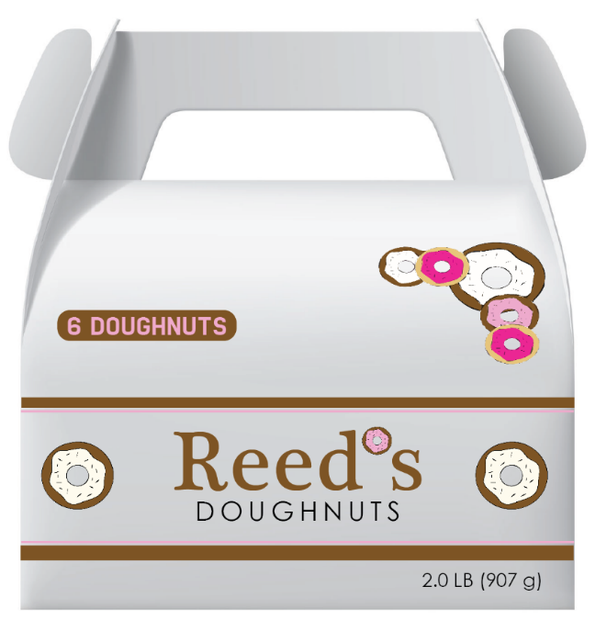
Declaration of Net Quantity
Additional Expression of Quantity
Similarly, the AEQ in the package below would be the “1/2 Liter” expression present in addition to the requiredDoNQ.

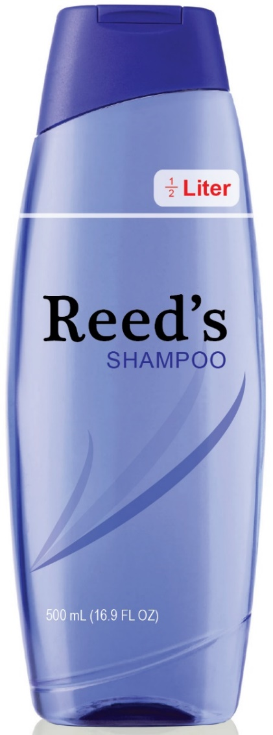
Declaration of Net Quantity
Additional Expression of Quantity (AEQ)

Additional examples of an Additional Expression of Quantity would be:
- Statement “1 Quart” separately appearing on the PDP from the Declaration of Net Quantity reading “1 Quart (0.946 Liters)”

- Statement “32 Fluid Ounces” separately appearing on the PDP from the Declaration of Net Quantity reading “1 Quart (0.946 Liters)”

- Statement “1.5 Liters” separately appearing on the PDP from the Declaration of Net Quantity reading “1.5 Liters (1.58 Quarts)”.

- Statement “3 Pounds” separately appearing on the PDP from the Declaration of Net Quantity reading “3 Pounds (1.36 Kilograms)”

- Statement of “24 Count” separately appearing on the PDP from the Declaration of Net Quantity reading “3 Pounds (1.36 Kilograms)”

- Statement “1/2 Kilogram” separately appearing on the PDP from the Declaration of Net Quantity reading “500 Grams (1.1 Pounds)”

- Statement “2 Dozen Cookies” separately appearing on the PDP from the Declaration of Net Quantity reading “2 Pounds (907 Grams)

- A Declaration of Identity “8 Ounce Steaks” appearing in addition to a PDP Declaration of Net Quantity

2. Reconstituted Expression of Quantity (REQ) – an exact expression appearing on the Principal Display Panel (PDP) in addition to the Declaration of Net Quantity (DoNQ), which details how much product the package contents provide when the product is prepared in accordance with label directions. This expression is most common for products requiring the addition of water but may be appropriate for other products. This expression is generally most useful to consumers when the prescribed directions for product preparation are very straightforward, such as the addition of just water. These statements are less useful when multiple steps or added ingredients are involved.
In the package diagram below, the Reconstituted Expression of Quantity (REQ) would be the “Makes 56 Quarts” expression which is present on the PDP in addition to the required Declaration of Net Quantity (DoNQ).

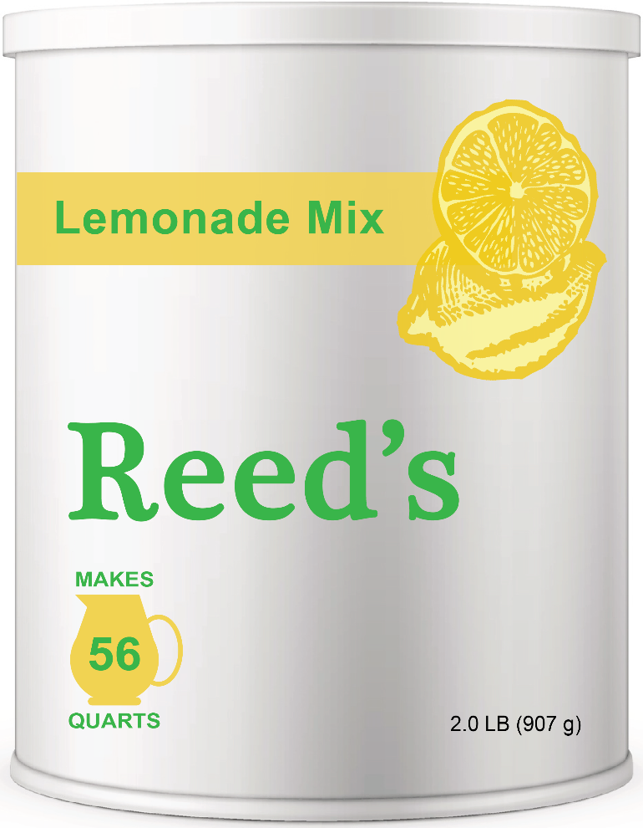
Declaration of Net Quantity
Reconstituted Expression of Quantity

Additional examples of a Reconstituted Expression of Quantity (REQ) would be:
- Statement “Makes 12 Gallons” separately appearing on the PDP from the Declaration of Net Quantity reading “8 Ounces (226 Grams)”

- Statement “Makes 2 Liters” separately appearing on the PDP from the Declaration of Net Quantity reading “4 Ounces (113 Grams)”

- Statement “Makes 50 Liters” separately appearing on the PDP from the Declaration of Net Quantity reading “1.5 Liters (1.58 Quarts)”

- Statement “Makes 20 Quarts” separately appearing on the PDP from the Declaration of Net Quantity reading “1 Liter (1.05 Quart)”

3. Derived Unit Expression (DUE) – an exact expression appearing on the Principal Display Panel (PDP) in addition to the Declaration of Net Quantity (DoNQ) which expresses a quantity in terms of a unit that is not a recognized unit of weight or measure within Legal Metrology or prevailing systems of measurement (e.g., the U.S. Customary or metric systems). The derived unit may be based upon a recognized unit of measure and/or be based on a measurable factor related to consumer usage.
In the package diagram below, the Derived Unit Expression (DUE) would be the “28 Doses” expression which is present on the PDP in addition to the required Declaration of Net Quantity.

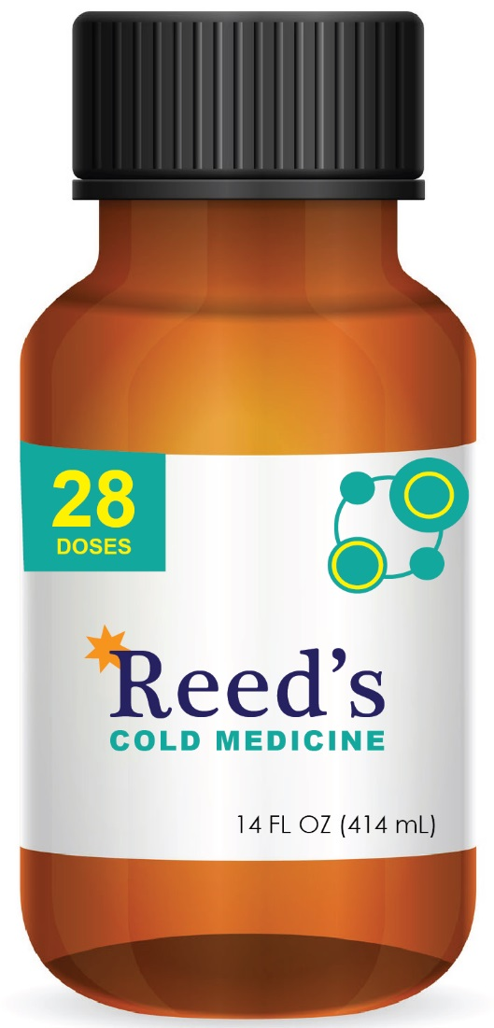
Declaration of Net Quantity
Derived Unit Expression

In the following package diagram, the Derived Unit Expression (DUE) would be the “20 Loads” expression which is present on the PDP in addition to the required Declaration of Net Quantity.

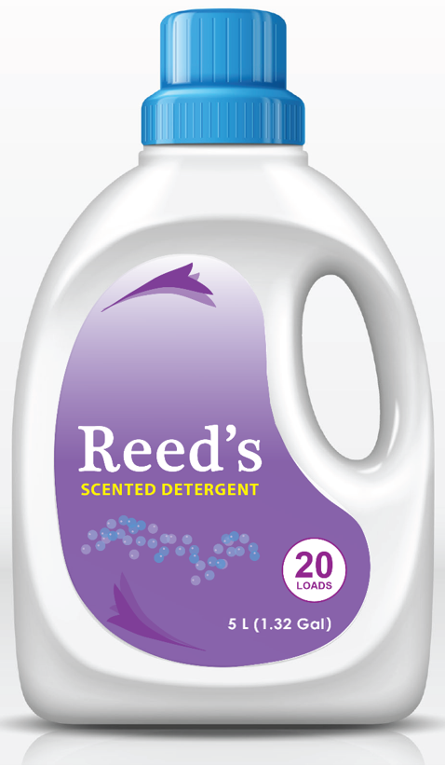
Declaration of Net Quantity
Derived Unit Expression

Additional examples of a Derived Unit Expression include the following:
- Statement “50 Uses” appearing on the PDP when Declaration of Net Quantity reads “8 Ounces (226 Grams)”

- Statement “75 Applications” appearing on the PDP when Declaration of Net Quantity reads “1.5 Liters (1.58 Quarts)”

- Statement “75 20-mL Applications” appearing on the PDP when Declaration of Net Quantity reads “1.5 Liters (1.58 Quarts)”

- Statement “30 Loads” appearing on the PDP when Declaration of Net Quantity reads “2 Pounds (907 Grams)”

4. Comparative Quantity Representation (CQR) – an expression appearing on the Principal Display Panel (PDP) in addition to the Declaration of Net Quantity (DoNQ) which compares the contents of that package to the contents of a comparable product package produced by the same or a different manufacturer. This comparative statement may be a statement of equivalence (e.g., “This Package Contains the same 24 FL OZ as our old Package”), a statement of differentiation (e.g., “This Box Contains 1 Pound more than Reed’s LARGE SIZE Box”) or another accurate and verifiable comparative statement.
In the package diagram below, the Comparative Quantity Representation (CQR) would be the “Makes 8 Quarts More than Other 2 LB Juice Mixes” expression which is present on the PDP in addition to the required Declaration of Net Quantity and the optionally added Reconstituted Expression of Quantity (REQ).

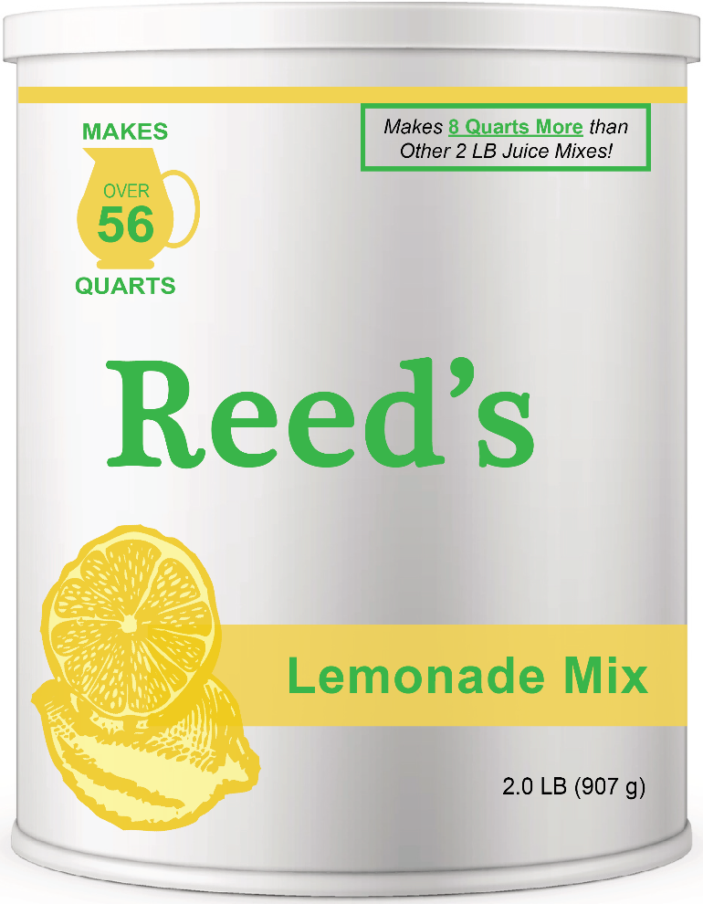
Comparative Quantity Expression
Declaration of Net Quantity

In the following package diagram, the Comparative Quantity Representation (CQR) would be, “This 8 Pound package contains the same Volume as our 15 Pound regular product” expression which is present on the PDP in addition to the required Declaration of Net Quantity.
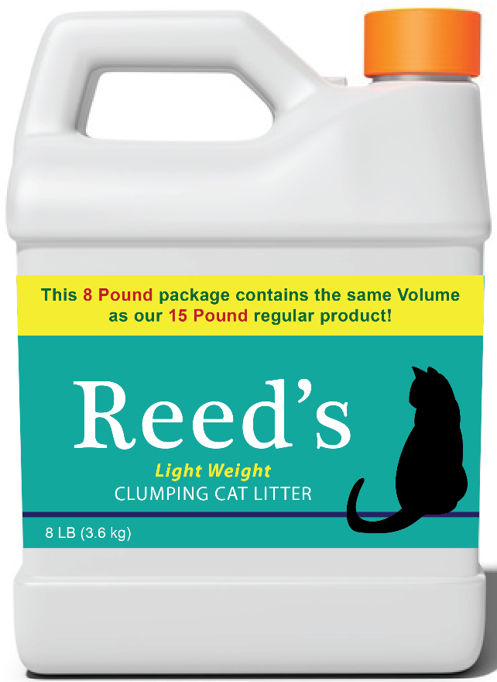
Comparative Quantity Expression
Declaration of Net Quantity
Additional examples of a Comparative Quantity Representation include the following:
- Statement “Contains 1 Pound more than Brand X Largest Size” appearing on the PDP when Declaration of Net Quantity reads “5 Pounds (2.26 Kilograms)”

- Statement “Contains 2 Ounces More than Brand Y 12 Ounce Box” appearing on the PDP when Declaration of Net Quantity reads “14 Ounces (396 Grams) ”

- Statement “Contains the Same 1.5 Liters as Our Old Package” appearing on the PDP when Declaration of Net Quantity reads “1.5 Liters (1.58 Quarts)”

- Statement “Contains 5 More Widgets than Brand Z 20 count Super Widget Assortment” appearing on the PDP when Declaration of Net Quantity reads “2 Pounds (907 Grams)”

- Statement “8 Big Rolls = 12 Regular Rolls” appearing on PDP with correct Declaration of Net Quantity for Paper Towel Product.
5. Comparative Performance Representation (CPR) – an expression appearing on the Principal Display Panel (PDP) in addition to the Declaration of Net Quantity (DoNQ) that compares the performance of that package to the performance of a comparable product package produced by the same or a different manufacturer. Examples of Comparative Performance Representations would include expressions such as “Same number of Uses as our Regular 18 Ounce Size”, “This Package Does 5 More Loads than Reed’s 4 Pound Powder Package”. “Lasts as long as Reed’s 2 Pound Freshening Bar”.
In the package diagram below, the Comparative Performance Representation (CPR) would be the “Does twice as many loads for the same size!” expression which is present on the PDP in addition to the required Declaration of Net Quantity and the optionally added Derived Unit Expression (DUE).
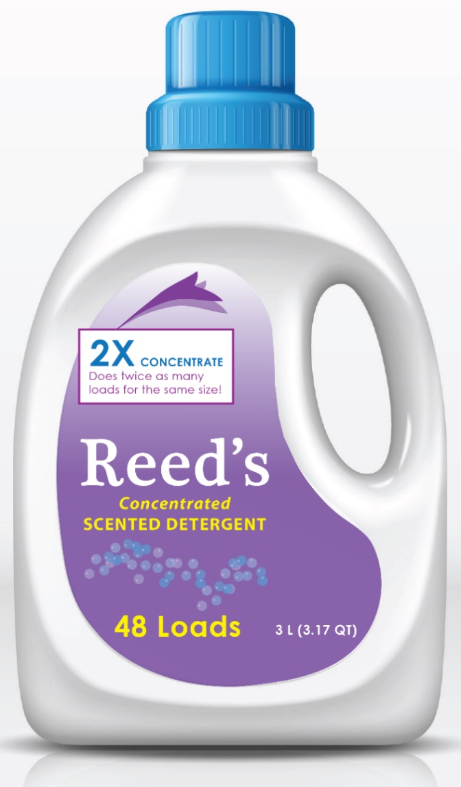
Declaration of Net Quantity
Comparative Performance Representation
Examples of a Comparative Performance Representation include the following:
- Statement “Same Uses as our Regular 18 Ounce Size Product” appearing on the PDP when Declaration of Net Quantity reads “8 Ounces (226 Grams)”

- Statement “20 more Doses than our Regular Size” appearing on the PDP when Declaration of Net Quantity reads “4 Ounces (113 Grams)”

- Statement “Lasts 2 Months Longer than Brand M” appearing on the PDP when Declaration of Net Quantity reads “1.5 Liters (1.58 Quarts)”

- Statement “Double the Absorptive Ability as Regular 20 Pound Products” appearing on the PDP when Declaration of Net Quantity reads “12 Pounds (5.44 Kilograms)”

Principles & Recommendations by Expression Category
In developing category principles and recommendations, the NCWM recognized that some principles should apply broadly across all or most expression categories while others may apply narrowly to a single or limited number of expression categories. To develop principles and recommendations that do not contain category-by-category repetition, the NCWM is providing the information in a tabular fashion.
This document has been drafted according to the schematic below with the presumption that a user would:
1) Determine the applicable expression category from the definitions above,
2) Determine which principles should be evaluated based on Table 1, and
3) Review the additional guidance available in Table 2 as needed. Table 1 identifies the principles generally applicable to each expression category, and Table 2 provides further details and guidance on each principle.

Identify
Expression
Category(ies)

Use Table 1
to identify
Applicable Principles

Use Table 2
for detail of each
Applicable Principle

Table 1: Summary of Principles
Principles | Additional Expression of Quantity  AEQ  “24 Buns” | Reconstituted  Expression of Quantity  REQ  “Makes 2 gallons” | Derived Unit  Expression  DUE  “20 Loads” | Comparative Quantity  Representation  CQR  “40% More Litter Per Pound” | Comparative Performance  Representation  CPR  “Lasts 25% Longer”
Expression should provide useful information to help consumers. | X | X | X | X | X
Expression must be accurate and  verifiable. | X | X | X | X | X
Expression must be clear and unambiguous. | X | X | X | X | X
Expression must not conflict with mandatory Declaration of Net Quantity(DoNQ). | X | X | X | X | X
Expression location and prominence (size, font, and contrast) must be balanced against the Declaration of Net Quantity (DoNQ). | X | X | X | X | X
Expression should provide Consumer Relevant Information. | X | X | X | X | X
Expressions should not conflict with units of Legal Metrology. |  |  | X | X | X
Package Label must provide directions for how to reconstitute. |  | X
Package Label must provide definition of derived unit. |  |  | X |  | X
Derived Unit definition must be consistent across similar products. |  |  | X |  | X
Comparative expression must be balanced, complete and appear in its entirety in the upper 70% of the Principal Display Panel (PDP). |  |  |  | X
Comparative expression which does not contain a reference to recognized units of Legal Metrology must be balanced and complete. |  |  |  |  | X
Table 2: Expression Principles and Guidance
Principle  and Scope | Detailed Guidance
1. Expression should be useful for consumers.  How does the expression provide practical and helpful information to assist consumers?  (Applies to all categories) | Manufacturers should consider whether providing quantity-related information beyond what is in the mandatory Declaration of Net Quantity (DoNQ) will be useful for consumers, and if so, how. Does the expression increase the clarity of quantity information, educate consumers about product quantity or performance, meaningfully assist with value comparisons, or provide other benefits? Generally, an additional quantity expression should have a logical or research-based rationale for why the information is useful to consumers.  For example, voluntary expressions may—  - Help consumers quickly identify a product on the shelf when there are many similar products in various sizes.  - Help consumers evaluate products used in different forms (liquid or solid) and different levels of concentration – for example, products that require water to be added as compared to those already containing water.  - Provide a common frame of reference for consumers to make quantity comparisons across multiple possible product forms.  - Help consumers understand that a new product has a different product concentration or density and how this new product compares to other products.  - Educate or reassure consumers about a product in comparison to a previous version of the product or a competitive product.  Not every product requires a voluntary expression.
2. Expression must be accurate and verifiable.  Is the statement true?  Can statement accuracy be verified?  (Applies to all categories) | Voluntary expressions that contain quantity-related information must be accurate and verifiable using appropriate objective evaluative procedures and are subject to external evaluation and confirmation.  For expressions using defined units of measure or count, accuracy should be based on test methodologies recognized by appropriate authorities such as a federal, state or international agency or standards organization. This includes content expressions embedded in a Declaration of Identity.  For expressions relating to product reconstitution, accuracy should be based upon the directions for product preparation appearing on the product label and test methodologies recognized by appropriate authorities such as a federal, state, or international agency or standards organization.  For Derived Unit Expressions (DUEs) and Comparative Performance Representations (CPR’s), accuracy should be based upon the unit definitions (which must be present on the product label) and verified using objective testing procedures. For example, since a Derived Unit Expresssion (DUE) does not use a unit of legal metrology, a manufacturer must define that unit on the package label, ensure an appropriate test method or validation process for quantifying the unit has been established, and ensure the expression appearing on the Principal Display Panel (PDP) is accurate and verifiable. Where possible, the accuracy of the declaration should be based on test methodologies recognized by appropriate authorities such as a federal, state or international agency of authority.  Statement accuracy must be supportable by manufacturer data and is subject to external evaluation and confirmation.
3. Expression must be Clear and Unambiguous  Is the intended meaning easy to understand?  (Applies to all categories) | Voluntary expressions which contain quantity-related statements must be clear and unambiguous.  Short expressions appearing in terms of recognized units with little to no modification such “2 Cups”, “5 Yards of Twine”, “1.5 Kilograms” or “3 Liters of Water” are typically straightforward and are generally presumed to be clear and unambiguous.  The use of additional language accompanying quantity-related terms requires careful consideration and evaluation to ensure their clarity, accuracy, and relevance. Statements that do not provide information to the consumer about the contents of a specific package should not appear on the Principal Display Panel (PDP).  - Expressions that contain quantity information and appear on the PDP separate from the DoNQ must be accurate, non-misleading, useful, relevant, and verifiable on the basis of the content of the individual package. Statements such as “Approximately 50 Cookies”, “About 2 Cups”, “300 Pencils on Average” or “Up to 50 Cookies” provide little assurance of the quantity contained in any given individual package. In these examples, a consumer purchasing one package may receive less than the amount stated in the expression, more than the amount stated in the expression or exactly the stated amount. While a statement of “approximately 25 candy bars” may be a technically correct statement based on manufacturing variability, this statement provides a consumer who purchases a single package with little assurance that the specific package they select contains 25 – it may be more, it may be less. As a result, statements using “about,” “approximately,” “up to” and similar terms are not recommended to appear on the PDP because they are generally considered unclear and ambiguous.  - An expression such as “Contains Less than 49 Cookies” may be an accurate and verifiable statement but does not provide the consumer with relevant and useful information.  - An expression such as “Good for 30 Applications” provides clear and verifiable information which can be verifiable whereas expressions such as “Provides Up to 30 Applications” or “30 Applications on Average” may overestimate or underestimate what a consumer should expect.  Expressions regarding reconstituted quantities must, clearly indicated information about the amount of ready-to-use product a consumer should expect a package to deliver based on clear label instructions for product preparation. These statements would have to be clearly distinct from the required net quantity information provided in the DoNQ. In many instances, manufacturers use icons to provide reconstituted information since icons efficiently provide both reconstituted product information and distinctness and separation from the DoNQ.  Expressions containing a derived unit require that the manufacturer define the derived unit on the package label so that is it available for consumer inspection prior to product purchase. Expressions that include one or more derived units have to be clearly distinct from the information provided by the required Declaration of Net Quantity (DoNQ). In many instances, manufacturers use icons to provide derived unit information since icons are an effective means to provide additional consumer information which is clearly distinct from the DoNQ.  Comparative statements, including Comparative Quantity Representations (CQRs) and Comparative Performance Representations (CPR’s), need to be complete and balanced expressions which help the consumer understand how the package with the statement compares to other packages. While product comparison information provided by CQRs and CPR’s can often be difficult to communicate in a limited amount of space or limited number of words, it is imperative that a manufacturer ensure a comparative statement appearing on the PDP is a complete, stand-alone statement. While an asterisk may be used to provide additional information substantiating the comparative statement, a manufacturer should not rely on the asterisked information to explain what a comparative statement really means. When an asterisk is used, the added information needs to be provided on the outer package label in a location and font type consistent with other regulatory required information required on other non-PDP panels of the package. Comparative statements must be complete, meaning they can stand on their own in communicating enough information for a consumer to correctly understand the intended message without having to inspect the rest of the package.
4. Expressions must not Conflict with the Information in the Mandatory Declaration of Net Quantity (DoNQ).  Is the statement consistent with the mandatory DoNQ?  (Applies to all categories) | Voluntary expressions which contain quantity-related information should provide information which is equivalent to or consistent with the information present in the required DoNQ. Expressions may:  - Simply repeat a portion of the of the DoNQ, such as “2 Pounds”  - Provide an equivalent information such as “4 Quarts” when DoNQ states “1 gallon”.  - Provide accurate and consistent information such as “Over 1 Quart” when DoNQ is “1 Liter”.  - Provide information in terms of other legal metrological units not represented in the DoNQ such as a volume declaration when product is labeled “2 pounds”.  - Provide information in terms of count that is not provided in the DoNQ  - Provide information on the reconstituted quantity consistent with the declared net quantity and preparation instructions.  - Provide information in terms of a derived unit consistent with the definition of the derived unit provided on the package.  - Provide comparative information that accurately accounts for the quantity information in the DoNQ  Information provided in voluntary expressions on the package Principal Display Panel (PDP) should supplement the information required to be provided in the DoNQ. Voluntary expressions should be evaluated by the manufacturer to ensure the message and information is consistent with what is provided in the DoNQ. For example, if a package label defines the term “dose” to be 2 fluid ounces, a package containing 1 quart with an expression in doses should state the package contains 16 doses. An expression of “17 Doses” or “20 Doses” would not be consistent. Similarly, a package labeled “1 Liter” should not contain an expression such as “contains at least 1 Liter” since that is fundamentally a different statement.
5. Expression location and prominence (size, font, and contrast) must be considered in relation to the Declaration of Net Quantity (DoNQ) to ensure appropriate balance.  Does the expression location, size, font contrast, and other attributes effectively provide information in addition to the DoNQ?  (Applies to all categories.) | Manufacturers should consider the cumulative effects of quantity statement location, size, font, color, and contrast on the package in relation to those of other Principal Display Panel (PDP) elements and statements.  The location, size, and contrast of a voluntary quantity-related expression should help the consumer make informed value comparisons at the point of purchase and not minimize the visibility or purpose of other information required to appear on the PDP. Importantly, an expression should complement or reinforce the information provided by the DoNQ and should not compete with or replace the visibility of the required DoNQ .  When an expression is added to the PDP, the manufacturer should consider the location, size, font, contrast, and other attributes of the expression in relation to the location, size, font and contrast of the DoNQ to ensure they are reasonably balanced. The goal for reasonable balance is to ensure the expression and DoNQ information are effectively communicated to the consumer at the point of purchase. Reasonable balance does not mandate that voluntary expressions must match the size, font, contrast, or other attributes of the DoNQ. Reasonable balance does allow manufacturers to adjust the size (generally equal or larger), adjust the font (generally bolder), modify the contrast (brighter colors, use of icons, banners, and backgrounds) and determine a location (top 70% of the PDP, lower 30% of PDP, distance from the DoNQ), to maximize the visibility of the added expression and the DoNQ.  Combining a voluntary quantity expression and the required DoNQ into a common box or other graphical/visual representation that appears to link both is not recommended. The DoNQ is mandated in law and regulation to have separation from other expressions on the PDP and added expressions need to be clearly separate from the DoNQ but in terms of required separation and visual presentation.  Since a DoNQ is mandated and required to appear in a limited portion of the PDP where consumers know where it can be found, manufacturers are generally going to design a voluntary expression to maximize the chances the expression is also seen at the point of purchase by the consumer.  A voluntarily added expression will generally be of equal or larger size, a different font, and higher contrast than the information provided in the DoNQ since these characteristics are important to help ensure a consumer sees and understands these statements at the time a consumer is making product selections. Not every product has or needs to have a voluntary expression related to quantity added to the PDP, and as a result, for those packages that a manufacturer believes warrant this added information, the manufacturer is attempting to make this information visible to a consumer who may not be necessarily looking for this information. As a result, the manufacturer is going to give this added expression greater prominence than the DoNQ. In doing this, the manufacturer must ensure the visibility of the information provided in the DoNQ is not compromised by the use of fonts, colors, and contrasts which largely mask the visibility of this information at the expense of the added expressions.  In general, an expression that repeats information present in the required DoNQ is more likely to be useful to a consumer if it is substantially separated from the DoNQ. Similarly, an expression that provides quantity-related information that is not present in DoNQ, (for example, count for a package labeled by weight) may be more useful to a consumer if it is located closer to the DoNQ since the consumer will look for and benefit from having all the net quantity-related information in one general area of the product label. Mixing fonts and using icons as part of the added expression can be effective ways to help facilitate conveying additional information in a manner that is clearly separate from the DoNQ. In the end, the manufacturer electing to provide additional information is responsible for ensuring the combination of the expression content and detail, size, location, font, and contrast provide information in addition to the DoNQ for the typical consumer.  When a comparative statement is planned, the manufacturer needs to determine where and how this information is best provided for the benefit of the consumer. Since comparisons can have multiple words, which may differ in font and contrast, a manufacturer must fully consider the location and font of each individual word/term of the expression as well as the overall statement in total in to assess how this might affect the information present in the required DoNQ .  Examples that help illustrate recommended practices for voluntarily added quantity expressions are provided in Appendix 2.
6. Expression information must be relevant to the consumer purchasing or using the product.  Are the conditions of use well defined and do the statements reflect real-life usage expectations?  (Applies to all categories)  Important for derived unit statements and comparative statements based on derived units | Voluntary expressions should provide information that a consumer purchasing the product is likely to want or need to know prior to purchase. Similarly, the voluntarily added information provided should reasonably relate to how a normal user would use the product.  Statements about reconstitution can help educate consumers about product quantity, especially when similar products are present in different product forms such as ready-to-use liquids, liquid concentrates, and solids. For example, an expression containing information about the amount of product a consumer can expect when package contents are reconstituted should relate to the purpose of that product. Knowing the contents of a package reliably prepares 5 gallons or 10 gallons of drink can be useful when a consumer is planning to provide beverages for a large group or has a dispenser with a 5-gallon capacity.  Similarly, an expression providing information in terms of a recognizable derived unit is more helpful and relevant to a consumer when the product is used in a regular and consistent manner by most users. For example, providing health or medicinal information based on “uses” or “doses” can be useful to consumers as they consider how long they might need to want to use the product. Similarly, providing laundry product information based on “loads” can be useful in helping consumers relate to varying degrees of product concentration, especially when a dosing cup is provided to reinforce the quantity expression. Generally, a derived unit expression should have a logical or research-based rationale for why this information is useful to consumers.  On the other hand, statements such as “Makes 60 Waffles” or “Washes 18 Floors” may be less helpful or useful due to variability in factors associated with making waffles such as ingredients, equipment, and actual size, or with the size of rooms in a house, variation in product concentration, differences in expected performance. In these instances, the relevance of the declaration seems less uniform, and the specificity of the expression is less likely to apply broadly to a large subset of consumers.
7. Expressions should not conflict with units of Legal Metrology  Is the expression consistent with units of Legal Metrology?  Is the expression exaggerating or minimizing a unit of measure?  Does the expression have the potential to create confusion?  (Applies to Derived Unit Expressions (DUE’s), Comparative Quantity Representations (CQR’s) and Comparative Performance Representations (CPR’s) | Voluntary expressions that provide quantity-related information in terms of derived units should ensure the expressions do not conflict with or redefine a unit of legal metrology. Units of legal metrology such as ounce, pound, ton, pint, quart, cup, liter, foot, inch, yard, bushel, etc., have precise definitions, and incorporating these terms into the definition of a derived unit requires careful consideration to ensure the derived unit is clear and non-misleading.  Voluntary expressions should avoid practices that could create confusion regarding existing units of measure. For example, federal Law prohibits any term qualifying a unit of weight, measure, or count that tends to exaggerate the amount of product in a container, such as “jumbo quart” or “full gallon”. In addition to complying with this requirement, manufacturers should also avoid other practices that may create confusion regarding existing units of measure, such as using a “10-inch foot”. Statements of this type provide no added value to consumers and can be viewed as misleading.
8. Expressions containing reconstituted product information must provide directions for reconstitution on the product label.  If an expression states how much product the package can make, the directions for how to prepare the product must be provided on the label.  (Applies to REQ’s) | When a Reconstituted Expression of Quantity (REQ) is present on the Principal Display Panel (PDP), the manufacturer also must provide information on the package label clearly detailing how the product is recommended to be reconstituted for consumer inspection prior to product purchase. Consumers should be able to tell what other products, ingredients, or equipment will be needed to prepare the product for use. A consumer should be able to readily view and accurately understand the directions to reconstitute the product prior to making a purchase decision.  The information detailing the reconstitution directions should be located on the outer package (not on the bottom of the package) for consumer inspection prior to product purchase. The location, size and appearance of this accompanying information should be sized appropriately to ensure a consumer can readily find this information either before purchase or during use.  A package can provide reconstitution details for how to prepare the entire package contents or a portion of the contents. For example, when a product states “Makes 64 quarts”, providing consumers with directions for making 2 quarts is encouraged since it is more practical for most consumers not to make all 64 quarts at one time in one container.
9. Expressions containing Derived Units must provide a definition of that unit on the package label.  If an expression conveys a quantity in terms of a Unit that is not defined in Legal Metrology, the Unit must be adequately defined on the label. information  (Applies to Derived Unit Expressions (DUE’s), Comparative Quantity Representations (CQR’s) and Comparative Performance Representations (CPR’s) | A consumer should be able to readily view and accurately understand a derived unit statement prior to making a purchase decision. Since a derived unit is not a recognized unit of Legal Metrology, information that defines, and, if necessary, explains the derived unit to ensure consumer understanding should be provided.  The information defining and explaining the derived unit should be located on the outer package (not on the bottom of the package) for consumer inspection prior to product purchase. The location, size, and appearance of this accompanying information should be consistent with the required regulatory language, such as the required product responsible party statement. Consistent with such requirements, the information must be legible and may be placed on the side or back panels of the package. It may have a font smaller than that required for the Declaration of Net Quantity (DoNQ), which is often larger than other required text.
10. Expressions that employ the same Derived Unit term must use the same definition for the Derived Unit.  The definition for that  Derived Unit  must be consistent across similar products using consistent terms amongst similar products.  Is the statement based on a consistent metric and meaning within a product category?  Important for derived unit statements and comparative statements based on derived units  (Applies to Derived Unit Expressions (DUE’s), Comparative Quantity Representations (CQR’s) and Comparative Performance Representations (CPR’s) | For statements that are not based on “units” of Legal Metrology, consumers need confidence that expressions appearing on similar and competing product packages can be applied consistently to facilitate value comparisons. Inconsistent definitions for the same “derived unit” or the use of different “derived units” by products in the same product category have the potential to confuse or mislead consumers.  Manufacturers using expressions containing derived units are responsible for ensuring that they help consumers and aid in value comparison and purchase decisions. When different definitions are used for similar products, individual companies and trade groups must work together to develop and implement consistent definitions.  For example, if competing laundry detergent packages declare the number of “loads”, consumers can rely on this declaration only if the term “loads” is defined in a common way, even if one product is a liquid, a second is a liquid concentrate, and a third is a powder. The uniform, common definition can be defined based on common product attributes--such as a delivered concentration or a degree or recognized performance, a defined quantity of product, or another consumer-related parameter. The key attributes of a derived unit that they must be objective, measurable, and verifiable by a third party.  Multiple definitions of a derived unit between similar products or competing products neutralize the potential benefit provided by recognizing derived units, and the prevention of multiple definitions should be aggressively enforced and policed within product categories to promote consistency and uniformity. Similarly, the creation of similar-but-different derived units should also be avoided generally. For example, company A should not create an “A-dose”, and company B should not create a “B-dose” to compete against other products bearing the term “dose”.  Consumers need confidence that comparative statements are based on consistent terms to facilitate value comparison. Using inconsistent terms in comparative claims has the potential to confuse or mislead consumers.
11. Comparative Expressions which contain a reference to a unit of Legal Metrology must be complete and balanced statements and must appear entirely in the upper 70% of the PDP.  (Applies to CQRs) | Manufacturer interest in making comparative statements on their packages has increased as new product technologies have been incorporated into products, resulting in better or longer performance, greater product efficiency, more concentrated products, and lighter-weight products. Traditional comparisons based solely on use of product net content declarations may not provide consumers with sufficient information necessary for consumers to make a fully informed decision. Comparative statements are one means by which manufacturers can provide information about new product forms and performance to consumers. They are also a means by which manufacturers can compare their products to competing products.  Manufacturers must carefully consider using comparative statements on the Principal Display panel to ensure the message is complete, clear, correct,  relevant, and non-misleading. They also need to ensure that consumers do not interpret a CQR (or parts thereof) as the required DoNQ.  Comparative Quantity Representations may provide consumers with important information but also have the potential to confuse or mislead consumers about products. These statements can vary in length, word choice, use of icons and pictograms, the quantity(ies) being compared, and can use limitless choices of fonts, colors, and contrasts to emphasize all or certain parts of a comparative statement. A manufacturer must carefully consider how the CQR content, location, font, and contrast will appear in conjunction with the package’s required DoNQ to help facilitate consumers ability to make accurate value comparisons. This is specifically true for a CQR since the weight or measure terms appearing in a CQR have the potential to be interpreted as aDeclaration of Net Quantity.  To help ensure CQRs (or portions of the comparative statement) which contain references to units of Legal Metrology are not misinterpreted as net content information, the following is recommended:  - A comparative expression comprised of one or more units of Legal Metrology must appear in its entirety in the upper 70% of the PDP or on another panel of the package. It should not appear in total or part in the lower 30% of the PDP.  - A comparative expression comprised of one of more units of Legal Metrology must be a complete statement with clear and explicit reference to the products that are being compared. For example, “This product provides 40% more product than the 20 ounce size”. Just saying “40% more product” is not a complete statement. Use of asterisks and asterisked statements located elsewhere on the label are not recommended as means to provide a complete statement. If a statement appears on the PDP, it must be a complete statement on the PDP.
- Information gathered on comparative products should use the same testing methodology as that used for the package bearing the CQR, unless it is not technically feasible and an alternate objective test method is used.

- While a CQR is not required to name another brand, it is the manufacturer's responsibility to ensure the CQR statement is accurate and valid. Although CQR accuracy is often easy to assess since the CQR and DoNQ are both present on the PDP, CQR statements are still required to be accurate and verifiable, should be supported by manufacturer data, and are subject to external evaluation and confirmation.

- A comparative expression comprised of one or more units of Legal Metrology must provide equal emphasis on the units of measure. For example, “This 46 OZ package provides over 100% more product than our 22 OZ package”.

- While asterisks may be used in conjunction with a CQR, asterisked information should be used to provide a reference for the basis of the expression and not explain what the CQR really means. A CQR needs to be able to stand on its own.

- To aid in verification, it is critically important that comparative statements be complete and include correct references to the package and the comparative product(s) to which this package is being compared. For example, a CQR should be a complete statement that makes clear the quantity being compared, the product used in comparison and, if the comparison appears unusual, enough context to ensure the statement is reasonably clear. A consumer’s first reaction to a CQR should not be, “that statement is unclear or doesn’t make sense”.

- When using a CQR, the comparative product should be another product currently marketed in that general marketplace or the previously marketed version to the same or similar product to make the representation relevant to the consumer. Comparing to a product marketed five years ago provides little value for most consumers.

Manufacturers are responsible for ensuring comparative expressions are complete and clear.

12. Comparative expression which does not contain a reference to recognized units of Legal Metrology must be balanced and complete.  Applies to Comparative Performance Representations (CPR’s) | Manufacturer interest in making comparative statements on their packages has increased as new product technologies have been incorporated into products, resulting in better or longer performance, greater product efficiency, more concentrated products, and lighter-weight products. Traditional comparisons based solely on use of product net content declarations may not provide consumers with sufficient information necessary for consumers to make a fully informed decision. Comparative statements are one means by which manufacturers can provide information about new product forms and performance to consumers. They are also a means by which manufacturers can compare their products to competing products.  Manufacturers must carefully consider using Comparative Performance Representations (CPR’s) on the Principal Display (PDP) panel to ensure the message is complete, clear, correct, relevant, and non-misleading.  Comparative Performance Representations may provide consumers with important information regarding how well or long a product might perform but also have the potential to confuse or mislead consumers about products. These statements can vary in length, word choice, use of icons and pictograms, the quantity(ies) being compared, and can use limitless choices of fonts, colors, and contrasts to emphasize all or certain parts of a comparative statement. A manufacturer must carefully consider how the CPR content, location, font, and contrast will appear in conjunction with the package’s required Declaration of Net Quantity (DoNQ) and other expressions to help facilitate consumers' ability to make accurate value comparisons.  To help ensure CPR’s are clear and not misinterpreted, the following is recommended:  - A comparative performance representation must be a complete statement with clear and explicit reference to the products that are being compared. For example, “This new 20-ounce package provides the same number of uses as our old 46-ounce package.” or “This 20-ounce concentrate provides 100% more uses over our 20-ounce unconcentrated product”. Just saying “100% more uses.” is not a complete statement. The use of asterisks and asterisked statements located elsewhere on the label are not recommended as a means to provide a complete statement. If a statement appears on the PDP, it must be a complete statement on the PDP.  - Information gathered on comparative products should use the same testing methodology as that used for the package bearing the CPR, Information gathered on comparative products should use the same testing methodology as that used for the package bearing the CPR,
- While a CPR is not required to name another brand, it is the manufacturer's responsibility to ensure the CPR statement is accurate and valid. Although CPR accuracy is often easy to assess since the CPR and DoNQ are both present on the PDP, CPR statements are still required to be accurate and verifiable, should be supported by manufacturer data, and are subject to external evaluation and confirmation.
- A comparative expression comprised of one or more units must provide equal emphasis on the units of measure. For example, “This 40 Load package provides double the uses as our 20 Load package”.
- While asterisks may be used in conjunction with a CPR, asterisked information should be used to provide a reference for the basis of the expression and not explain what the CPR really means. A CPR needs to be able to stand on its own.
- To aid in verification, it is critically important that comparative statements be complete and include correct references to the package and the comparative product(s) to which this package is being compared. For example, a CPR should be a complete statement that makes clear the quantity being compared, the product used in comparison and, if the comparison appears unusual, enough context to ensure the statement is reasonably clear. A consumer’s first reaction to a CPR should not be, “that statement is unclear or doesn’t make sense”.
- When using a CPR, the comparative product should be another product currently marketed in that general marketplace or the previously marketed version to the same or similar product to make the representation relevant to the consumer. Comparing to a product marketed five years ago provides little value for most consumers.

Enforcement
Voluntarily added quantity-related expressions are distinct from the Declaration of Net Quantity (DoNQ) and therefore require a different enforcement strategy. The DoNQ is mandatory and is enforced using practices developed over many decades and set out in extensive detail in applicable laws, regulations, and guidance. In contrast, as a type of voluntary label claim, voluntary statements are enforced in the same way as other voluntary claims.

Importantly, voluntary statements are subject to a wide range of legal and regulatory requirements. Some of these requirements are general in nature, and some are specific to net contents. An example of a general requirement is the FDA's prohibition of false or misleading statements of any kind on food labels. Specific prohibitions are set out in many state laws and regulations, such as laws that prohibit misrepresentations relating to quantity. For example, Florida law provides that "no person shall sell or offer or exposure for sale less than the quantity he or she represents." Wisconsin law prohibits representations “in any manner a false quantity or price in connection with the purchase or sale, or any advertising thereof, of any commodity, thing or service.”

These and other requirements for voluntary statements are legal obligations and companies must be prepared to demonstrate compliance as necessary. Enforcement practices that are selected will depend on the situation and may include a range of tactics:

- Informal inquiries (e.g., questions during inspections or via a phone call)
- Written requests to demonstrate compliance (e.g., letters sent to the attention of a company's executives or legal/regulatory departments), which may be initiated by either regulators or by industry in the event of a potential competitive dispute.
- Written warnings from a regulatory agency that a particular product label is false, misleading, or otherwise violative of a specific requirement.
- Negotiations to resolve labeling concerns, such as a regulatory agency seeking a consent decree or a company asking the National Advertising Division (NAD) to resolve a competitive dispute.
- Formal legal challenges, such as product seizures or stop-sale orders, where the relevant requirements for such actions are met.

These guidelines are intended to aid in all such compliance efforts as appropriate. For example:

- A regulatory agency may provide the guidelines as a resource to help educate a company about legal requirements and best practices for clear and non-misleading statements.
- A company may provide the guidelines to a competitor that is making what is believed to be an unsupported or misleading claim, to help emphasize the seriousness of quantity-related statements.
- The guidelines may help define the issues that need to be addressed in a legal negotiation or proceeding.

Due to the inherent nature and diversity of voluntary statements, the guidelines' specific use will be case-specific.

Appendix 1
Supplemental Statements
There has been discussion regarding when, where or how added quantity-related information can appear on a package label. The required Declaration of Net Quantity (DoNQ) statement is specific to its content and location in the Fair Packaging and Labeling Act (FPLA) and in specific product regulations. Conversely, FPLA and federal agency regulations speak minimally and vaguely to the subject of adding other accurate information to the product label.
This Appendix summarizes the legal/regulatory history regarding use of “supplemental statements” which are mentioned in FPLA, and in agency regulations (such as those promulgated by the Federal Trade Commission (FTC) and the Food and Drug Administration (FDA)).
Fair Packaging and Labeling Act (FPLA)
The supplemental statement requirement comes from FPLA Section 4(b):
“Requirements of labeling; placement, form, and contents of statement of quantity; supplemental statement of quantity
(b) Supplemental statements
No person … shall distribute … any packaged consumer commodity if any qualifying words or phrases appear in conjunction with the separate statement of the net quantity of contents required by subsection (a), but nothing … shall prohibit supplemental statements, at other places on the package, describing in nondeceptive terms the net quantity of contents: Provided, That such supplemental statements of net quantity of contents shall not include any term qualifying a unit of weight or mass, measure, or count that tends to exaggerate the amount of the commodity contained in the package.” (15 U.S.C. 1453)
There are three parts to this information from FPLA:
  - No mandatory language is specified for the supplemental statement.
  - Supplemental statements are allowed “at other places”.
  - Terms that exaggerate an amount (the net quantity) are not allowed.

What is a Supplemental Statement?
There is no official definition in the FPLA or regulations promulgated by the Federal Trade Commission (FTC) and the Food and Drug Administration (FDA). U.S. congressional legislative history has provided this example: “6 oz. of fast acting X detergent”, and in the following, Congress has said this is a “supplemental statement” that can be “apart from the required net quantity statement”:
“Subsection 4(b) prohibits the qualification of the separate quantity statement by any modifying words or phrases. However, a supplemental statement of the net quantity of contents set apart from the separate net quantity statemen, required by the bill, may be modified by nondeceptive words or phrases, so long as such words or phrases do not tend to exaggerate the amount of the commodity contained in the package. For example, where a package contains a separate net quantity statement in conformity with promulgated regulations, such as ‘6 oz. net weight,’ the package could also contain in a supplemental statement, apart from the required net quantity statement, the phrase ‘6 oz. of fast acting X detergent’ but could not contain the statement ‘6 jumbo oz. of X detergent’ at any place on the package.” (Senate Report 1186 at 5-6)
Food and Drug Administration (FDA)
The FDA administers the FPLA with respect to foods, drugs, cosmetics and medical devices. Pursuant to their authority under FPLA, FDA has issued food labeling regulations under Title 21, Chapter 1, Subchapter B in the Code of Federal Regulations. 21 CFR §101.7(o) states:
“Nothing in this section shall prohibit supplemental statements at locations other than the principal display panel(s) describing in nondeceptive terms the net quantity of contents; Provided, that such supplemental statements of net quantity of contents shall not include any term qualifying a unit of weight, measure, or count that tends to exaggerate the amount of the food contained in the package; for example, ‘jumbo quart’ and ‘full gallon’.”
What this means is that the Declaration of Net Quantity may not contain statements designed to imply that one product is different in quantity from other products that declare the same net contents. What this also means is that Congress wanted the required declaration to be separate from supplemental statements designed to promote product sales. 21 CFR §101.7(o) ensures that such separation exists by permitting supplementary net quantity statements on label panels other than the Principal Display Panel (PDP). However, there is no indication in Senate Report No. 1186, or elsewhere in the legislative history of the FPLA that congressional concern about a "supplementary statement" was intended to encompass other forms of non-misleading information about the quantity of contents other than the one required. To the contrary, the broad congressional policy in Section 2 of the FPLA states:
"Packages and labels should enable consumers to obtain accurate information as to the quantity of the contents and should facilitate value comparisons". (15 U.S.C. 1451)
Note: Declaration of a statement of net quantity of contents in terms of both drained weight and net weight would not be inconsistent with this policy because such declarations advise consumers of the amount of food and the accompanying packing medium, thereby assisting purchasing decisions. [62 Fed. Reg. 9833-34 (Mar. 4, 1997)]
Federal Trade Commission (FTC)
The FTC administers the FPLA with respect to other “consumer commodities” that are expended in the household. Pursuant to their authority under FPLA, FTC has issued labeling regulations under Title 16, Chapter 1, Subchapter E in the Code of Federal Regulations. 16 CFR §500.24 states:
“Supplemental statements.
Nothing contained in the regulations in this part shall prohibit supplemental statements, at locations other than the principal display panel, describing in non-deceptive terms the net quantity of contents … Required combination declarations of net quantity of contents (for example, a combination of net weight or mass plus numerical count, numerical count plus dimensions of the commodity, etc.) are not regarded as supplemental net quantity statements and shall be located on the principal display panel. Dilution directions or other similar directions for use are not regarded as supplemental net quantity statements and may be located on the principal display panel. Size characterizations in compliance with standards promulgated under section 5(c)(1) of the Act may appear on the principal display panel.”
Uniform Packaging and Labeling Regulation (UPLR)
The Uniform Packaging and Labeling Regulation (UPLR) was adopted by the National Council on Weights and Measures (NCWM) to provide accurate and adequate information on packages as to the identity and quantity of contents so that purchasers can make price and quantity comparisons to parallel regulations adopted by federal agencies under FPLA. Section 6.12 in NIST Handbook 130 states:
“Supplementary Quantity Declarations -
The required quantity declaration may be supplemented by one or more declarations of weight, measure, or count, such declaration appearing other than on a principal display panel.”
FDA Interpretations
In the absence of a definition for supplemental statements, several instances emerged over time which required FDA to declare what is and what is not supplemental. The first instance is an FDA example when the regulation was issued, the remaining are cases where FDA expressed an opinion based on a marketplace circumstance.
- On a commodity requiring a declaration of fluid measure, a weight declaration IS supplemental when it is included as part of the Declaration of Net Quantity Statement.
- On a commodity for which weight or volume is sufficient (e.g., sliced cheese, candy bars at Halloween, where weight is enough), count may be voluntarily added and IS NOT supplemental.
- A voluntary declaration of drained weight IS NOT supplemental when combined with a mandatory declaration of the total package weight, including packing liquids.
- A reconstitution declaration such as “makes 1 quart” IS NOT supplemental.
- Metric labeling WAS NOT supplemental when it was voluntarily provided. Metric labeling is now required for most products.
Metric Labeling
Metric labeling is not considered supplemental:
“(p) A separate statement of the net quantity of contents in terms of the metric system is not regarded as a supplemental statement and an accurate statement of the net quantity of contents in terms of the metric system of weight or measure may also appear on the principal display panel or on other panels.” [32 Federal Register 10729, 10733 (July 21, 1967)]
FTC Interpretations
FTC has similarly provided interpretations of their regulation since it has been issued.
- Required combination Declarations of Net Quantity of contents (e.g., net weight plus count) ARE NOT supplemental (seems to be limited to mandatory and differs from FDA).
- Dilution directions or other similar directions for use ARE NOT supplemental.
- Size characterizations in compliance with standards promulgated under section 5(c)(1) of the Act ARE NOT supplemental.
- Performance claims per letter from Robin Rosen Spector, Attorney, FTC Division of Enforcement, Bureau of Consumer Protection, to Michael Tomenga, Nov. 4, 2010:
“Commission staff believes that the ‘lasts the same as’ statement on the Kingsford charcoal packaging does not qualify the package’s unit of weight. Consumers would likely reasonably interpret that statement as a performance claim about the product. The claim appears as a distinct item on the display panel and is separated from the net quantity declaration in accordance with the requirements of the FPLA regulations. Therefore, we would not recommend that the Commission bring a law enforcement action for violations of the FPLA based on the facts presented in your letter. Nevertheless, under section 5 of the Federal Trade Commission Act, the company must possess and rely upon reasonable substantiation for the claim and the claim should not be deceptive. See FDC Policy Statements on Deception and Substantiation: http://www.ftc.gov/bcp/policystmt/ad-decept.htm; http//www.ftc.gov/bcp/guides/ad3subst.htm. “
- Performance claims per letter from James A. Kohm, Associate Director, FTC Division of Enforcement, Bureau of Consumer Protection, to David Sefcik, Nov. 30, 2016:
“All of the quantity-related expressions in the Subcommittee’s draft guidance are descriptive or supplemental quantity information. Therefore, this information can only appear elsewhere on the packaging (anywhere except the principal display panel). See 16 CFR Sections 500.6(b) (‘The declaration of net quantity shall appear…on the principal display panel…and shall not include any term qualifying a unit of weight or mass, measure, or count…’) and 500.24 (‘Nothing contained in the regulations in this part shall prohibit supplemental statements, at locations other than the principal display panel, describing in non-deceptive terms the net quantity of contents…’). Nonetheless, we are unlikely to recommend that the FTC pursue enforcement action for non-deceptive labels. Doing so could deprive consumers of valuable information in some situations.”
Summary
In summary, the term "supplemental statement" which appears in FPLA, FTC and FDA regulations is not defined. Based on the history of opinions and clarifications provided by the federal agencies since adoption of FPLA, it becomes apparent that the definition is not intended to be expansive and somewhat narrow. The FDA on numerous occasions has opined that certain quantity related expressions are NOT supplemental statements and FTC on at least one occasion has similarly opined this viewpoint as well.
While it is not clear what exactly is and is not a supplemental statement, the many circumstances where the agencies have concluded that an expression is NOT a supplemental statement give some insight into allowable and non-allowable expressions. In the most recent FTC opinion suggesting (which was written without a review of the history of previous FDA and FTC recommendations) that the term supplemental statement could be broadly interpreted, FTC goes on to state that added quantity expressions provide useful information to consumers, and they recommend against enforcement actions for packages which display this information. The other opinions provided by FTC and FDA also appear to similarly recognize that the information being provided is useful to consumers.
As a result, this NCWM Best Practice Document has been developed to help ensure that any and all quantity expressions which might appear on a package are clear, non-misleading and useful.

Appendix 2
Illustrations and Discussion of Voluntarily Added Expressions
The purpose of this Appendix is to illustrate package Principal Display Panel (PDP) examples for the purposes of illustrating some of the principles discussed by this document. These examples are intended to be representative and specifically do not cover every possible permutation of possible label scenario since the number of possible scenarios is extremely large.
This appendix is comprised of diagrams focusing on a limited number of label elements. Diagrams were selected as more appropriate than photos of marketed products to avoid possible product identification and the perception of an implicit product endorsement or critique.
This appendix was developed because it is essential that manufacturers consider the cumulative effects of expression location, size, font, color, and contrast on the package in relation to other required and voluntary PDP elements and statements. Expression location, presentation, size and contrast should help the consumer to make informed value comparisons at the point of purchase and not minimize the visibility or content of other information required to appear on the PDP.
A manufacturer is responsible for ensuring an Additional Expression of Quantity (AEQ’s) location, font, graphics or wording provides clear and non-misleading information that does not contradict or marginalize the information provided in the required Declaration of Net Quantity (DoNQ)
Additional Expressions of Quantity can appear on the PDP as illustrated in the following examples, which illustrate differences in color, font size, expression wording, and graphic design such as graphic features or icons. An AEQ may employ a single color and font type or may combine 2 or more colors and fonts. AEQs may express information in the same unit as in the DoNQ or other common recognizable units of legal metrology or count appropriate for the type of product and package size.

1. Additional Expression of Quantity (AEQ) – Additional Expressions of Quantity (AEQ) may appear in the upper 70 % or lower 30% of the Principal Display Panel (PDP). The AEQ can be located opposite the Declaration of Net Quantity (DoNQ), or adjacent to the DoNQ, provided the Declaration of Net Quantity minimum separation requirements are satisfied.

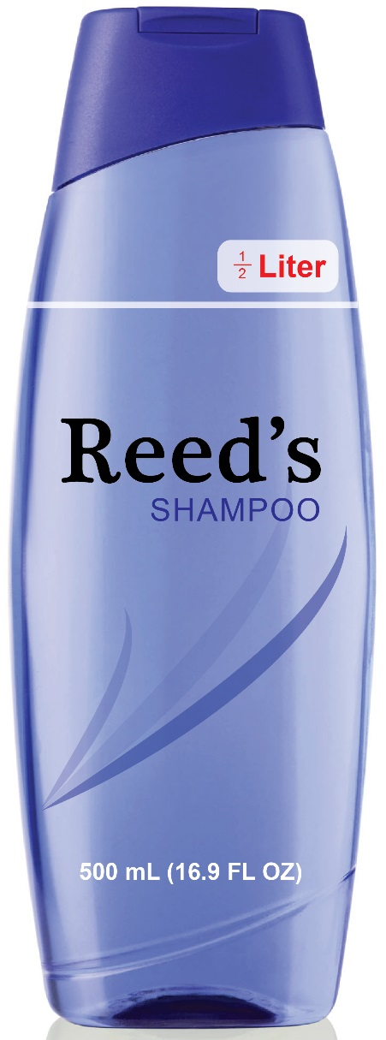 | 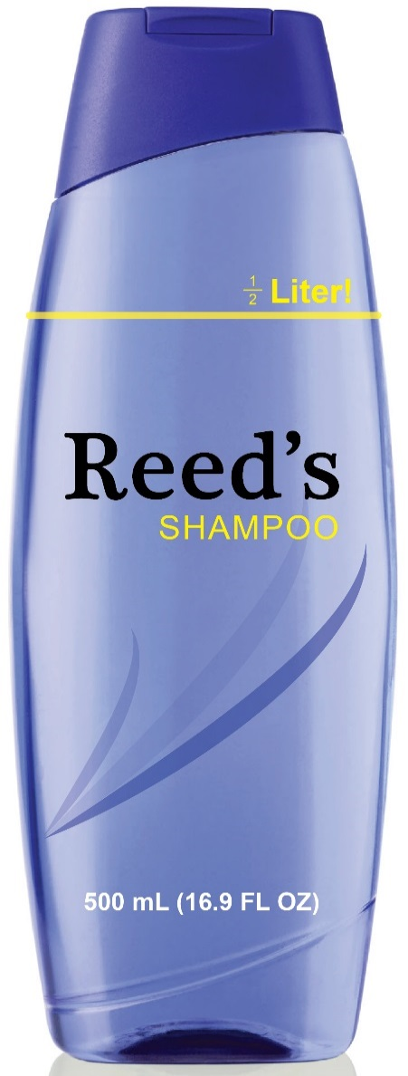 |  |  | 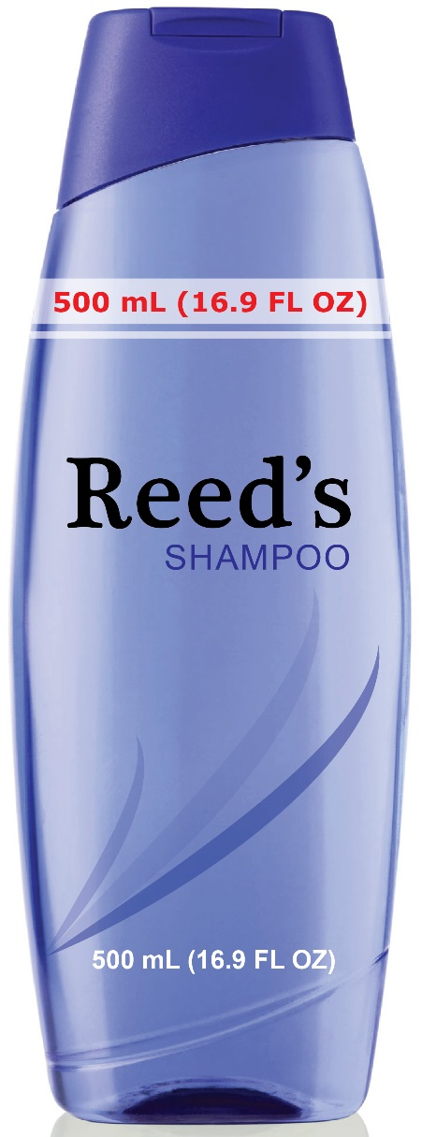
PREFERRED  This example illustrates the inclusion of an AEQ (½ Liter) near the top of the PDP which is equivalent to an element of the DoNQ. The color and contrast of the ½ Liter expression have been selected to increase the visibility of the AEQ. Both the DoNQ and AEQ are clear and non-misleading. | QUESTIONABLE  This example illustrates the inclusion of an AEQ (½ Liter) near the top of the PDP which is equivalent to an element of the DoNQ, however, the color and contrast of the ½ Liter expression could mitigate the visibility of the AEQ on this package. |  |  | PROBLEMATIC  This example illustrates the repetition of the DoNQ state-ment at a second location on the PDP. The DoNQ has a prescribed location on the PDP and should be provided only at that location. FTC regulations do not support inclusion of the DoNQ at a second location on the PDP. Reinforcing that there is one and only one DoNQ at a specific location on the PDP is good policy for both consumers and manufacturers.
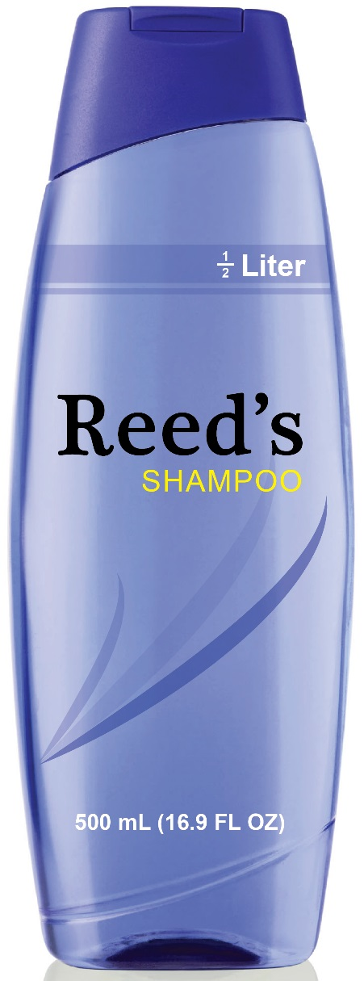 | 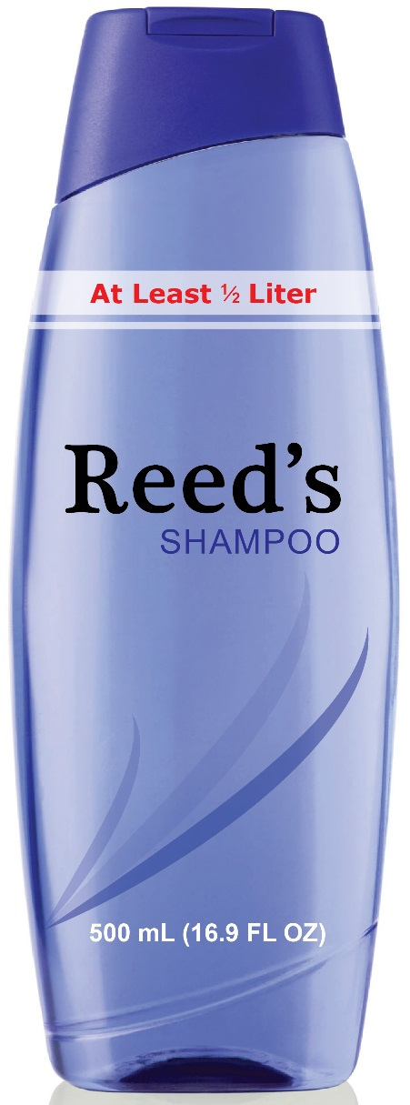 |  | 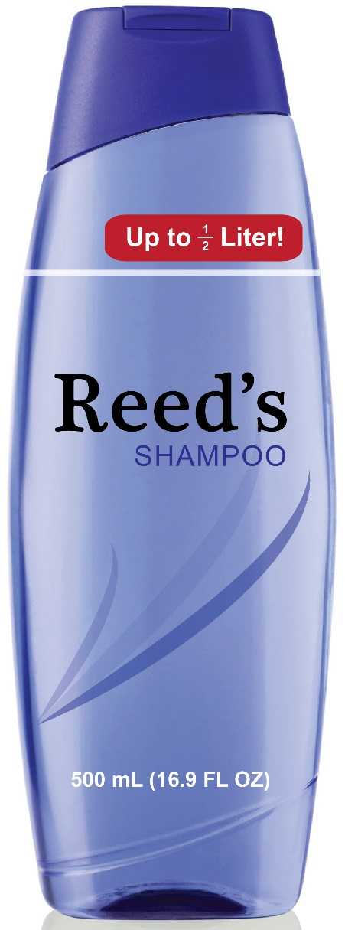
PREFERRED | PROBLEMATIC |  | PROBLEMATIC
This example illustrates the inclusion of an AEQ that states ½ Liter near the top of the PDP which is an equivalent expression to 500 mL in the Declaration of Net Quantity (DoNQ). | This example illustrates the inclusion of the phrase “At Least ½ Liter” near the top of the PDP while the DoNQ states 500 mL. Since the DoNQ states the package contains 500 mL, the AEQ must be an equivalent statement. “At Least ½ Liter” is not an equivalent statement to 500 mL and implies the package may or may not contain more than 500 mL without any added clarification. As a result, this is viewed as problematic. |  | This example illustrates inclusion of the expression “Up to ½ Liter!”. This example is problematic since “up to” does not communicate a precise and verifiable quantity to a prospective buyer of an individual package, and may actually contain less. This expression also is not consistent with the DoNQ. Expressions like “up to”, “approximately” and “about” suggest a quantity range instead of a verifiable quantity. Additionally, the ½ may be hard to see as a result of its size and contrast.

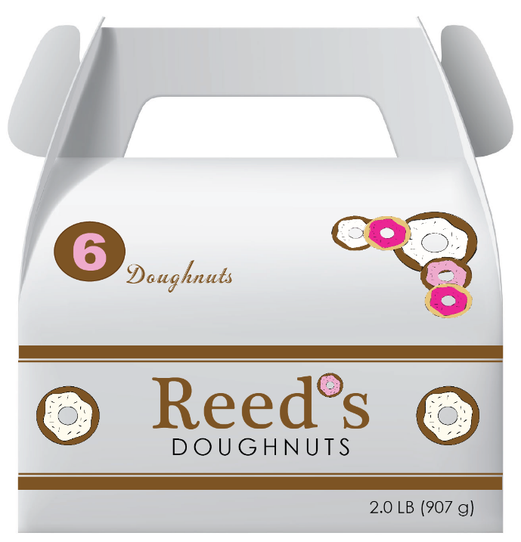  .  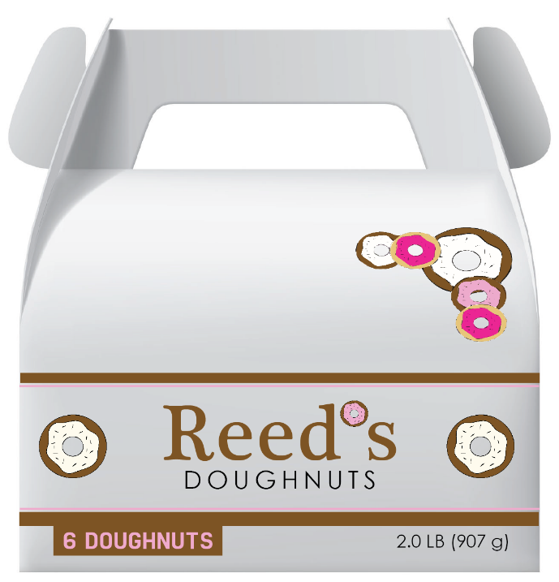 | PREFERRED  This example illustrates the inclusion of an AEQ (6 Doughnuts) near the top of the PDP which provides package count information in addition to the weight/mass information provided by the DoNQ. The “6” and “Doughnuts” appear with differing font, color and contrast in a manner which makes the AEQ clear.  PREFERRED  This example illustrates the inclusion of an AEQ (6 DOUGHNUTS) in the lower 30% of the PDP on the opposite side of the label and separate from the DoNQ which provides weight/mass information The “6” and “DOUGHNUTS” appear with the same font, color and contrast in a manner which makes the AEQ clear.
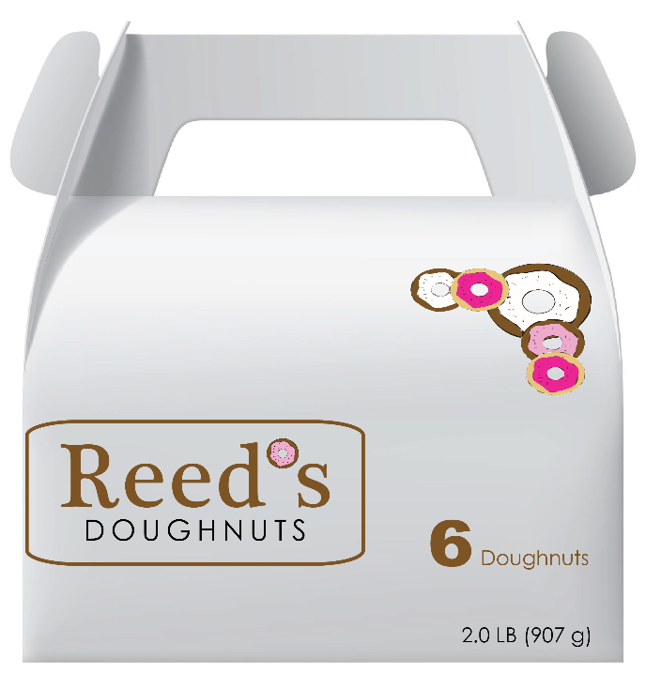 | PREFERRED  This example illustrates the inclusion of an AEQ (6 Doughnuts) in the lower 30% of the PDP on the same side by separate from the DoNQ. The “6” and “Doughnuts” have different font sizes and their color differs from the DoNQ, which makes the AEQ clear separate and distinct from the DoNQ.
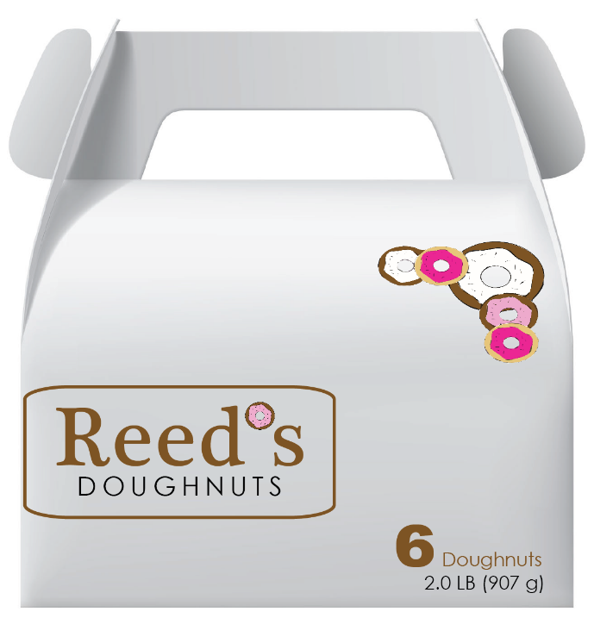 | PROBLEMATIC  This example illustrates the inclusion of an AEQ (6 Doughnuts) in the lower 30% of the PDP immediately adjacent to the DoNQ. In this case, the “6 Doughnuts” is not separate from the DoNQ despite having a different color and font.
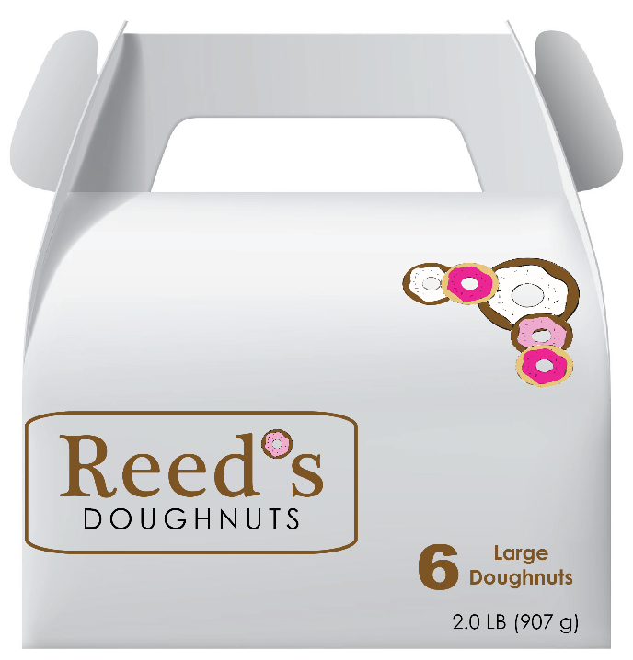 | PROBLEMATIC  This example illustrates the inclusion of an AEQ (6 Large Doughnuts) in the lower 30% of the PDP which provides package count information in addition to the weight/mass information provided by the DoNQ. The “6” and “Large Doughnuts” appear in differing font sizes and color from the DoNQ, but the AEQ location is almost too close to the DoNQ and the DoNQ separation requirement. The term “Large” in the AEQ is an undefined quantity term which makes the AEQ less objective Terms such as “Large” and “Jumbo” are prohibited from the DoNQ because they can exaggerate quantity, and an AEQ on the PDP should similarly not use exaggerating terms.
2. Reconstituted Expression of Quantity (REQ) – Reconstituted Expressions of Quantity may appear in the upper 70 % or lower 30% of the Principal Display Panel (PDP) as illustrated in the examples below. The REQ may be located opposite the Declaration of Net Quantity (DoNQ), or adjacent to the DoNQ, provided the Declaration of Net Quantity minimum separation requirements are satisfied. Where two or more REQs are present (not shown), they may appear in both the upper 70% and/or lower 30% of the PDP. It is not required for the REQ statements to be identical provided they are both accurate and non-misleading.

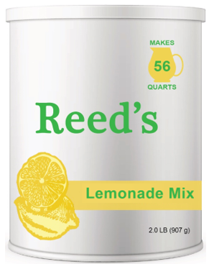  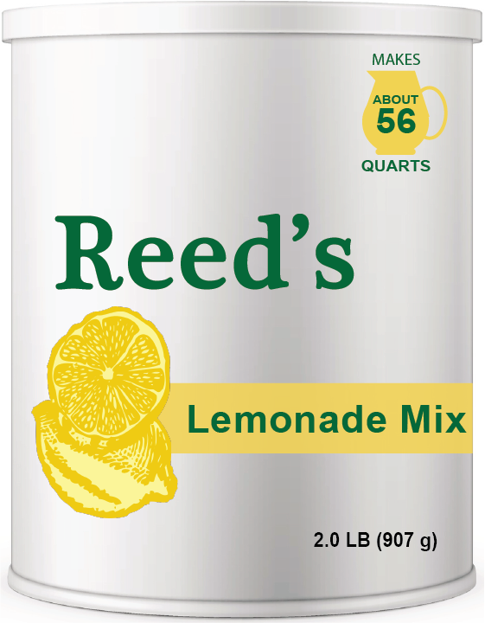  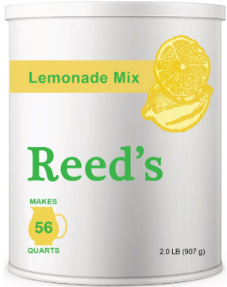  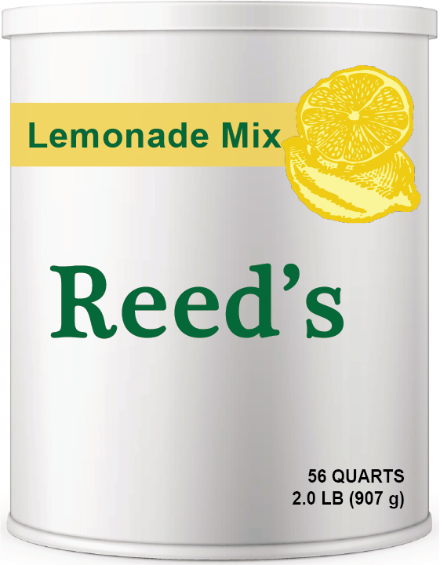 | PREFERRED  This example illustrates the inclusion of an REQ  (Makes 56 Quarts) in the upper 70% of the PDP which provides information concerning how much product the package contents can make per the package instruction. The REQ includes a pitcher related to how the product is mixed and consumed. The REQ is accurate and separate from the DoNQ.  PROBLEMATIC  This example illustrates the inclusion of an REQ  (Makes about 56 Quarts) in the upper 30% of the PDP. The REQ separates itself from the rest of the label including the DoNQ, however, the term but “about” does not communicate a precise and verifiable quantity. Expressions like “up to”, “approximately” and “about” suggest a quantity range instead of a verifiable quantity, and in this example “About 56 Quarts” is problematic because it is inexact and not verifiable, and a consumer may or may not be able to make 56 quarts of reconstituted product.  PREFERRED  This example illustrates the inclusion of an REQ (Makes 56 Quarts) in the lower 30% of the PDP on the opposite side from the DoNQ. The REQ provides information concerning how much product the package contents can make per the package instruction. The REQ includes a pitcher related to how the product is mixed and consumed. The REQ is accurate and separate from the DoNQ.  PROBLEMATIC  In this example “56 Quarts” appears with the “2.0 LB 907g” in the DoNQ. While the inference might be that this package makes 56 quarts, the actual package contents is not 56 quarts. Whether the 56 Quarts in this example is immediately adjacent to the DoNQ or separate from the DoNQ, stating 56 Quarts without “Makes” is an incorrect statement.

PREFERRED
In this example, we show the PDP and the product reconstitution instructions from the back of the package label.

This PDP with the REQ follow the principles of this Document. One added requirement for REQs are clear and verifiable reconstitution instructions which must appear someplace on the package label. These instructions provide clear and verifiable directions for reconstituting product.
Reconstituted Instructions (from package back panel labeling)

PROBLEMATIC
In this example, we show the PDP and the product reconstitution instructions from the back of the package label.

This PDP with the REQ follow the principles of this Document. One added requirement for REQs are clear and verifiable reconstitution instructions which must appear someplace on the package label. The instructions provided in this example are not specific, objective or verifiable.
Reconstituted Instructions (from package back panel labeling)

3. Derived Unit Expression (DUE) – A manufacturer is responsible for ensuring a Derived Unit Expression (DUE’s) location, font, graphics or wording provides clear and non-misleading information which does not contradict or marginalize the information provided in the required Declaration of Net Quantity (DoNQ).
Derived Unit Expressions can appear in the upper 70% or lower 30% of the Principal Display Panel (PDP) as illustrated in the following examples which illustrate differences in color, font size, expression wording, and graphic design such as graphic features or icons. Icons are used commonly for this type of expression. A DUE may employ a single color and font type or may combine 2 or more colors and fonts. Where two or more DUEs are present (not shown), they may appear in both the upper 70% and/or lower 30% of the PDP. It is not required for the DUE statements to be identical provided they are both accurate and non-misleading.
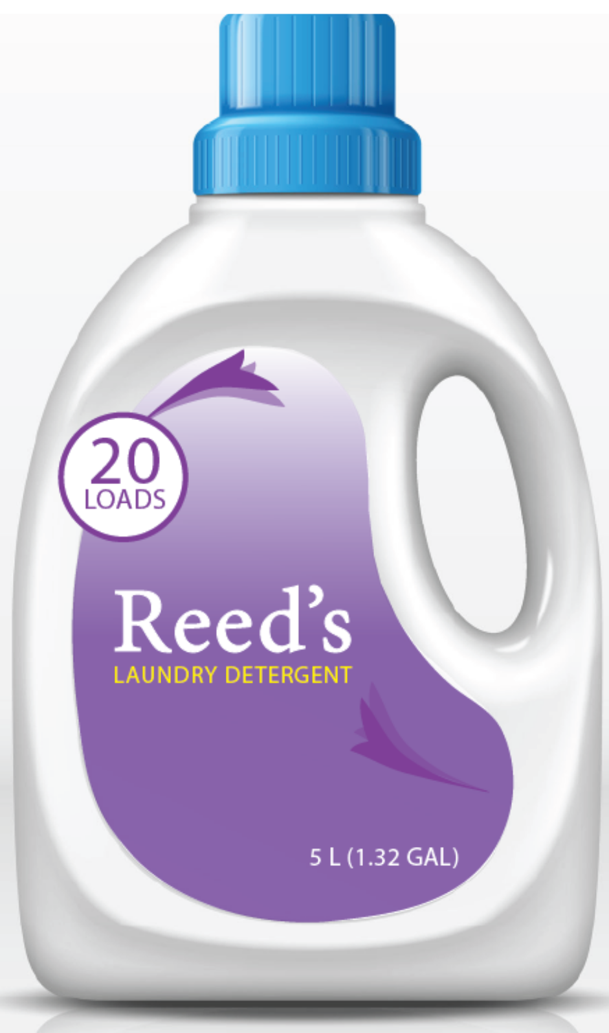
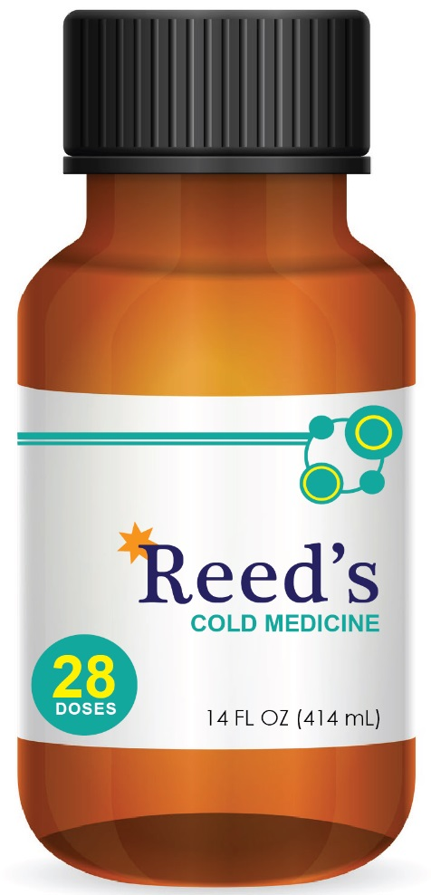

This example illustrates the inclusion of a DUE (28 DOSES) in the lower 30% of the PDP which provides information concerning how many derived units the package contents can make per the package instruction. The DUE is accurate, verifiable and separate from the DoNQ.

This example includes the PDP and a statement from elsewhere on the package label. In this case, the PDP shows the inclusion of a DUE (20 LOADS) in the upper 70% of the PDP which provides information concerning how many derived units (LOADS) the package contents can deliver. The PDP of this package adheres to the principles for DUEs contained in this Document.
One requirement for DUEs is that there must be a derived unit definition (which is clear and verifiable) someplace else on the package labeling. See examples below.

PROBLEMATIC
In this example, the derived unit is not clearly defined and is not verifiable.

PREFERRED
In this example, the derived unit is defined to be 8 fluid ounces of detergent. This is clear and verifiable.

USE APPROXIMATELY ONE CUP OF DETERGENT FOR YOUR LAUNDRY LOAD

ONE LOAD IS 1 CUP (8 FL OZ) WHICH IS THE AMOUNT OF DETERGENT TO DO A MEDIUM LOAD

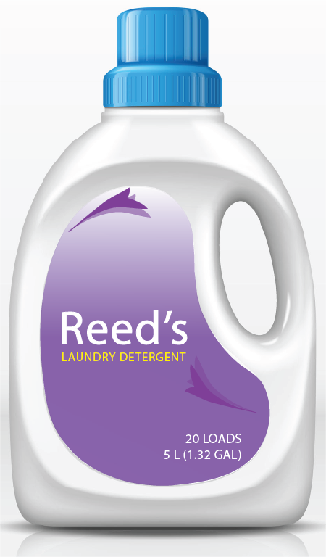 | PROBLEMATIC  In this diagram, the derived unit expression appears with minimal separation from the DoNQ in the lower 30% of PDP. With this spacing the “20 Loads” appears to be part of the DoNQ, which is in violation of DoNQ requirements since Loads (and other Derived Units) are not units of Legal Metrology. As a result, separation of a DUE from the DoNQ must be sufficiently large to ensure that the DUE is clearly not part of the DoNQ.
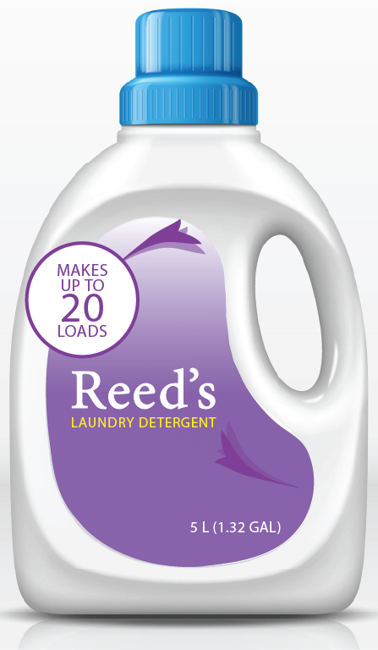 | PROBLEMATIC  In this diagram, the DUE statement “Makes Up to 20 Loads” is an inexact expression that does not provide accurate quantity information that consumers can rely upon and regulators can verify. Exactly how many Loads are delivered? Expressions appearing on the PDP need to provide precise and accurate values, not ranges.
4. Comparative Quantity Representation (CQR) – A manufacturer is responsible for ensuring a Comparative Quantity Representation (CQR’s) location, font, graphics or wording provides clear and non-misleading information which does not contradict or marginalize the information provided in the required Declaration of Net Quantity (DoNQ). Because CQRs may employ the same units as those contained in the DoNQ, manufacturers should carefully consider the CQR expression content, location, graphics and fonts to minimize the likelihood that a portion of the CQR is misinterpreted to be the DoNQ.
Comparative Quantity Representations should appear in the upper 70% of the Principal Display Panel (PDP) as illustrated in the following examples which illustrate differences in color, font size, expression wording, and graphic designs. A CQR may employ a single color and font type or may combine 2 or more colors and fonts. CQR’s may express information in the same unit as in the DoNQ or other common recognizable units of legal metrology or count appropriate for the type of product and package size.

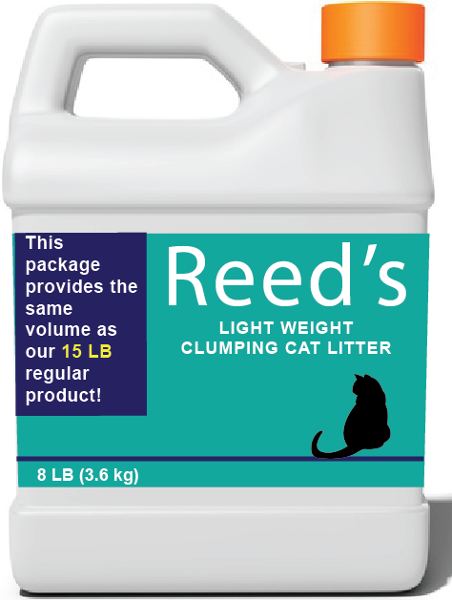 |  | 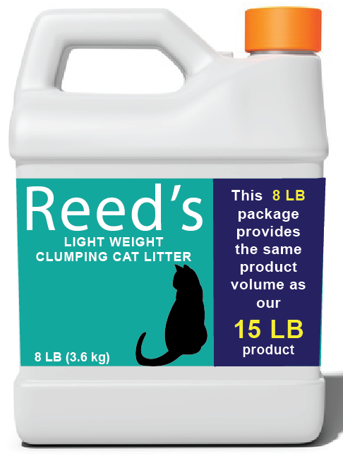
QUESTIONABLE  The CQR on this package is questionable because the expression is very close to extending into the lower 30% of the PDP. Because CQRs are full statements which have numbers which can be over emphasized, the statements in their entirety need to remain outside the lower 30% of the PDP to ensure separation from the DoNQ. |  | PROBLEMATIC  The CQR on this package covers the entire right side of the PDP. The expression extends into the lower 30% of the PDP where the 15 LB portion of the expression appears in a larger font with a bolder color. This presentation can be misinterpreted by a consumer shopping in a retail establishment as being a 15 LB package, not the 8 LB package it really is. While CQRs can make words and numbers of differing sizes, colors, and fonts, these statements are to remain outside the lower 30% of the PDP to avoid potential confusion.

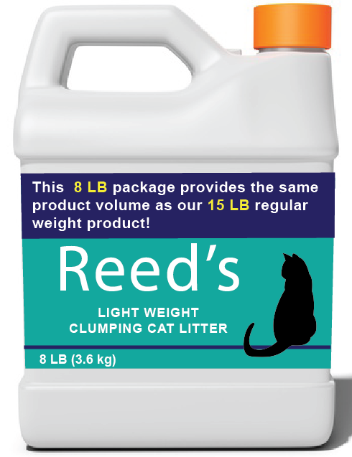 |  | PREFERRED  The CQR on this package label provides a comparison between this package and another package which is clearly defined. Its location is outside the lower 30% in its entirety and clearly separate from the DoNQ
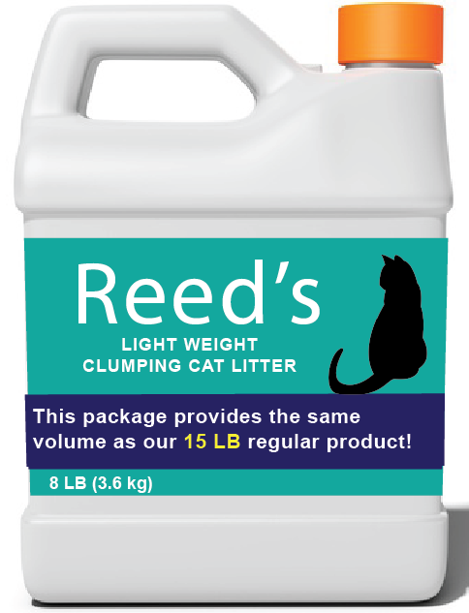 |  | PROBLEMATIC  The CQR on this package is problematic because the expression is clearly within the lower 30% of the PDP. Because CQRs are full statements which have numbers which can be over emphasized, the statements in their entirety need to remain outside the lower 30% of the PDP to ensure separation from the DoNQ.

5. Comparative Performance Representation (CPR) – A manufacturer is responsible for ensuring a Comparative Performance Representation (CPR’s) location, font, graphics or wording provides clear and non-misleading information which does not contradict or marginalize the information provided in the required Declaration of Net Quantity (DoNQ).
Comparative Performance Representations can appear in the upper 70% or lower 30% of the Principal Display Panel (PDP) as illustrated in the following examples which illustrate differences in color, font size, expression wording, and graphic design. A CPR may employ a single color and font type or may combine 2 or more colors and fonts.
 |  | 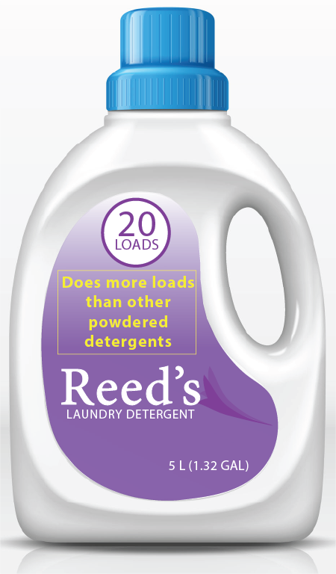
  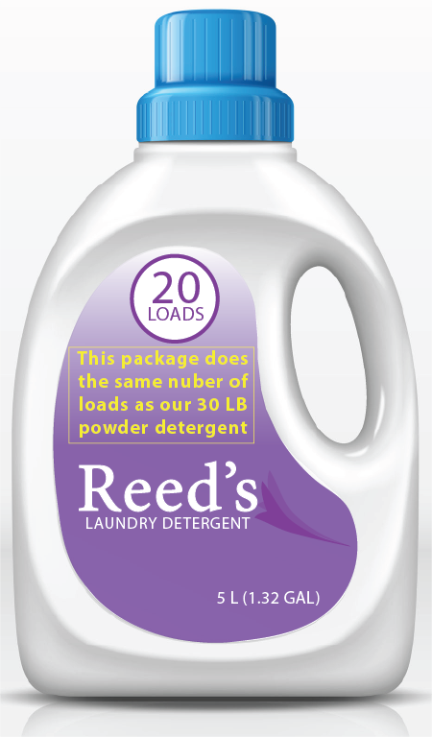
PREFERRED |  | PROBLEMATIC
The CPR on this package is an expression which clearly compares the number of Loads delivered between 2 specific packages. The statement is clearly separate from the DoNQ. |  | The CPR on this package is a general statement comparing this package to powdered detergents without clear comparison to any specific package. While located separate from the DoNQ, a CPR needs to provide specific and comparisons which can be used by consumers and verified by regulators.

Resources

Federal Trade Commission Act (15 U.S.C. § 45)
https://www.ftc.gov/legal-library/browse/statutes/federal-trade-commission-act

https://www.ftc.govhttp://uscode.house.gov/view.xhtml

Fair Packaging and Labeling Act
https://www.ftc.gov/enforcement/rules/rulemaking-regulatory-reformproceedings/fair-packaging-labeling-act-regulations-0

NIST Handbook 130 Uniform Laws and Regulations (includes Uniform Weights and Measures Law, Uniform Packaging and Labeling Regulation, Uniform E-Commerce Regulation) https://www.nist.gov/pml/weights-andmeasures/publications/nist-handbooks/handbook-130-current-edition

FDA Food Labeling Guide https://www.fda.gov/foodlabelingguide

FDA Updated Nutrition Labeling Examples https://www.fda.gov/media/99151/download

FDA Cosmetic Labeling Regulations https://www.fda.gov/cosmetics/cosmetics-labeling-regulations/codefederal-regulations-sections-cosmetics-labeling-cfr-title-21-part-701

FDA Cosmetic Labeling Guide https://www.fda.gov/cosmetics/cosmetics-labeling-regulations/cosmetics-labeling-guide

https://www.api.org/-/media/files/publications/2024-catalog/2024-publication-catalog.pdf.
See, e.g., NIST Handbook 130– Uniform Weights and Measures Law § 15 (Misrepresentation of Quantity).
See, e.g., Federal Trade Commission Act § 5 (15 U.S.C. § 45).
The National Advertising Division of the Council of Better Business Bureaus offers an alternative dispute resolution service that reviews claims made in national advertisements.

