Attachment A-1 (Supporting Document for NYCDOT)

- Four (4) Quartz sensors were installed in the center lane of the BQE Corridor in 2019.
- Five trucks (two Class 9 trucks – 3S2 & 3S2 Split, one Class 6 truck, and two Class 5 trucks) were used for calibration tests I.
- Quartz sensors were able to comply with accuracy requirements for all standards (ASTM, NIST, OIML, and COST).
- The maximum error for GVW is 4.4% which meets the maximum tolerance of 6%. The single axle and tandem axle also meet the tolerance of 15% and 10%, respectively.
- If other types of trucks not covered by this test were employed, the accuracy for other trucks would be improved.
- Accuracy varies depending on truck speed. However, the speed variance could be eliminated by the optimization process.
- Although the site included severe rutting, Quartz sensors met the accuracy and compliance for ASTM E1318 Type III.
- Calibration factors drifted slightly after the initial calibration. Routine calibration is highly recommended every 6 months.
Form 15: Attachment A Submitted by: NYCDOT-C2SMART-Kistler-MDOT

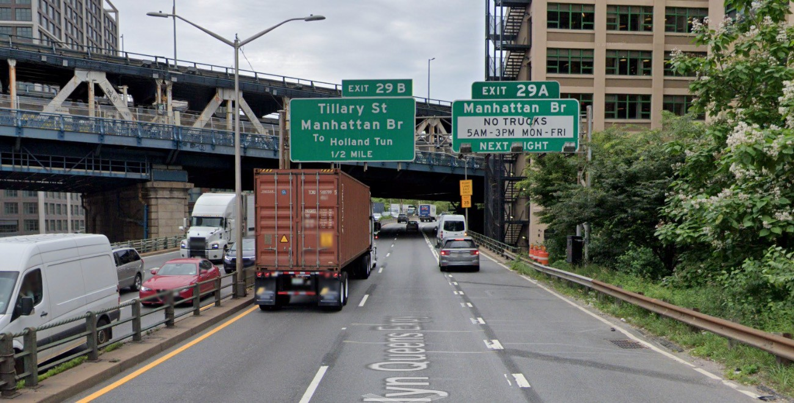1 of 11
BQE Calibration Results and Summary
Standards | GVW | Single | Tandem
Quartz Results (max error, %) | 4.4 | 12.4 | 8.0
Number of Test | 30 | 30 | 42
ASTM Type III (%) | 6 | 15 | 10
ASTM Type III Compliance (%) | 100 | 100 | 100
NIST Class A (%) | 10 | 20 | 15
OIML F10 (%) | 5 | 8 | 8
COST A(5) (%) | 5 | 8 | 7

Attachment A-2 (Supporting Document for Maryland DOT)

02/15/2019 US-50 East Lane 2 (Fast Lane) Truck weight: 69140
Span before Calibration:
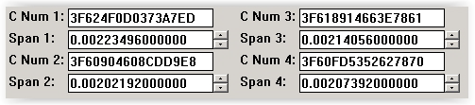

Test truck pass:
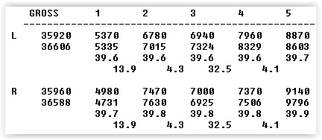

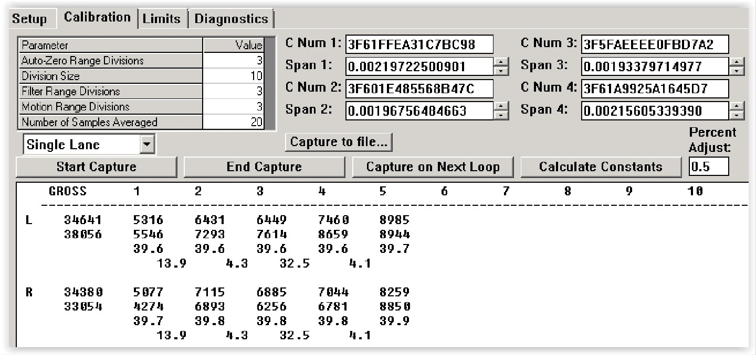
After calculate constants:

Test 1 – Gross Weight -0.61 %
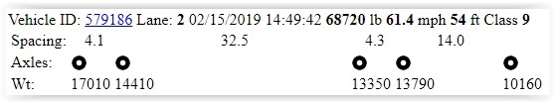 | 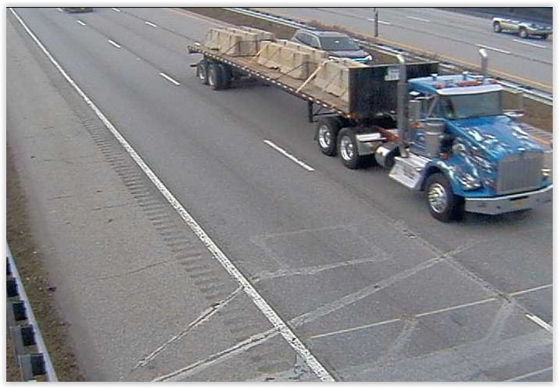
Test 2 – Gross Weight -2.96 %
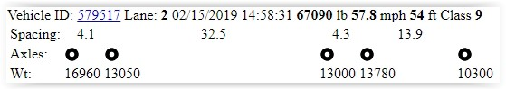 | 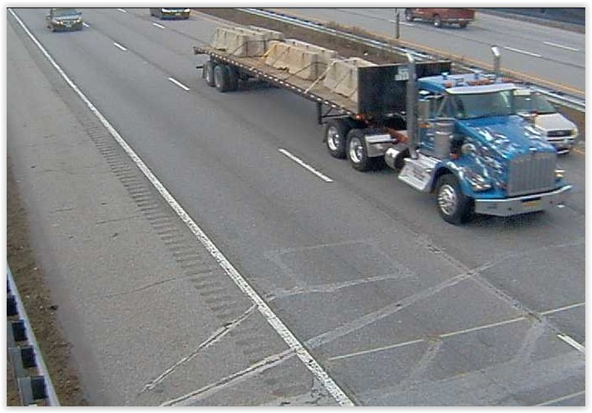
Test 3 – Gross Weight -3.92 %
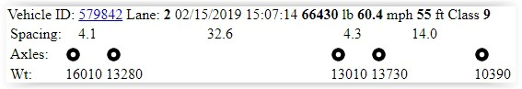 | 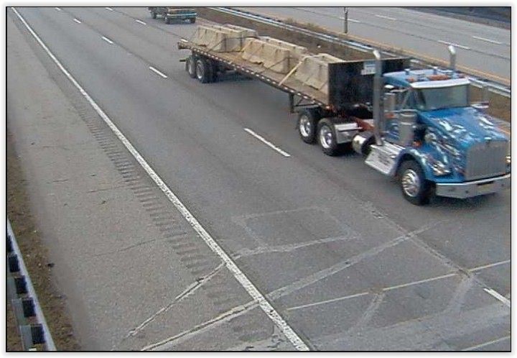

Test 4 – Gross Weight -2.88 %
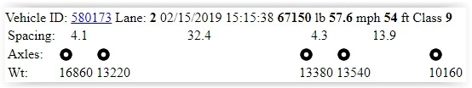 | 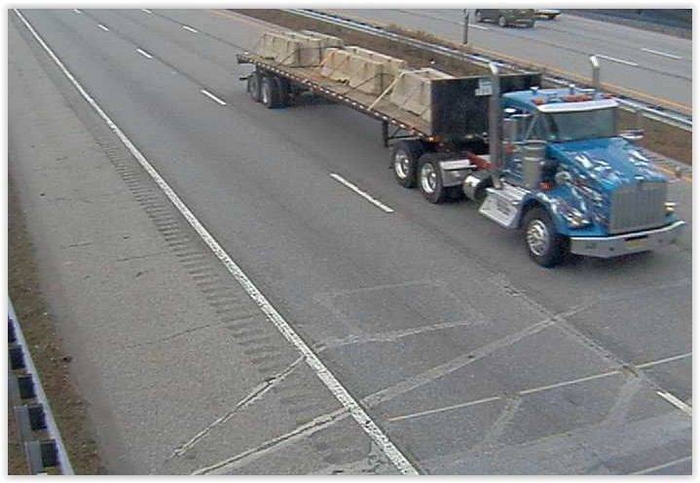
Test 5 – Gross Weight -0.98 %
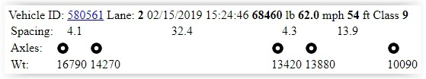 | 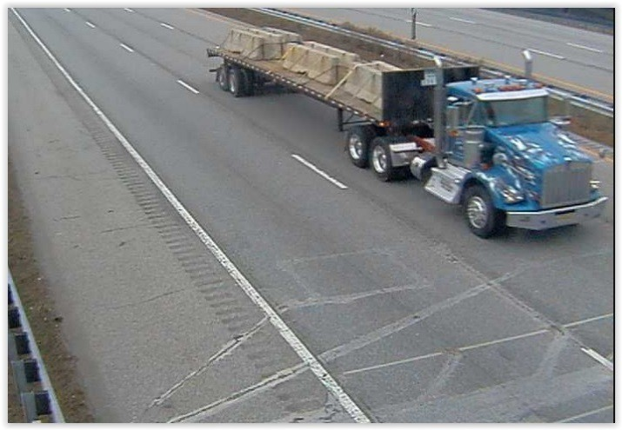
Test 6 – Gross Weight -3.50 %
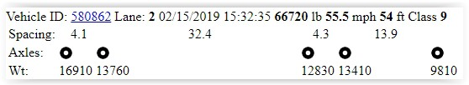 | 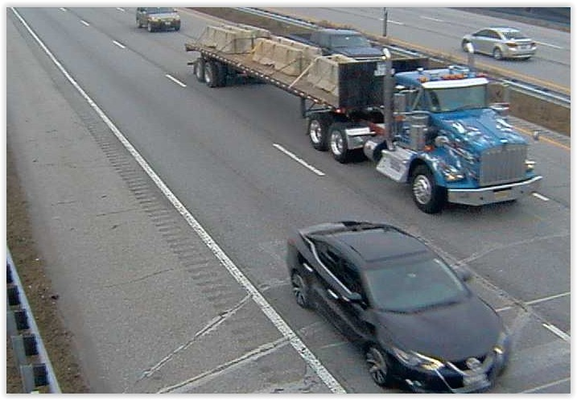

Test 7 – Gross Weight -3.43%
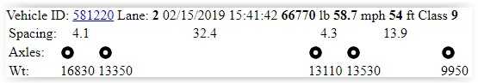 | 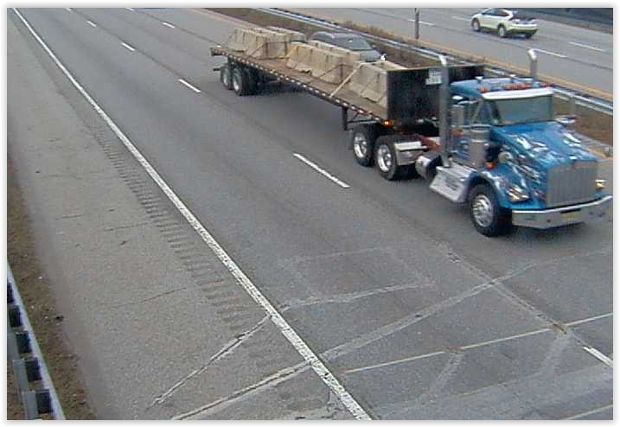
Test 8 – Gross Weight -3.14 %
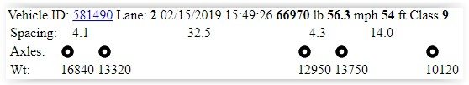 | 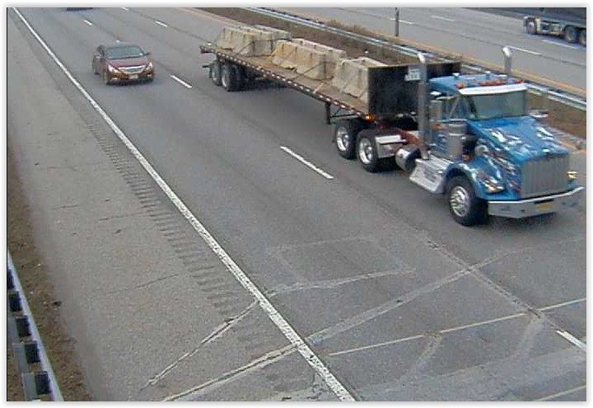
Test 9 – Gross Weight -3.27 %
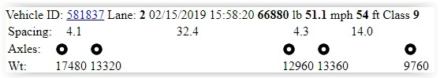 | 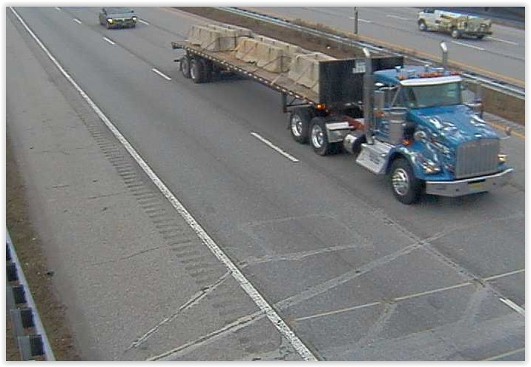

Test 10 – Gross Weight -3.24 %
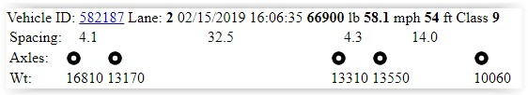 | 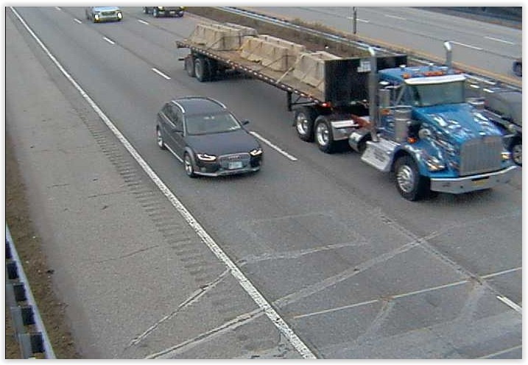

US-50 East Lane 2 |  |  |  |  |  |  |  |  |  |  | Actual weight: |  |  | 69140
 |  |  |  | Spacing |  |  |  | Weight
 | ID | Time | Speed | Sp4 | Sp3 | Spc 2 | Spc 1 | Ax5 | Ax4 | Ax3 | Ax2 | Ax 1 | Position | Gross | Err %
1 | 579186 | 14:49:42 | 51.4 | 4.1 | 32.5 | 4.3 | 14.0 | 17010 | 14410 | 13350 | 13790 | 10160 | Center | 68720 | -0.61
2 | 579517 | 14:58:31 | 57.8 | 4.1 | 32.5 | 4.3 | 13.9 | 16960 | 13050 | 13000 | 13780 | 10300 | Center | 67090 | -2.96
3 | 579842 | 15:07:14 | 60.4 | 4.1 | 32.6 | 4.3 | 14.0 | 16010 | 13280 | 13010 | 13730 | 10390 | Center | 66430 | -3.92
4 | 580173 | 15:15:38 | 57.6 | 4.1 | 32.4 | 4.3 | 13.9 | 16860 | 13220 | 13380 | 13540 | 10160 | Center | 67150 | -2.88
5 | 580561 | 15:24:46 | 62.0 | 4.1 | 32.4 | 4.3 | 13.9 | 16790 | 14270 | 13420 | 13880 | 10090 | Center | 68460 | -0.98
6 | 580862 | 15:32:35 | 55.5 | 4.1 | 32.4 | 4.3 | 13.9 | 16910 | 13760 | 12830 | 13410 | 9810 | Center | 66720 | -3.50
7 | 581220 | 15:41:42 | 58.7 | 4.1 | 32.4 | 4.3 | 13.9 | 16830 | 13350 | 13110 | 13530 | 9950 | Center | 66770 | -3.43
8 | 581490 | 15:49:26 | 56.3 | 4.1 | 32.5 | 4.3 | 14.0 | 16840 | 13320 | 12950 | 13750 | 10120 | Center | 66970 | -3.14
9 | 581837 | 15:58:20 | 51.1 | 4.1 | 32.4 | 4.3 | 14.0 | 17480 | 13320 | 12960 | 13360 | 9760 | Center | 66880 | -3.27
10 | 582187 | 16:06:35 | 58.1 | 4.1 | 32.5 | 4.3 | 14.0 | 16810 | 13170 | 13310 | 13550 | 10060 | Center | 66900 | -3.24
 |  |  |  |  |  |  |  |  |  |  |  |  |  | Min | -3.92
 |  |  |  |  |  |  |  |  |  |  |  |  |  | Max | -0.61
 |  |  |  |  |  |  |  |  |  |  |  |  |  | Avg | -2.79
 |  |  |  |  |  |  |  |  |  |  |  |  |  | Range | 3.31
 |  |  |  |  |  |  |  |  |  |  |  |  |  | StdDev | 1.10

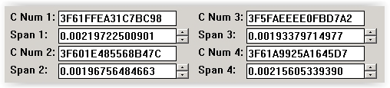
Increase span by 0.8 percent for average to be approximately minus two percent. Before:

New span values:
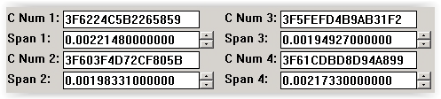

Static Weights Prior to Calibration
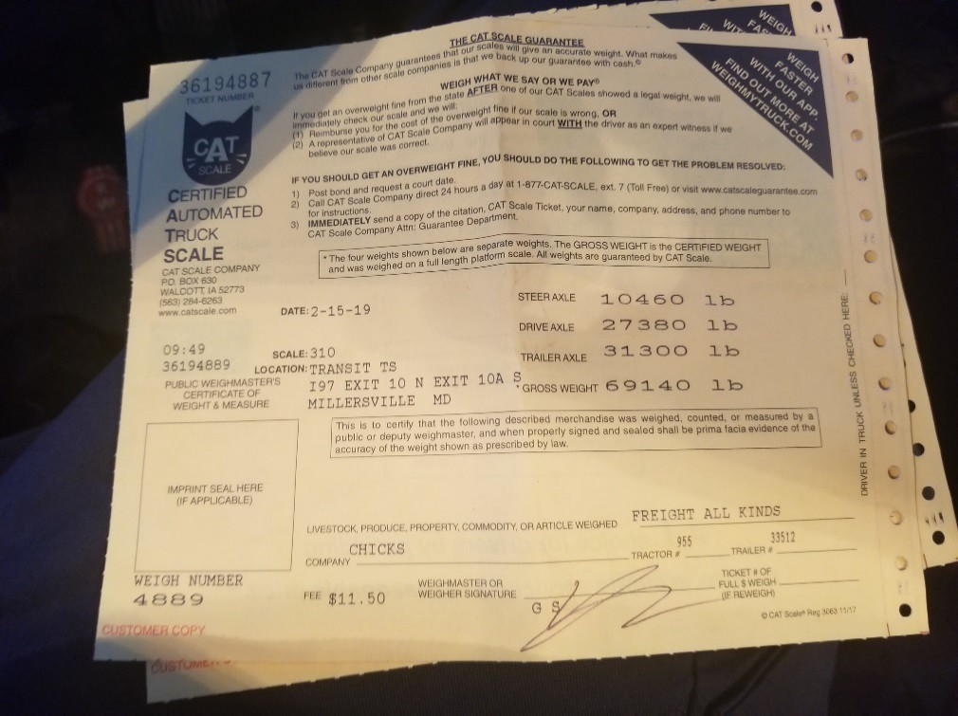

Static Weight After Calibration
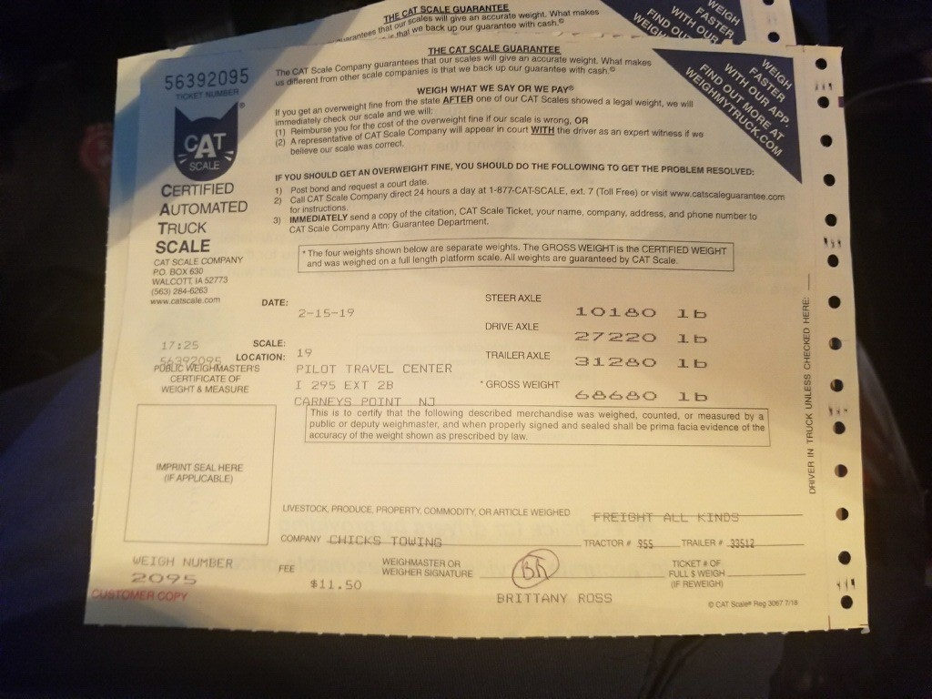

Submitted by: NYCDOT-C2SMART-Kistler-MDOT
Attachment A-3 (Supporting Document for Indiana DOT)

To: Katie England, INDOT
From: Darcy Bullock, Purdue University Wayne Bunnell, Purdue University Tim Wells, INDOT Research Division
Date: January 24, 2017
Subject: Evaluation of Kapsch Weigh-in Motion site in Chesterton, IN (EB I-94 at Mile Marker 28)

We are writing to summarize the results of discussion on January 19, 2017, and provide requested follow up information.
In the Spring of 2016, INDOT and Kapsch partnered to construct an evaluation WIM just west of the Brummit Road Overpass on EB I-94 at approximately Mile Marker 28 (Figure 1). Lane preparation and sensor installation occurred in May 2016 and calibration was performed by Kapsch in June 2016. On June 30, 2016, we received initial training by Kapsch and performed pilot testing of evaluation protocol with Indiana State Police (ISP). In July, plans were developed to conduct an evaluation over a variety of pavement temperatures during the period August to December and to summarize those results in January 2017.
A total of 615,872 Class 9 vehicles crossed over the WIM from August 1 to December 31, 2016. A Class 9 vehicle is the most common tractor trailer unit with 5 axles. We subsequently performed validation activities on randomly selected Class 9 trucks on August 3, September 6, October 5, November 9, and December 7, 2016. This validation involved photographing Class 9 vehicles weighed at the ISP EB I-94 Chesterton weigh station and matching those photographs with the photographs obtained from the cameras at the WIM (Figure 1). Only vehicles with no error flags (lane changes, acceleration, deceleration…) were selected for further study. A sample size of 688 vehicles was subsequently used to prepare the plot shown in Figure 2. All but 4 of the vehicles fall within +/- 5%. The four vehicles that were outside of that tolerance had discrepancies of -5.70%, +5.23%, -6.34%, and +5.41%.
We also prepared a histogram that counts the number of vehicles observed over 85,000 lbs, using a grouping size of 1,000 lbs. The distribution of the 595 vehicles over 85,000 lbs is shown in Figure 3. The number of trucks in each 1,000 lb grouping is shown above the bar. For example, one can see there were 37 trucks observed with a weight of 90,000-90,999 and 2 trucks over 110,000 during that period. The data shown in Figure 3 has not been validated on certified ISP scales (nor have the carriers been checked to see if they had an overweight permit issued by DOR), but given the close correlation between the WIM and certified scales shown in Figure 2, we believe Figure 3 accurately characterizes the frequency of overweight trucks in the right lane (Figure 1), by GVW, for the 5 month study period.

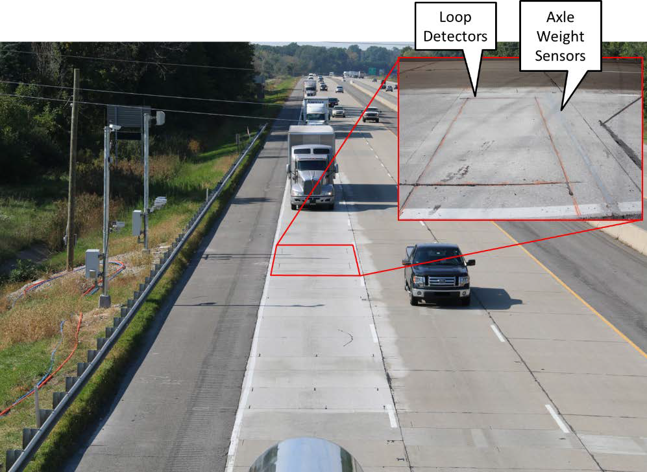

Figure 1: Site Photo of WIM (cameras on shoulder)
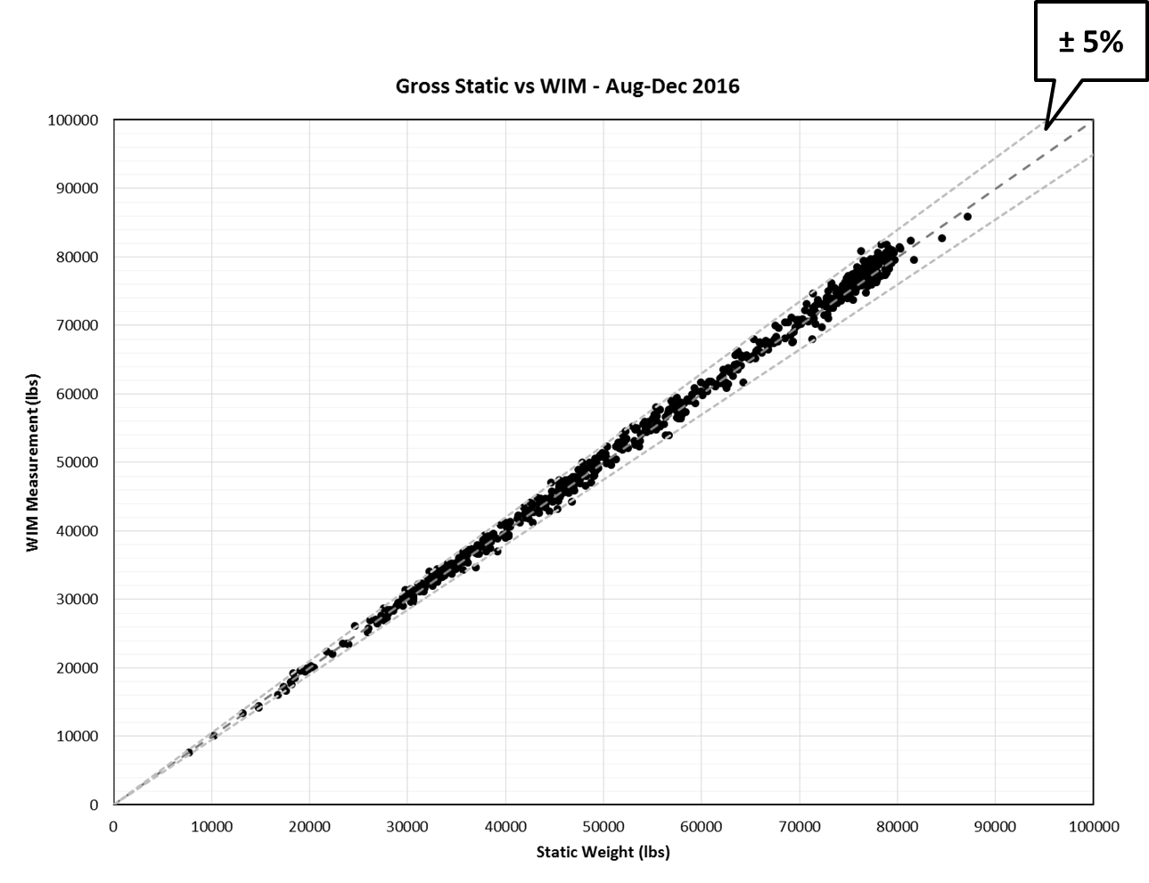

Figure 2: Comparison of WIM weights with Indiana State Police Static Scale Weights

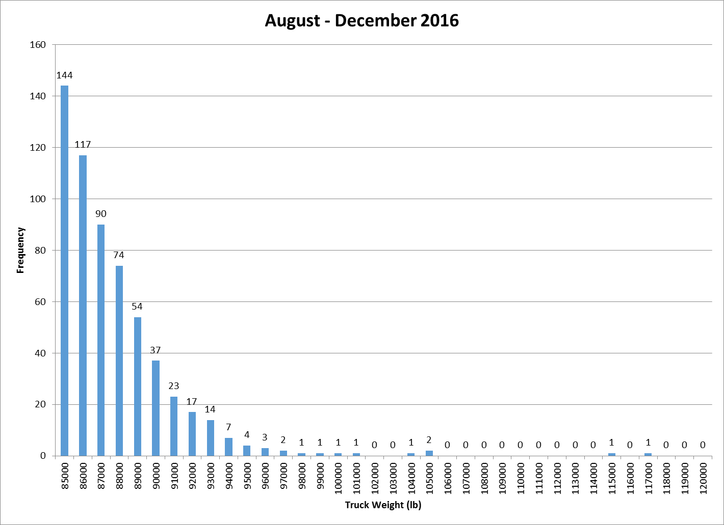
2 Trucks > 110,000 lb

Figure 3: Count of vehicles over 85,000 lbs from August 1 to December 31, 2016.

