2026 Interim Meeting Agenda
NCWM Board of Directors

Mr. Kevin Schnepp, NCWM Chairman
California

INTRODUCTION
The Board of Directors (hereinafter referred to as the "Board") will address the following items in Table A during the Interim Meeting. Table A identifies the agenda items by reference key, title of item, page number and the appendices by appendix designations. The first three letters of an item's reference key are assigned from the Subject Series List. The next 2 digits represent the year the item was introduced. The acronyms for organizations and technical terms used throughout the agenda are identified in Table B. In some cases, background information will be provided for an item. The fact that an item appears on the agenda does not mean it will be presented to the National Council on Weights and Measures (NCWM) for a vote. The Board will review its agenda and may withdraw some items, present some items for information meant for additional study, issue interpretations, or make specific recommendations for change to the publications identified, which will be presented for a vote at the Annual Meeting. The Board may also take up routine or miscellaneous items brought to its attention after the preparation of this document. The Board may decide to accept items for discussion that are not listed in this document, providing they meet the criteria for exceptions as presented in NCWM Policy 3.1.4. Handbooks, Procedures to Modify Handbooks. The Board has not determined whether the items presented will be Voting or Informational in nature; these determinations will result from their deliberations at the Interim Meeting.
Items may be grouped into “Blocks” if they are:
- Opposing Items: Items in direct conflict with each other, and only one may be adopted,
- Interdependent Items: Items addressing a similar topic where, if one is adopted, all need to be adopted, and
- Related Items: Items addressing a similar topic across multiple codes or regulations.
An "Item Under Consideration" is a statement of proposal and not necessarily a recommendation of the Board. Suggested revisions are shown in bold face print by striking out information to be deleted and underlining information to be added. Requirements that are proposed to be nonretroactive are printed in bold faced italics. Additional letters, presentations and data may have been part of the committee's consideration. Please refer to www.ncwm.com/publication-15 to review these documents.
All sessions are open to registered attendees of the meeting. If the Board must discuss any issue that involves proprietary information or other confidential material; that portion of the session dealing with the special issue may be closed if (1) NCWM Chairman or, in their absence, NCWM Chairman-Elect approves; (2) the Executive Director is notified; and (3) an announcement of the closed meeting is posted on or near the door to the meeting session and at the registration table. If possible, the posting will be done at least a day prior to the planned closed session.
Note: It is policy to use metric units of measurement in publications; however, recommendations received by NCWM technical committees and regional weights and measures associations have been printed in this publication as submitted. Therefore, the report may contain references to inch-pound units.

Subject Series List
Activity Reports ACT Series
Strategic Planning, Policies, and Bylaws SPB Series
Financial FIN Series
Other Items OTH Series

Table A
Table of Contents
Reference Key | Title of Item | BOD Page
ACT – Activity Reports 7

ACT-1 I Membership 7

ACT-2 I Meetings 7

ACT-3 I Participation in International Standard-Setting 8

ACT-4 I Associate Membership Committee Activity 8

ACT-5 I Task Groups, Subcommittees, Steering Committees 9

ACT-6 I Regional Association Activities 11
SPB – Strategic Planning, Policies, and Bylaws 11

SPB-24.1 I Electronic Publications 15 & 16 12

SPB-26.1 Article X – Voting System 12
FIN – Financial 16

FIN-26.1 Associate Membership Dues 16

FIN-1 I Treasurer's Report 17
Appendices
A ACT-3: Report of the Activities of the International Organization of Legal Metrology (OIML) and Regional Legal Metrology Organizations A20
B ACT-4: Associate Membership Committee (AMC) Agenda and Draft Meeting Minutes B24
Table B
Glossary of Acronyms and Terms

Acronym | Term | Acronym | Term
AMC | Associate Membership Committee | NTEP | National Type Evaluation Program
NCWM | National Council on Weights and Measures | OIML | International Organization of Legal Metrology
NIST | National Institute of Standards and Technology | OWM | Office of Weights and Measures
Details of All Items
(In order by Reference Key)

ACT – Activity Reports

ACT-1 I Membership
The chart and graph below show NCWM membership levels of recent years by membership categories. October 1 is the lowest level of membership for every fiscal year because it is the day that any memberships that were not renewed become lapsed. Significant growth is realized throughout the following 12 months as additional members return, and new members are received. The potential growth remains significant and NCWM continues to enhance programs and services that add value to membership.
Year Type | Oct.  2017 | Oct.  2018 | Oct.  2019 |  | Oct.  2020 | Oct.  2021 | Oct.  2022 | Oct.  2023 | Sept.  2024 | Sept.  2025
Associate | 658 | 643 |  | 636 | 607 | 608 | 609 | 573 | 720 | 607
Foreign Associate | 68 | 70 |  | 79 | 77 | 91 | 86 | 76 | 110 | 82
Total Associate | 726 | 713 |  | 715 | 684 | 699 | 695 | 649 | 830 | 689
State Government | 615 | 739 |  | 744 | 614 | 698 | 644 | 564 | 722 | 626
Local Government | 429 | 412 |  | 406 | 397 | 389 | 380 | 350 | 418 | 319
Total  Active | 1044 | 1151 |  | 1150 | 1011 | 1087 | 1024 | 914 | 1140 | 945
NIST | 15 | 15 |  | 17 | 16 | 15 | 19 | 14 | 15 | 14
Other Federal Government | 10 | 10 |  | 8 | 7 | 7 | 5 | 7 | 14 | 11
Foreign Government | 13 | 14 |  | 14 | 13 | 13 | 14 | 15 | 19 | 17
Retired | 223 | 225 |  | 235 | 241 | 245 | 248 | 353 | 185 | 140
Total Advisory | 261 | 264 |  | 274 | 277 | 280 | 286 | 389 | 233 | 182
Grand Total | 2031 | 2128 |  | 2139 | 1972 | 2066 | 2008 | 1952 | 2203 | 1816

ACT-2 I Meetings
Interim Meetings:
- January 11-14, 2026 Renaissance Mobile Riverview Plaza Hotel, Mobile, Alabama
- January 24-27, 2027 Sonesta Redondo Beach & Marina, Redondo Beach, California
- January 23-26, 2028 Biltmore Los Angeles, Los Angeles, California
Annual Meetings:
- July 26-30, 2026 111th Annual Meeting: Marriott Old City, Philadelphia, Pennsylvania
- July 11-15, 2027 112th Annual Meeting: Marriott Knoxville Downtown, Knoxville, Tennessee
- July 2028 Date and location to be determined in the Central Region
NCWM strives to plan meetings in locations that have reasonably priced airline service and are within government per diem rates. For more information about our meetings, contact Ms. Elisa Stritt, NCWM Director of Operations, at (402) 434-4872 or elisa.stritt@ncwm.com.

ACT-3 I Participation in International Standard-Setting
David Sefcik (NIST OWM) provided a report during the Open Hearings of the 2025 NCWM Annual Meeting. See Appendix A for a copy of the full report. The Board of Directors expresses appreciation to Mr. Sefcik for his report and the important efforts of the NIST, Office of Weights and Measures around the world.
See the NTEP Committee Agenda for additional reports on NCWM's involvement internationally, including the Mutual Recognition Arrangement (MRA) with Measurement Canada and the OIML Certificate System (CS).

ACT-4 I Associate Membership Committee Activity
AMC Committee Chair Bill Callaway provided the following report.
Hello Everyone!!! My time as the Chairman of the AMC committee is winding down. We will be selecting the next AMC team on Wednesday morning. I wanted to thank everyone on the AMC committee for their support & professionalism throughout the past several years.
I am happy to report that the Associate Membership Committee is doing well. As a reminder to everyone the AMC committee is comprised of industry representatives who make up approximately 40% of NCWM’s total membership. AMC membership dues are slightly higher than Government Membership dues. The amount for Associate Member dues in excess of government member dues is deposited into a special AMC account to create the AMC Fund. The AMC fund is intended to be used for the purpose of funding Weights & Measures Training throughout the country. Any expenditure from this fund is at the authorization of the AMC and in accordance with the bylaws and policies.
To apply for AMC funds is easy. On the NCWM website under Associate Membership Committee download the application. Complete the application and send it to Don Onwiler. We will circulate the application to the AMC and vote on the funding of the application.
Some criteria for funding selection are as follows:
- The application is thoroughly completed with all the information the AMC needs to make a decision.
- Training requests that benefits a higher number of participants are generally preferred over those for fewer or single-person benefit. Multi-state training that encourages uniformity will also be given priority consideration.
- In general, attending meetings will not be considered training, especially requests for travel expense or attendance fees for NCWM Annual, Interim or Regional meetings. Food & beverage expenses is not considered a training activity that the AMC will Fund.
- As a lower priority, requests for the purchase of training materials will be considered, but requests for purchase of assets (such as LCD projectors) will not.
- Reasonable funding for travel and expenses will be considered if it is necessary to acquire an “expert trainer” that would benefit a high number of Weights and Measures Officials. This will be an option when qualified volunteers are not available.
The following is a summary of the training the AMC Committee has funded over the past 12 months.
- Connecticut – Financial contribution to help fund a Lab Metrology Mentoring Program. The goal is to assist with new lab set up and/or continuing education for existing staff in the amount of $3,500 for ~30 participants.
- Colorado - In-person small-scale training for new hires, management staff and refresher for advanced inspectors. The course is a joint training with staff from the New Mexico Department of Agriculture and Colorado Department of Agriculture in the amount of $2,000 for 30 participants.
- New York – Provide a weeklong training school covering multiple topics, to include: NIST EPOs, updates to NCWM Handbooks, petroleum quality, package checking, and safety issues. This school is open to all NYSWMA members, inspectors from surrounding states as well as representatives from NCWM and NIST in the amount of $5,000 for 70+ participants.
- Wisconsin - These funds will be used to have a NIST certified trainer attend and present a one day training on small capacity scales, specifically retail computing scales, at the Wisconsin Weights and Measures Association Annual Meeting in 2025 in the amount of $3,000 for 60 participants.
- Illinois – NIST Vehicle Tank Meters & Loading Rack Training in the amount of $4,000 for ~ 25 inspectors.
- Montana – Large Scale Inspection, Test & Certification Course in the amount of $5,995 for 25 participants.
I am happy to report that the AMC Committee has approved ~ $23,495 to be used for training ~ 240 approximately participants.
Special thanks to the AMC committee for your hard work as well as to the employers of the AMC committee participants for allocating the resources for you to participate in the NCWM.

ACT-5 I Task Groups, Subcommittees, Steering Committees
Task Groups, Subcommittees, Steering Committees:
Focus groups, task groups, subcommittees, and steering committees are created by the NCWM Chairman and operate as defined in NCWM Policy 1.5.1. Subgroups Supporting the Work of the Organization. A task group is given a specific charge, and it reports to the appropriate NCWM standing committee. A task group will disband after completing its assignment. A subcommittee is charged with ongoing responsibilities in support of a standing committee in a specific field of expertise. A steering committee is charged with unbiased fact-finding that will assist NCWM membership in decision processes for difficult issues. A steering committee will disband upon completion of its specific charge.
NCWM offers resources to these task groups and subcommittees including meeting space at Interim and Annual Meetings, conference calling and web meeting services, group email services, a dedicated web page for posting and archiving documents related to their work, and broadcast e-mail services to reach targeted audiences. Additionally, NIST OWM has provided technical advisors and web meeting forums. These tools enable year-round progress of task group and subcommittee work.
Because NCWM task groups and subcommittees are part of the NCWM organizational structure and report directly to its standing committees, their proposals may appear in NCWM Publication 15 without first being vetted through a regional association. NCWM vets any such proposals through the open hearings of NCWM.
Current task groups and subcommittees are listed here.
Reporting to the Board of Directors:
Cannabis Task Group:
Chair: Mr. Charles Rutherford
612-655-5494, charlie@cprsquaredinc.com
Policy and Bylaw Review Task Group
Chair: Mr. Chris Guay
513-652-6597, guay.cb@gmail.com
EVSE Training Planning Committee
Chair: Mahesh Albuquerque
303-318-8502, mahesh.albuquerque@state.co.us
EVSE Task Group
Chair: Kevin Schnepp
916-229-3458, kevin.schnepp@cdfa.ca.gov
NCWM Standards Development Task Group
Chair: Jason Flint
973-420-8915, flnt@dca.njoag.gov
Reporting to the Laws and Regulations Committee:
Fuels and Lubricants Subcommittee
Chair: Vanessa Benchea
813-868-8263, Vanessa.Benchea@fdacs.gov
Packaging and Labeling Subcommittee
Chair: Mr. Chris Guay
513-652-6597, guay.cb@gmail.com
Uniform Shipment Law Task Group
Chair: Miland Kofford
801-538-7158, mkofford@utah.gov
Moisture Allowance Task Group
Chair: Tory Brewer
304-722-0602, tory.d.brewer@wv.gov
Reporting to the Specifications and Tolerances Committee:
Milk Meter Tolerance Task Group
Chair: Mr. Aaron Yanker
719-250-1851, aaron.yanker@state.co.us
Verification Scale Division (e) Task Group
Chair: Evan Foisy
631-560-3497, EFoisy@andonline.com

Transportation-for-Hire Systems Task Group
Chair: Mark Lovisa
225-925-3780, mlovisa@ldaf.state.la.us

Reporting to the Professional Development Committee:
Safety Subcommittee
Chair: John Satterlee
217-785-8480, john.satterlee@illinois.gov
Women in Weights and Measures Subcommittee
Chair: Cheryl Ayer
303-318-8502, cheryl.e.ayer@agr.nh.gov
Metrology Subcommittee
Chair: Frank Greene
860-713-7237, frank.greene@ct.gov
Member Education and Mentorship Subcommittee
Chair: Brian Fuller
515-201-5413, Brian.Fuller@IowaAgriculture.gov
Fraud Prevention and Education Task Group
Chair: Alan Walker
805-274-9044, alan.walker@FDACS.gov

ACT-6 I Regional Association Activities
2025 Meetings
NEWMA Interim Meeting
October 20-22, 2025
Location TBD
Contact: Mr. James Willis, James.Willis@agriculture.ny.gov
CWMA Interim Meeting
September 29 – October 2, 2025
Dubuque, Iowa
Contact: Ms. Sherry Turvey, Sherry.Turvey@ks.gov
WWMA Annual Meeting
September 7-11, 2025
Helena, Montana
Contact: Mr. Brent Ricks, bricks@mt.gov
SWMA Annual Meeting
October 26 – 29, 2025
Greenville, South Carolina
Contact: Valerie Forbes, valerie.forbes@delaware.gov

SPB – Strategic Planning, Policies, and Bylaws

SPB-24.1 I Electronic Publications 15 & 16
Source:
Board of Directors
Purpose:
Get membership feedback on eliminating printed copies of Publications 15 & 16.
Item under Consideration:

NCWM offers Publications 15 and 16, the Interim and Annual Meetings agendas, in two formats. They are available as downloads from the NCWM website and provided as printed books at the meetings. NCWM is gradually reducing the number of printed copies, and will discontinue printing them in 2027. Attendees will continue to have access to the publications in PDF format from the NCWM website, and NCWM will provide adequate power supply throughout the ballroom for electronic devices.
Previous Action:
New in 2024
Original Justification:
Society has become less dependent on paper by recognizing the advantages of electronic files. They provide easy word searches and links from a table of contents to a specific item in the file. By eliminating printed books, NCWM would provide a positive environmental impact while realizing cost savings from printing and shipping hundreds of large books twice yearly.
Recognizing the need for electronic devices, NCWM would include access to power supplies throughout the meeting rooms.
Item Development:
2025 Annual Meeting: Very limited printed copies of Publications 15 and 16 will be available in 2026. NCWM will discontinue printing these publications in 2027.

2025 NCWM Interim Meeting: Staff has reduced the number of books published based on the demand of previous meetings. NCWM will continue assessing the demand while the board encourages attendees to move toward viewing on their electronic devices.

SPB-26.1 Article X – Voting System
Source:
NCWM Policy and Bylaws Review Task Group
Purpose:
Clarify the process for amending the reports.
Item under Consideration:
Amend the NCWM Bylaws as follows:
Article X - Voting System
.
.
.

Section 6 - Committee and Board of Directors Reports
Alternatives that may be used in voting on the reports:
- vote on the entire report at once,
- Vote on the report by separate and distinct parts which can be done by a
  - vote on grouped items or sections, and/or
  - vote on individual items; according to
    - committee discretion,
    - on request by a registered attendee, or
  - vote to adopt the remainder of the report after having voted on the individual items within the report.
Once a vote on an individual item, grouped item(s) or section(s) is completed that result will stand unless there is a successful action to reconsider a specific vote per Roberts Rules, and cannot be recalled for another vote at the same Annual Meeting.

Section 7 - Amendments and Changes

Technical Items
  - Changes
Committee chairs A committee may offer changes to their final reports on the day of voting amend the classification or the proposed text of an item in its report until there is a call for the vote on that item.

Amendments
Substantive amendments can be made at the request of to the classification or the proposed text can be proposed from the floor by weights and measures officials only, and:
    - a A majority of the voting delegates of the House of State Representatives and the House of Delegates must vote favorably before a proposed amendment can be accepted for debate.
    - A two-thirds favorable vote of the House of State Representatives and the House of Delegates on the amendment is required for passage (the requirement for a minimum vote of 27 in each House also applies).

Business Items
  - Changes
Committee or Board members The Board of Directors may offer editorial changes to their final reports on the day of voting amend the classification or the proposed text of an item in their report until there is a call for the vote on the item.

Amendments
Substantive amendments can be made at the request of to the classification or the proposed text can be proposed from the floor by any member, and:
    - a A majority of the voting delegates of each House must vote favorably before a proposed amendment can be accepted for debate.
    - a A two-thirds favorable vote of each House on the amendment is required for passage (the requirement for a minimum vote of 27 in all three Houses also applies).

.

.

.

Section 9A - Voting - Technical Issues
Only members of the House of Delegates and the House of State Representatives will vote on the technical questions before the Corporation. At the conclusion of debate (if authorized) on a motion, there shall be a call for the vote by voice vote, a show of hands, standing, or electronic count. The requirements for minimum votes in a house are found in Article X, Section 4.

Motion Accepted If:
  - the majority of the House of State Representatives casts the required minimum votes in favor of the item

And
  - the majority of the House of Delegates casts the minimum required votes in favor of the item or the House of Delegates fails to cast the minimum required votes in opposition to the item.

Motion Rejected If:
  - the majority of the House of State Representatives casts the minimum required votes in opposition of the item

And
  - the majority of the House of Delegates casts the minimum required votes in opposition of the item or the House of Delegates fails to cast the minimum required votes in favor of the item.

Issue Returned to Committee for Future Consideration If:
  - The House of Representatives fails to cast the minimum required votes.
  - The minimum required votes is cast in each house but one house votes yea and the other house votes nay.

Or
  - Either the House of Representatives or House of Delegates casts a tie vote of 27 votes or more each in favor and in opposition to the item.
The issue cannot be recalled for another vote at the same Annual Meeting.
.
.
.

Section 9B - Voting - Business Issues
All members of the Corporation, including Associate Members, will vote on all business issues before the Corporation. At the conclusion of debate (if authorized) on a motion, there shall be a call for the vote by voice vote. In the event that a voice vote is too close to be determined in the opinion of the Chair, there shall be a show of hands, standing vote, or machine (electronic) vote count. There is no minimum voting requirement for any house to conduct business on issues.

Motion Accepted If:
  - a majority of those members present and voting vote Yea.

Motion Rejected If:
  - a majority of those members present and voting vote Nay.

Tie Vote:
  - In the case of a tie vote, the vote of the Chair shall prevail.

Section 10 - Procedures
The Corporation officers and committees observe in all of their procedures the principles of due process  the protection of the rights and interests of affected parties; specifically, they: (a) give reasonable advance notice of contemplated committee studies, items to be considered for committee action, and tentative or definite recommendations for Corporation action, for the information of all parties at interest, and (b) provide that all interested parties have an opportunity to be heard by committees and by the Corporation.
Previous Status:
2026: New Proposal
Original Justification:
The NCWM Policy and Bylaws Review Task Group reports to the Board of Directors. The task Group has recognized some ambiguity in the bylaws regarding the procedures to amend items on the agendas of committees and the board. This leaves interpretation to the parliamentarian. The changes proposed by the task group aim to clarify the process outlined in the bylaws, thereby avoiding scrutiny in the parliamentarian’s instructions.
Comments in Favor:
Regulatory:

Industry:

Advisory:

Comments Against:
Regulatory:

Industry:

Advisory:

Neutral Comments:
Regulatory:

Industry:

Advisory:

Item Development:
New Proposal
Additional letters, presentation and data may have been submitted for consideration with this item. Please refer to https://www.ncwm.com/publication-15 to review these documents.

FIN – Financial

FIN-26.1 Associate Membership Dues
Source:
Seraphin Test Measure
Purpose:
Provide additional funds for the Associate Membership Committee (AMC) to support training for weights and measures programs.
Item under Consideration:

Increase Associate Member dues from $115 to $140.

Previous Status:
New proposal
Original Justification:
The Associate Membership Committee discussed AMC funds that are available for training at the 2025 NCWM Annual Meeting. Recently the AMC has received requests that have exceeded the available funds and have had to reduce or deny the requested amount. After discussion, the AMC voted on and approved that it request to the NCWM Board of Directors that it raise Associate Member dues from $115 to $140. This would provide the Associate Member Committee with approximately $20,000 per year of additional funding for training support.
The submitter acknowledges that the $25 increase in dues could be a burden to some Associate Members.
The increase of dues would be a vote of the Board of Directors as provided for in the NCWM Bylaws, Article IV, Section 1 – Fee.
Comments in Favor:
Regulatory:

Industry:

Advisory:

Comments Against:
Regulatory:

Industry:

Advisory:

Neutral Comments:
Regulatory:

Industry:

Advisory:

Item Development:
New Proposal
Additional letters, presentation and data may have been submitted for consideration with this item. Please refer to https://www.ncwm.com/publication-15 to review these documents.

FIN-1 I Treasurer's Report
Overall, NCWM’s financial health is strong and there are no concerns. NCWM has self-funded the startup of its NTEP laboratory without incurring debt. All financial transactions and balances have been properly recorded and reported, and our internal controls, including the annual audit by Dana F. Cole & Company completed in December 2024, are effective in ensuring the accuracy and reliability of the financial information. Our financial statements accurately reflect NCWM’s financial position and performance. We have sufficient liquidity to meet our current and future obligations, and financial performance is in line with expectations based on the current market. There are no immediate risks or areas of concern that require attention. I recommend continuing to monitor NCWM’s financial performance and taking proactive measures to ensure its long-term financial stability.
Respectfully submitted by Mahesh Albuquerque, Treasurer.
ASSETS | September 30, 2024 |  | September 30, 2025
Current Assets | $ |  | $
Checking/Savings
Associate Member Fund | 36,660.32 |  | 18,975.61
Certificates of Deposit | 427,081.31 |  | 274,278.41
Equities | 987,320.75 |  | 1,136,077.80
Money Market Fund | 175,832.57 |  | 152,921.34
Checking | 113,942.57 |  | 33,838.03
Savings | 11,022.86 |  | 11,050.44
Total Checking/Savings | 1,751,860.38 |  | 1,627,141.66
Accounts Receivable | 12,038.83 |  | 56,415.81
Other Current Assets | 206,570.42 |  | 573,041.32
Fixed Assets | 7,015.48 |  | 13,642.32
Other Assets | 452,830.99 |  | 471,181.05
TOTAL ASSETS | 2,430,316.10 |  | 2,741,422.16
LIABILITIES & EQUITY
Liabilities
Current Liabilities | 582,848.06 |  | 622,683.34
Total Liabilities | 582,848.06 |  | 622,683.34
Equity
Designated - Associate Membership | 55,174.62 |  | 18,972.44
Unrestricted Net Assets | 1,574,919.61 |  | 1,829,139.07
Net Income | 217,373.81 |  | 270,627.31
Total Equity | 1,847,468.04 |  | 2,118,738.82
TOTAL LIABILITIES & EQUITY | 2,430,316.10 |  | 2,741,422.16

Kevin Schnepp, California | NCWM Chairman
Jason Flint, New Jersey | NCWM Chairman-Elect
Marc Paquette, Vermont | NTEP Committee Chair
Mahesh Albuquerque, Colorado | Treasurer
Daniel Walker, Ohio | Active Membership - Central
James Willis, New York | Active Membership – Northeastern
Paul Floyd, Louisiana | Active Membership - Southern
Bill Striejewske, Nevada | Active Membership - Western
Matt Curran, Florida | At-Large
Jason Glass, Kentucky | At-Large
Ray Johnson, Fairbanks Scales | AMC Representative

Don Onwiler, NCWM | Executive Director
Katrice Lippa, NIST, OWM | Executive Secretary
Erica Garnier, Measurement Canada | Advisor
Jeff Gibson, NCWM | NTEP Administrator
Board of Directors

Appendix A
Report of the Activities of the International Organization of Legal Metrology (OIML) and Regional Legal Metrology Organizations
National Institute of Standards and Technology (NIST), Office of Weights and Measures (OWM)

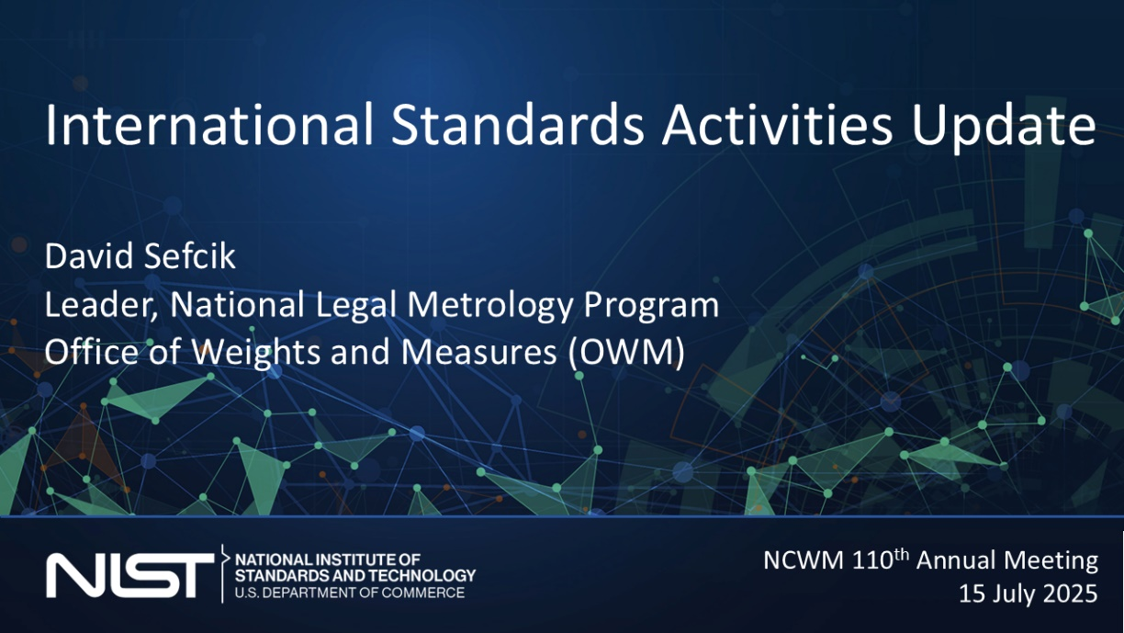
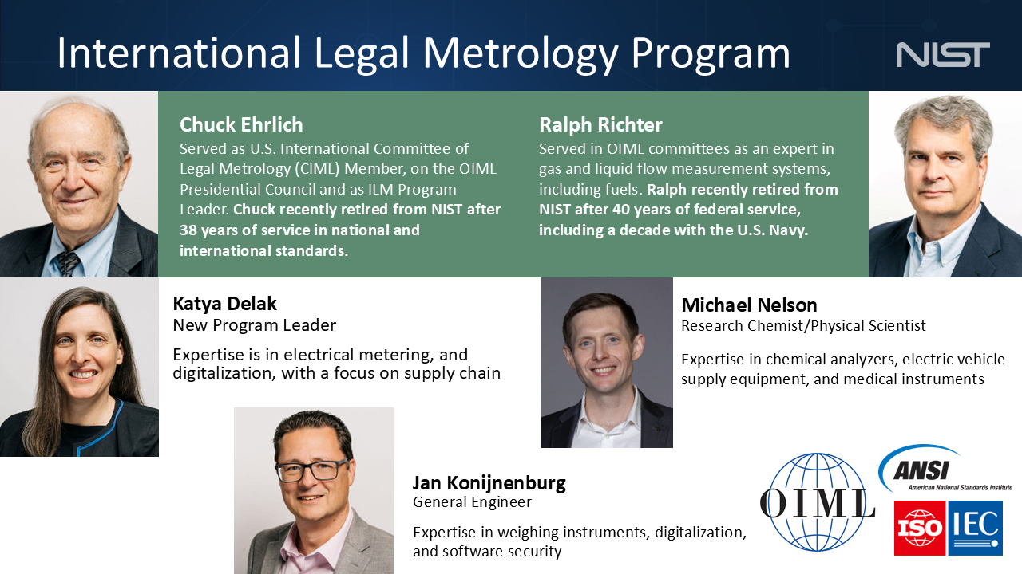

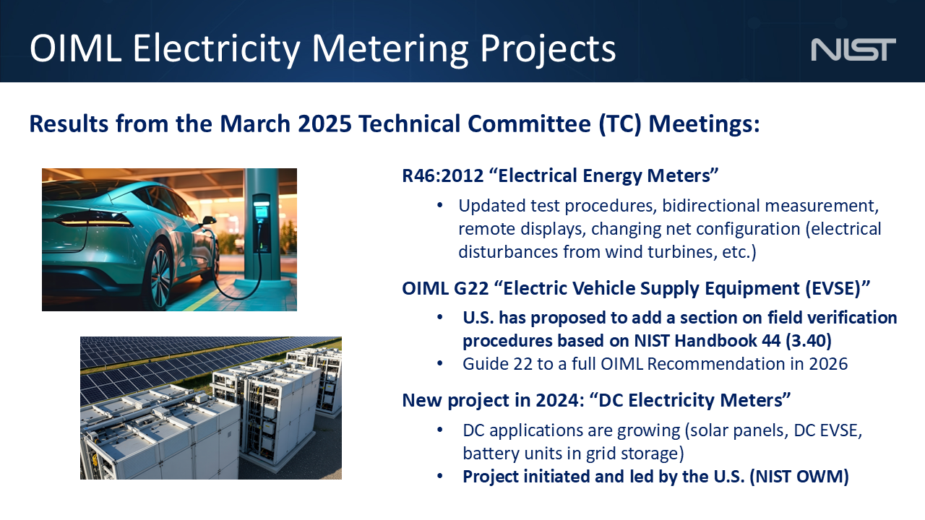
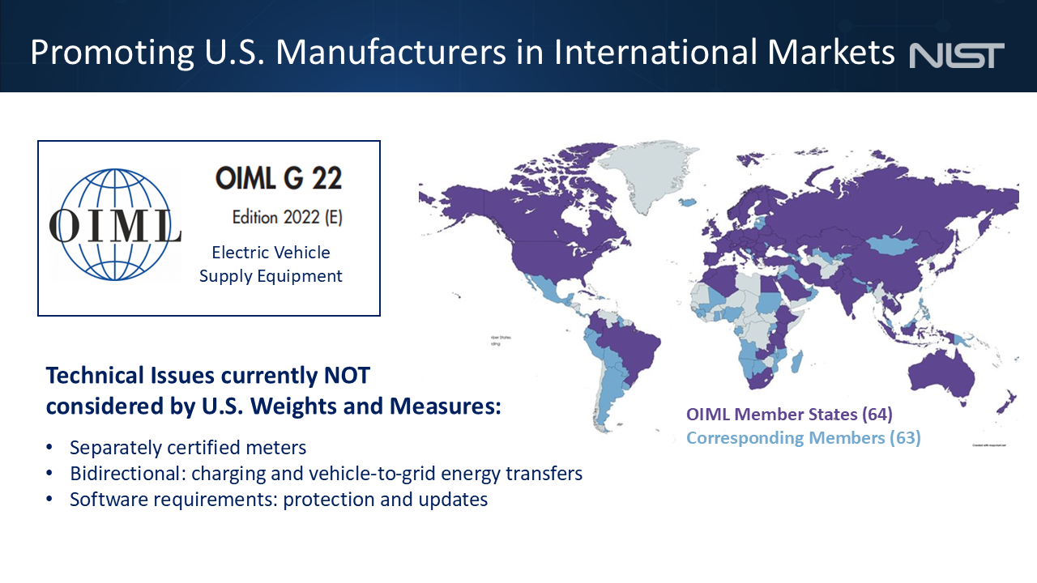

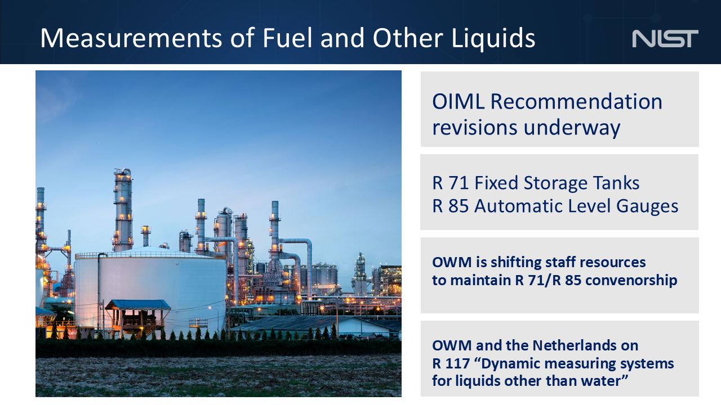

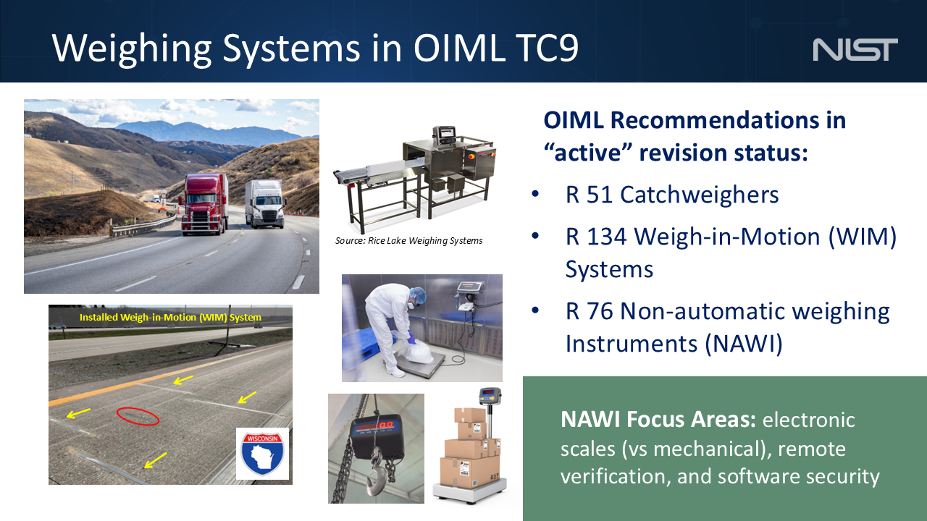

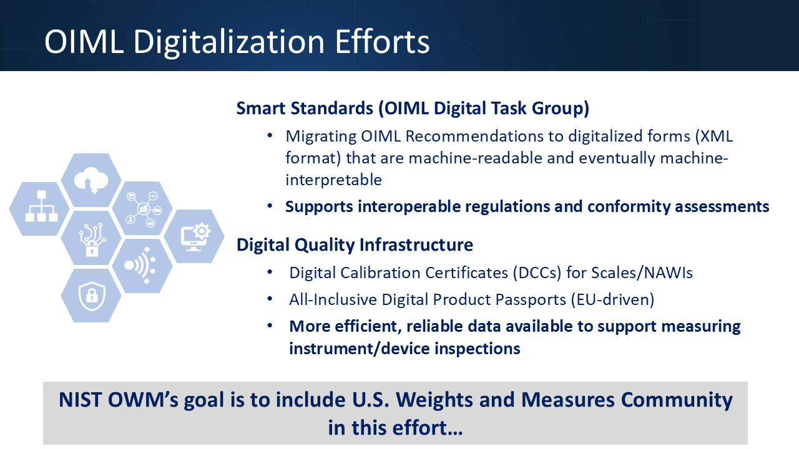

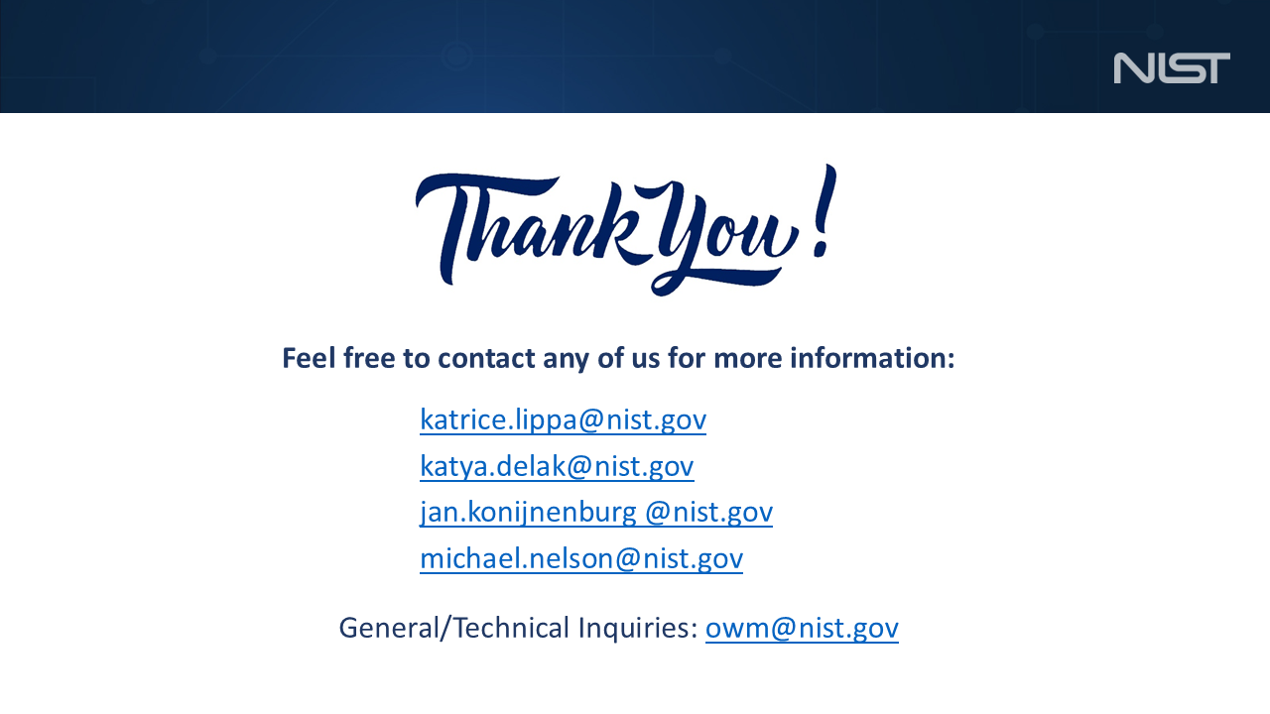

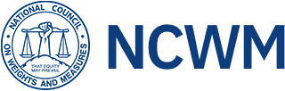
National Council on Weights & Measures
Associate Membership Committee Meeting Notes
110th Annual Meeting
Wednesday, July 16, 2025
Reno, NV

Call to Order: Chair Bill Callaway called the meeting to order.
Minutes from last meeting: The Committee reviewed and approved the minutes of the previous meeting from January 2025.
Elections: Per the bylaws elections for next committee members are held annually. These are one-year terms with rotation or succession upward to chair each year, unless determined otherwise. The election results were as follows.
  - Chair Jim Pettinato
  - Vice-chair Brent Price
  - Secretary-treasurer Reid Wagner
At least 5 members (up to 10) are nominated to review proposals. The list includes the three officer positions. Some members were added, and the list now includes:
  - Bill Calloway
  - Jim Pettinato
  - Brent Price
  - Reid Wagner
  - Bob Murnane
  - Prentiss Searles
  - David Boykin
  - Perry Lawton
  - Chris Wagner
Ray Johnson is the appointed AMC representative for the BOD.
Financial Report: A financial statement was distributed to the attendees. In summary, the account balance as of July 1, 2025, was $30232. There are payments pending of $11123, resulting in a net balance of $19109.
There is one request not yet approved for Louisiana EVSE and package inspection training.
Bill Callaway reviewed the criteria for requests of AMC funds to the members present.
NCWM Committee Reports:
BOD: Chris Guay provided the BOD update. Chris is retiring and Ray Johnson is taking over as the Associate member on the BOD.
  - EVSE training next month in Denver with a few openings left
  - The new NCWM office and lab grand opening was in June 2025 in Lincoln NE

L&R: Brent Price reported no major changes from statuses of items from interim meeting.
PDC: Perry Lawton reported as noted above that the EVSE training is upcoming, and NIST will possibly roll out other EVSE material/training in the future.
Old Business
- Montana large scale course and NIST VTM loading race training applications were approved.
- The Louisiana AMC fund application was rejected by the group because the request was for food and beverage. They (LA) were not going to modify the request, so no further activity on this item.
New Business
- Increasing AMC dues was discussed. Our AMC membership is approximately 800 members, and currently $15 is collected from each annual membership for the AMC.
- Bob Murnane in writing had suggested that we collect additional funds, as we have been short and denied some requests. Also, the existing $15 extra in dues has been in effect a long time.
- Chris Wagner provided a review of past years spendings and expressed concern that we could easily have a shortfall of funds and resulting rejection of funding request based on recent expenditures. If we reject requests for insufficient funds, then future requests will diminish. We perhaps should keep a safety reserve amount in the account, for example one full year of funds in reserve. He proposed increasing the dues and stated that the annual membership fee to NCWM was very reasonable as compared to other trade membership organizations.
- It was decided to increase the annual associate membership from $115 to $140 effective fall 2026. Bob Murnane will submit a Form 15 request for this change.
Additional comments and discussions
- Chuck Corr asked that if anyone has inputs for member education and mentorship group
  - one suggestion is that in the breakout sessions have the committee introduce themselves
- David Boykin says it’s a good experience for AMC members to participate in development of RSA exams, and the contact is Jerry Buendel for exams.
- Don Onwiler says that folks should take or need to take the HB 44 training exam first to improve passing rates for RSA exams.
- Bill Callaway stated that it is in the best interest with RSA exams if we get the states to reciprocate between state to state. Scott Simmons says we need encouragement for states to adopt, and this will elevate HB44.
- Comment was that Industry (AMC members) needs to tell the story of innovations for the regulators, on new methods and technology, and to gain trust (example was QR code for EVSE).
- Don Onwiler stated that 14 states accept RSA, but most do not mandate the NCWM test, working on this to get other states on board.
- Scott Simmons mentioned that NIST has HB44 self-study preparation, and it is great preparation for taking any of these exams
- David Boykin said that his company NCR has a SharePoint site that references the NIST HB44 preparation.
- Richard Suiter commented that some states need education, and that training and focus on safety are key elements, and there is a need for retention of employees. Maybe AMC can be working on education programs.
- Mahesh Albuquerque stated that the EVSE training in August is still looking for sponsors.
The meeting was adjourned ~ 9:00 am

